
DEPARTMENT OF INFORMATION TECHNOLOGY
A PROJECT REPORT ON
Browser Based Discrete – Event Simulator
“JustCmul8: A No-Code, Browser-Based Discrete Event Simulation Platform”

SUBMITTED BY
Ms. Khushi Singh – 261713
Mr. Mohit Gupta – 261715
UNDER THE GUIDANCE OF
Ms. Jinal Gujar
Submitted in partial fulfilment of the requirements for qualifying
BACHELOR OF SCIENCE (INFORMATION TECHNOLOGY)
Semester – V Examination
THAKUR COLLEGE OF SCIENCE AND COMMERCE
(Empowered Autonomous College, Permanently Affiliated to University of Mumbai)
THAKUR VILLAGE, KANDIVALI (EAST), MUMBAI – 400 101, MAHARASHTRA
ACADEMIC YEAR 2026 – 2027

CERTIFICATE OF APPROVAL
This certifies that the project titled “Browser Based Discrete – Event Simulator” was carried out at Thakur College of Science and Commerce by Ms. Khushi Singh (Roll No. 261713) and Mr. Mohit Gupta (Roll No. 261715), students of Bachelor of Science (Information Technology). It is submitted in partial fulfilment of the Semester–V examination for the B.Sc. (Information Technology) degree of the University of Mumbai, academic year 2026 – 2027.
The students have finished every phase of the project. The work in this report is theirs, and it has not been offered to any other university or institute for a degree or diploma.

______________________________  Ms. Jinal Gujar  Project Guide | ______________________________  Prof. Dr. Santosh Kumar Singh  Head of Department
______________________________  External Examiner | ______________________________  Principal

Date: ______________ College Seal / Stamp: ______________
CANDIDATES’ DECLARATION
We declare that the project described in this report, “Browser Based Discrete – Event Simulator”, is our own work. It was done during the academic year 2026 – 2027 under the guidance of Ms. Jinal Gujar and is submitted to the Department of Information Technology, Thakur College of Science and Commerce, in partial fulfilment of the Bachelor of Science in Information Technology (Semester–V) degree.
The analysis, design, source code, integration of the simulation engine, testing and write-up were all done by the two of us. Where we drew on published literature, official technical documentation or open-source libraries, we have said so in the text and listed the source under References. None of this material has been submitted, wholly or partly, to another university or institute for any degree or diploma.
We accept that any lapse in academic integrity, whenever it is found, can lead to disciplinary action under the rules of the college and the University of Mumbai.

Place: Mumbai
Date: ______________
______________________________  Ms. Khushi Singh  Roll No. 261713 | ______________________________  Mr. Mohit Gupta  Roll No. 261715
ACKNOWLEDGEMENT
Many people helped this project along, and we would like to thank them here.
Our first thanks go to our guide, Ms. Jinal Gujar of the Department of Information Technology, who kept us on course through the whole development of JustCmul8. She insisted that the simulation engine be checked before any feature was stacked on it. We had planned it the other way round, and following her advice spared us a lot of re-work. She also read our early drafts, and the shape of this report came out of her comments.
Prof. Dr. Santosh Kumar Singh, Head of the Department of Information Technology, made it possible for students to take on a project of this size, and his suggestions in the review sessions were useful. We are grateful to him.
We thank the Principal and management of Thakur College of Science and Commerce for the laboratory, network and machines we used. Testing a WebAssembly Python runtime, and trying real-time collaboration on several computers at once, needed the department laboratory.
The faculty of the department taught us data structures, database systems, software engineering and web technologies, and we used that material directly: priority queues, normalisation and the life-cycle models all appear in the work below. The laboratory assistants also deserve thanks for sorting out machine access and configuration during long testing sessions.

Ms. Khushi Singh – 261713
Mr. Mohit Gupta – 261715
ABSTRACT
A few are the number of people who use DES, a powerful demonstration tool, in order to see how a queue, a production line or a delivery network will behave before beginning to spend money to change it. For example, the commercial packages, like AnyLogic, Arena and Simul8, cost thousands each year for a licence. The so-far main open-source alternative is the Python library SimPy, but before a first run of a model, a user has to write and debug their own code. Almost all of these tools have to be downloaded and installed, an issue in shared labs and managed machines. Drawing tools like these, such as Visio and Lucid chart, work vice versa: they're easy to use, but they don't execute their diagrams, nor tell you what will happen if one extra counter is opened.
JustCmul8 is our attempt towards filling that gap. No downloading or installation required and nodes are dragged to a canvas, connected, and each node is completed with normal form fills and the model is run. It is designed in such a way that the model is never approximated in JavaScript. The graph is consolidated to a true Python SimPy script, executed by a CPython interpreter that was ported to WebAssembly (Pyodide) and passed in as a Web Worker, so there's no freeze in the interface. These numbers are accordingly built from the same hardware that would be implemented in a terminal.
The front end is a single-page application implemented in Next.js 16, React 19 and TypeScript, and the canvas is based on React Flow and Zustand state management library. Supabase manages sign-in, storage and real-time channels, and PostgreSQL Row-Level Security does projects at the database level – without having to rely on client code. The twelve working modules contain fifteen node types and span six domains: human queues, vehicle traffic and the liquid and material flow, manufacturing, logistics and network signalling. The analytics layer calculates utilisation, waiting times, throughput, queue lengths, consistency with Little's law and a composite system health score after a run, and it identifies the name of the bottleneck node. A Monte Carlo facility is a facility that takes a run several times on independent replications and provides 95 per cent intervals instead of just one. These are surrounded by an animated digital-twin playback, a cost and return-on-investment panel, a Python code inspector with Jupyter export, and other executive PDF reports and revokable share links. A Google Gemini assistant accessed via a model router that observes model health and defaults automatically suggests a message in the form of a candidate graph and makes suggestions to improve this model's performance.
INDEX
1. INTRODUCTION 1
1.1 Background and Motivation 1
1.2 Objective and Scope of the Project 3
1.3 Problem Definition 6
1.4 Limitations 7
2. REQUIREMENT ANALYSIS 9
2.1 User Requirements / SRS / Functional Requirements 9
2.2 Feasibility Study 13
2.3 Details of Hardware and Software Used 15
2.4 Proposed System and Advantages of the Proposed System 17
3. PROJECT PLANNING 20
3.1 List of Activities / Tasks 20
3.2 Timeline for Each Task 22
3.3 Gantt Chart and Activity Network Diagram 24
3.4 Resource Planning 27
3.5 Proposed Software Development Model 29
4. SOFTWARE MODULES 32
4.1 Module 1: Platform and Data Layer 33
4.2 Module 2: Visual Graph Editor 34
4.3 Module 3: Node Configuration Panel 36
4.4 Module 4: Simulation Engine 37
4.5 Module 5: AI Assistant 38
4.6 Module 6: AI System Optimiser 39
4.7 Module 7: KPI Dashboard and Results 39
4.8 Module 8: Monte Carlo and Scenario Comparison 41
4.9 Module 9: Digital Twin Animated Playback 41
4.10 Module 10: Simulation Template Gallery 42
4.11 Module 11: Executive Report and Share 43
4.12 Module 12: Real-Time Collaboration 43
4.13 Hardware Modules and Considerations 44
4.14 Individual Work Justification 45
5. SYSTEM ANALYSIS AND DESIGN 47
5.1 Context Diagram 47
5.2 DFD, ERD, Class Diagram and State Transition Diagram 48
5.3 Use Case Diagram 54
5.4 Architecture Design 57
5.5 Activity, Component and Collaboration Diagrams 59
5.6 Table Design 62
5.7 Architecture / Deployment Diagram 66
6. SYSTEM IMPLEMENTATION AND METHODOLOGY 68
6.1 Development Methodology 68
6.2 Technologies Used 68
6.3 Algorithms and Techniques Used 69
6.4 Module-wise Implementation 72
6.5 Database Implementation 72
6.6 User Interface Design 73
6.7 Important Code Snippets 76
7. SYSTEM TESTING 80
7.1 Testing Strategy 80
7.2 Testable Units 81
7.3 Test Case Design with Reference to the Project 82
7.4 Test Approach 86
7.5 Test Results and Validation 87
8. RESULTS AND DISCUSSION 89
8.1 System Output 89
8.2 Result Analysis 97
8.3 Performance Evaluation 99
9. COST AND BENEFIT ANALYSIS AND SOFTWARE PARAMETER ESTIMATION 102
9.1 Effort Estimation 102
9.2 KSLOC Analysis 103
9.3 Function Point Analysis 104
9.4 Comparison of Estimates and Cost–Benefit Analysis 106
10. CONCLUSION AND FUTURE SCOPE 108
10.1 Achievements of the Project 108
10.2 Conclusion 109
10.3 Future Scope 109
REFERENCES AND BIBLIOGRAPHY 112

LIST OF FIGURES
Figure 1.1: Functional Modules of JustCmul8 grouped by area 5
Figure 2.1: Execution Pipeline of the Proposed System 18
Figure 3.1: Weekly Gantt Chart of the JustCmul8 Development Schedule (July W1 – December W4, 2026) 24
Figure 3.2: Activity Network Diagram of the JustCmul8 Development Lifecycle 26
Figure 3.3: Iterative and Incremental Development Model adopted for JustCmul8 29
Figure 4.1: Module Structure of JustCmul8 32
Figure 5.1: Context Diagram (DFD Level 0) for JustCmul8 47
Figure 5.2: Level-1 Data Flow Diagram for JustCmul8 49
Figure 5.3: Level-2 Data Flow Diagram: Decomposition of Process P4 (Simulation Execution) 50
Figure 5.4: Entity Relationship Diagram for the JustCmul8 Database 51
Figure 5.5: Class Diagram of the JustCmul8 Object Model 52
Figure 5.6: State Transition Diagram for a Node During Simulation Execution 53
Figure 5.7: Use Case Diagram for JustCmul8 54
Figure 5.8: Multi-Tier Architecture of JustCmul8 58
Figure 5.9: Activity Diagram of the End-to-End User Workflow 60
Figure 5.10: Component Diagram of the JustCmul8 Implementation 61
Figure 5.11: Collaboration Diagram for the Simulation Run Interaction 62
Figure 5.12: Deployment Architecture of JustCmul8 67
Figure 6.1: Landing Page 74
Figure 6.2: Registration and Login Screens 75
Figure 6.3: Project Dashboard 75
Figure 6.4: Workspace with the Visual Graph Editor 75
Figure 6.5: Node Configuration Panel 76
Figure 6.6: Template Gallery 76
Figure 7.1: Layered Testing Strategy for JustCmul8 80
Figure 8.1: Executive Summary Tab of the Results Dashboard 89
Figure 8.2: Flow and Balance Check (Little’s Law Verification) 90
Figure 8.3: Traffic Heatmap 90
Figure 8.4: Line Buildup Timeline 91
Figure 8.5: Station Counters 91
Figure 8.6: Person / Item Journey (Entity Tracer) 92
Figure 8.7: Cost and Return-on-Investment Panel 92
Figure 8.8: Monte Carlo Analysis with 95% Confidence Bands 93
Figure 8.9: Digital Twin Animated Playback 93
Figure 8.10: AI Assistant Generating a Model from a Description 94
Figure 8.11: AI System Optimiser Recommendation 94
Figure 8.12: Python Code Inspector 95
Figure 8.13: Real-Time Presence and Live Cursors 95
Figure 8.14: Export, Share and Executive PDF Report 96
Figure 8.15: Read-Only Shared View 96
Figure 8.16: Profile and Settings 97
Figure 8.17: Simulated Results against Queueing Theory (M/M/1 and M/M/3 benchmarks) 97
Figure 8.18: Deviation of Simulated Metrics from Theory against Accepted Tolerance 98

LIST OF TABLES
Table 1.1: Comparison of Discrete Event and Continuous Simulation 2
Table 1.2: Probability Distributions Implemented in JustCmul8 2
Table 2.1: User Classes and Access Levels 9
Table 2.2: Functional Requirements 10
Table 2.3: Non-Functional Requirements 12
Table 2.4: Indicative Cost Comparison with Commercial Alternatives 14
Table 2.5: Development Hardware and Software Configuration 15
Table 2.6: Minimum and Recommended Client Requirements 16
Table 2.7: Technology Stack with Justification 17
Table 2.8: Comparison of the Proposed System with Existing Approaches 18
Table 3.1: List of Activities and Tasks with Dependencies 21
Table 3.2: Planned Timeline of Each Task (July W1 – December W4, 2026) 22
Table 3.3: Project Milestones and Completion Criteria 23
Table 3.4: Human Resources and Responsibilities 27
Table 3.5: Hardware, Software and Service Resources 28
Table 3.6: Planned Effort Allocation by Phase 28
Table 3.7: Phases of the Adopted Life-Cycle Model 30
Table 3.8: Why the Iterative and Incremental Model Was Preferred 30
Table 4.1: Module Overview and Requirement Coverage 32
Table 4.2: The Fifteen Node Types Supported by the Simulation Engine 35
Table 4.3: The Six Simulation Domains and Their Vocabularies 36
Table 4.4: Key Performance Indicators and Their Computation 40
Table 4.5: Hardware Roles in the Deployed System 44
Table 4.6: Division of Work between Team Members 45
Table 5.1: Use Case Specification: Run Simulation 55
Table 5.2: Use Case Specification: Generate Model via AI 56
Table 5.3: Use Case Specification: Share Project Read-Only 56
Table 5.4: Use Case Specification: Collaborate in Real Time 57
Table 5.5: Table: auth.users (managed by Supabase Auth) 63
Table 5.6: Table: public.profiles 63
Table 5.7: Table: public.projects 63
Table 5.8: Table: public.simulation_runs 64
Table 5.9: Table: public.chat_history 64
Table 5.10: Table: public.project_shares 65
Table 5.11: Row-Level Security Policies 65
Table 6.1: Complexity of Graph Operations on the Adjacency List 70
Table 6.2: Module-wise Implementation Summary 72
Table 7.1: Testable Units and the Techniques Applied to Them 81
Table 7.2: Engine Verification Test Cases and Results 82
Table 7.3: Invariants Asserted for the Complex Model (Benchmark B6) 83
Table 7.4: Functional Test Case Design 84
Table 7.5: Edge-Case Probes and Observed Behaviour 87
Table 7.6: Requirements Traceability 88
Table 8.1: Worked Example: M/M/1 Queue at ρ = 0.8 (λ = 0.8, μ = 1.0, 36,000 s, 5 replications) 98
Table 8.2: Results for the Multi-Stage Hospital-Flow Model (7,200 s, 3 seeds) 98
Table 8.3: Engine Throughput Measured by the Verification Harness 100
Table 8.4: Browser Performance Measurements (to be recorded) 100
Table 9.1: COCOMO Coefficients by Development Mode 102
Table 9.2: COCOMO Estimation Results 102
Table 9.3: Source Lines of Code by Layer 103
Table 9.4: Measured Project Size 103
Table 9.5: Standard IFPUG Complexity Weights 104
Table 9.6: Function Point Count by Component Type 104
Table 9.7: General System Characteristics and Degrees of Influence 105
Table 9.8: Comparison of Estimates against Planned Effort 106
Table 9.9: Development and Operating Costs 107
Table 9.10: Benefits of the Platform 107

LIST OF ABBREVIATIONS
Term | Meaning | Term | Meaning
AI | Artificial Intelligence | NFR | Non-Functional Requirement
API | Application Programming Interface | OAuth | Open Authorization
COCOMO | Constructive Cost Model | PK / FK | Primary Key / Foreign Key
CRUD | Create, Read, Update, Delete | PM | Person-Months
CSV | Comma-Separated Values | PRNG | Pseudo-Random Number Generator
DES | Discrete Event Simulation | Pyodide | CPython distribution for WebAssembly
DFD | Data Flow Diagram | RBAC | Role-Based Access Control
ERD | Entity Relationship Diagram | RLS | Row-Level Security
FIFO / LIFO | First / Last In, First Out | SDLC | Software Development Life Cycle
FP / FPA | Function Point / Analysis | SimPy | Simulation in Python (DES library)
FR | Functional Requirement | SLOC / KSLOC | (Thousand) Source Lines of Code
HCI | Human–Computer Interaction | SPA | Single-Page Application
JSON / JSONB | JavaScript Object Notation / Binary | SRS | Software Requirements Specification
KPI | Key Performance Indicator | TLS | Transport Layer Security
LLM | Large Language Model | UAT | User Acceptance Testing
M/M/1, M/M/c | Markovian queues with 1 or c servers | UFP / VAF | Unadjusted FP / Value Adjustment Factor
ML | Machine Learning | UML | Unified Modeling Language
WASM | WebAssembly | UUID | Universally Unique Identifier

1. INTRODUCTION
What if we change this is a question that sooner or later arises on the lips of a bank branch, a factory floor, a hospital ward and a courier company. Testing one counter, or a new order for workstations, or a completely re-routed fleet, is an expensive experiment – particularly if you go wrong. Discrete Event Simulation (DES) provides the ability to get answers from a computer before any of the money goes. What has always been problematic is that it required a $100 license, programming and having to be installed locally. JustCmul8 was founded to eliminate them all in one go. The chapter describes the rationale for its construction, the goal in mind, the issues that underlie it, and its limits.

1.1 Background and Motivation

1.1.1 Simulation as Decision Making Tool
Real operations subject to randomness and competition for common resources. It is not always evenly-distributed that customers arrive. The machine isn't the same length everywhere. Often two entities want the same server at the same time. All averages cover up this: if people come in 'clumps' to a counter which requires 4 minutes per transaction an average, the counter can accumulate a long queue of customers. A simulation generates a number of service times and arrival times, all random, and then observes what happens to the entire (random) bunch that has been fed into the system; the person making the decision sees the likely outcome – and how variable it is likely to be. It is applied in production, medicine, logistics, transport and telecommunications as well as public services. The great thing about it is that an experiment that may wreak havoc, pose risk or take a ton of money on site, is now inexpensive and repeatable in the pool. A 3rd triage nurse can be tested under no one being inconvenienced at a hospital.

1.1.2 Theoretical Background
Several established topics from computer science, operations research and software engineering went into the project. The following ones have been used directly in the design and the code. Two forms of simulation are mentioned: Discrete Event Simulation and Continuous Simulation. A DES models a system as an occurrence of events in separate moments of simulated time. 2 events is no different than 1, so the clock doesn't tick between 2 events, but just jumps from event to event. If a customer arrives, another machine has completed a job and a packet is delivered to a router, they are all events. In Continuous Simulation, on the other hand, variables with smooth changes are simulated and summed by small, fixed-sized steps. The DES does not touch the time intervals where no events occur; thus, a whole working day can be emulated in a fraction of a second.
Table 1.1: Comparison of Discrete Event and Continuous Simulation
Aspect | Discrete Event Simulation | Continuous Simulation
Time advance | Jumps to the next scheduled event | Advances in small fixed increments
State change | Instantaneous, at event instants only | Smooth and continuous throughout
Mathematical basis | Probability and queueing theory | Differential and difference equations
Typical application | Queues, production lines, supply chains | Thermal, hydraulic and control systems
Computational cost | Proportional to the number of events | Proportional to the simulated duration
Role in JustCmul8 | Primary execution paradigm | Approximated by container-level sampling

Probability distributions. The model is parameterized using the values from probability distributions of arrival gap and service time to make the parameter's values change as they do in the real life. There are five samplers, all of which have different uses.
Table 1.2: Probability Distributions Implemented in JustCmul8
Distribution | Parameters | Characteristics | Typical use
Exponential | mean (1/λ) | Memoryless; short intervals frequent, long ones rare | Inter-arrival times of independent arrivals
Uniform | min, max (mean ± 50%) | All values in the range equally likely | A duration known only to lie between two bounds
Normal | mean, std. deviation | Symmetric about the mean; truncated at zero | Machine cycle times with small random error
Poisson | λ (mean rate) | Arrival counts in a fixed interval; exponential gaps | Arrivals per period
Deterministic | fixed value | No variability; repeats exactly | Conveyor transfers and scheduled operations

Queueing theory: The formula for simple queues is known to the simulator and can thus be compared with the formula on which it is based. For an M/M/1 queue, the utilisation is ρ = λ/μ, the mean wait in the queue is Wq = ρ/(μ − λ) and the mean amount of people waiting is Lq = ρ²/(1 − ρ). For those quantities, Erlang-C is used in a multi-server queues. Little's law, L = λW, is a mathematical fact that relates the average number of entities handled by a system to the average time that any particular entity spends in the system, and is true for almost every stable queue. The results are used twice: for verification of the engine during development, and during run time to test if each simulation is self-consistent or not.
Monte Carlo estimation: Each different instance of the random process in which a draw may be made is a stochastic run. Monte Carlo analysis is performed many times using different streams of random data and assumes the outcome is a sample. The 95 per cent confidence interval of a metric is the sample mean plus or minus 1.96 standard errors, where the standard error is the sample standard deviation divided by the square root of the number of replications.
Supporting concepts: Software Development Life Cycle (SDLC) divides the job into Analysis, Design, Implementation, Testing and Deployment. The architecture is multi-layered, separating the presentation from the state, separation of the domain logic from the state, separation of the execution from the storage, these layers can be tested independently from one another. So graph traversal is verifying if a model is OK – which is a directed graph. The relational database theory ensures user data security through primary and foreign keys and referential integrity as well as row level security. Namely, ideas around human–computer interaction enable the tool to be easy to use for all people (regardless of whether or not they are programmers): Ideas of naming the objects themselves with plain labels, the little mental load and familiar drag and drop etc.

1.1.3 Motivation
This was done with three reasons being in mind. Students, small businesses and most colleges can't afford to buy commercial simulators where they could test the decisions – and they would benefit the most. I tried using the best free engine, SimPy, but it is a code library, meaning that if the user isn't familiar with the queues, then he can't use it for generator functions. WebAssembly is now running at close to native speed on browsers and for the first time a real Python simulation engine can run on the user's device, without any server, no install. These combined provided us the brief – Make a platform that is free, doesn't require any minimum operating requirements such as a body of simulator software, rather the words of the user's own profession, and with a verifiable engine underneath. How people work today is what inspired the creation of the AI assistant and live collaboration, to describe what they want in normal language and add a workspace and collaborate with colleagues.

1.2 Objective and Scope of the Project

1.2.1 Objective
The primary goal of JustCmul8 is to develop and share a free, no-code DES that can be used by students, researchers, start-ups and companies to create, run, analyse and share simulation models within a Web browser as if they were software that does not require an installation, learning a programming language or paying a license fee.
Users are provided with a drag-and-drop modelling environment that is built on top of a real-time Python-based SimPy engine, running via WebAssembly as a typical web application. A machine-learning-based assistant converts a description in the English language to a model that is then implemented as a computer program, while an interactive dashboard provides the results and a computer-generated animation demonstrates how the system operates, using a digital twin.
The specific objectives are these.
- Eliminate the need for cost and installation barrier – no licence fee, and there is nothing to install other than an up-to-date browser.
- Ensure simulation is an accurate simulation: use realistic Python SimPy engine, rather than a simulation in visual form; check the simulation against analytical queueing theory. Here, remove the coding prerequisite: provide a graphical user interface that a non-coders individual can use.
- Record uncertainty: provide confidence intervals, not one number on the off-hand.
- Find the bottleneck automatically, verify with Little's law, quantify overall system health, and recommend changes, along with corresponding projected benefits and costs.
- Facilitate collaboration and sharing: live presence and shared cursors in a share workspace, read-only shared cursor links that can be canceled.
- Support Growth: Design the system to be extensible to create new domains, node types and engines in accordance with the registry without re-engineering the base system.

1.2.2 Scope of the Project
JustCmul8 highlights the design and development of browser based application for building, running, analysing and sharing DES models. These are divided into four groups of 12 functioning modules, that in total cover the entire system from account registration to exporting the final result.
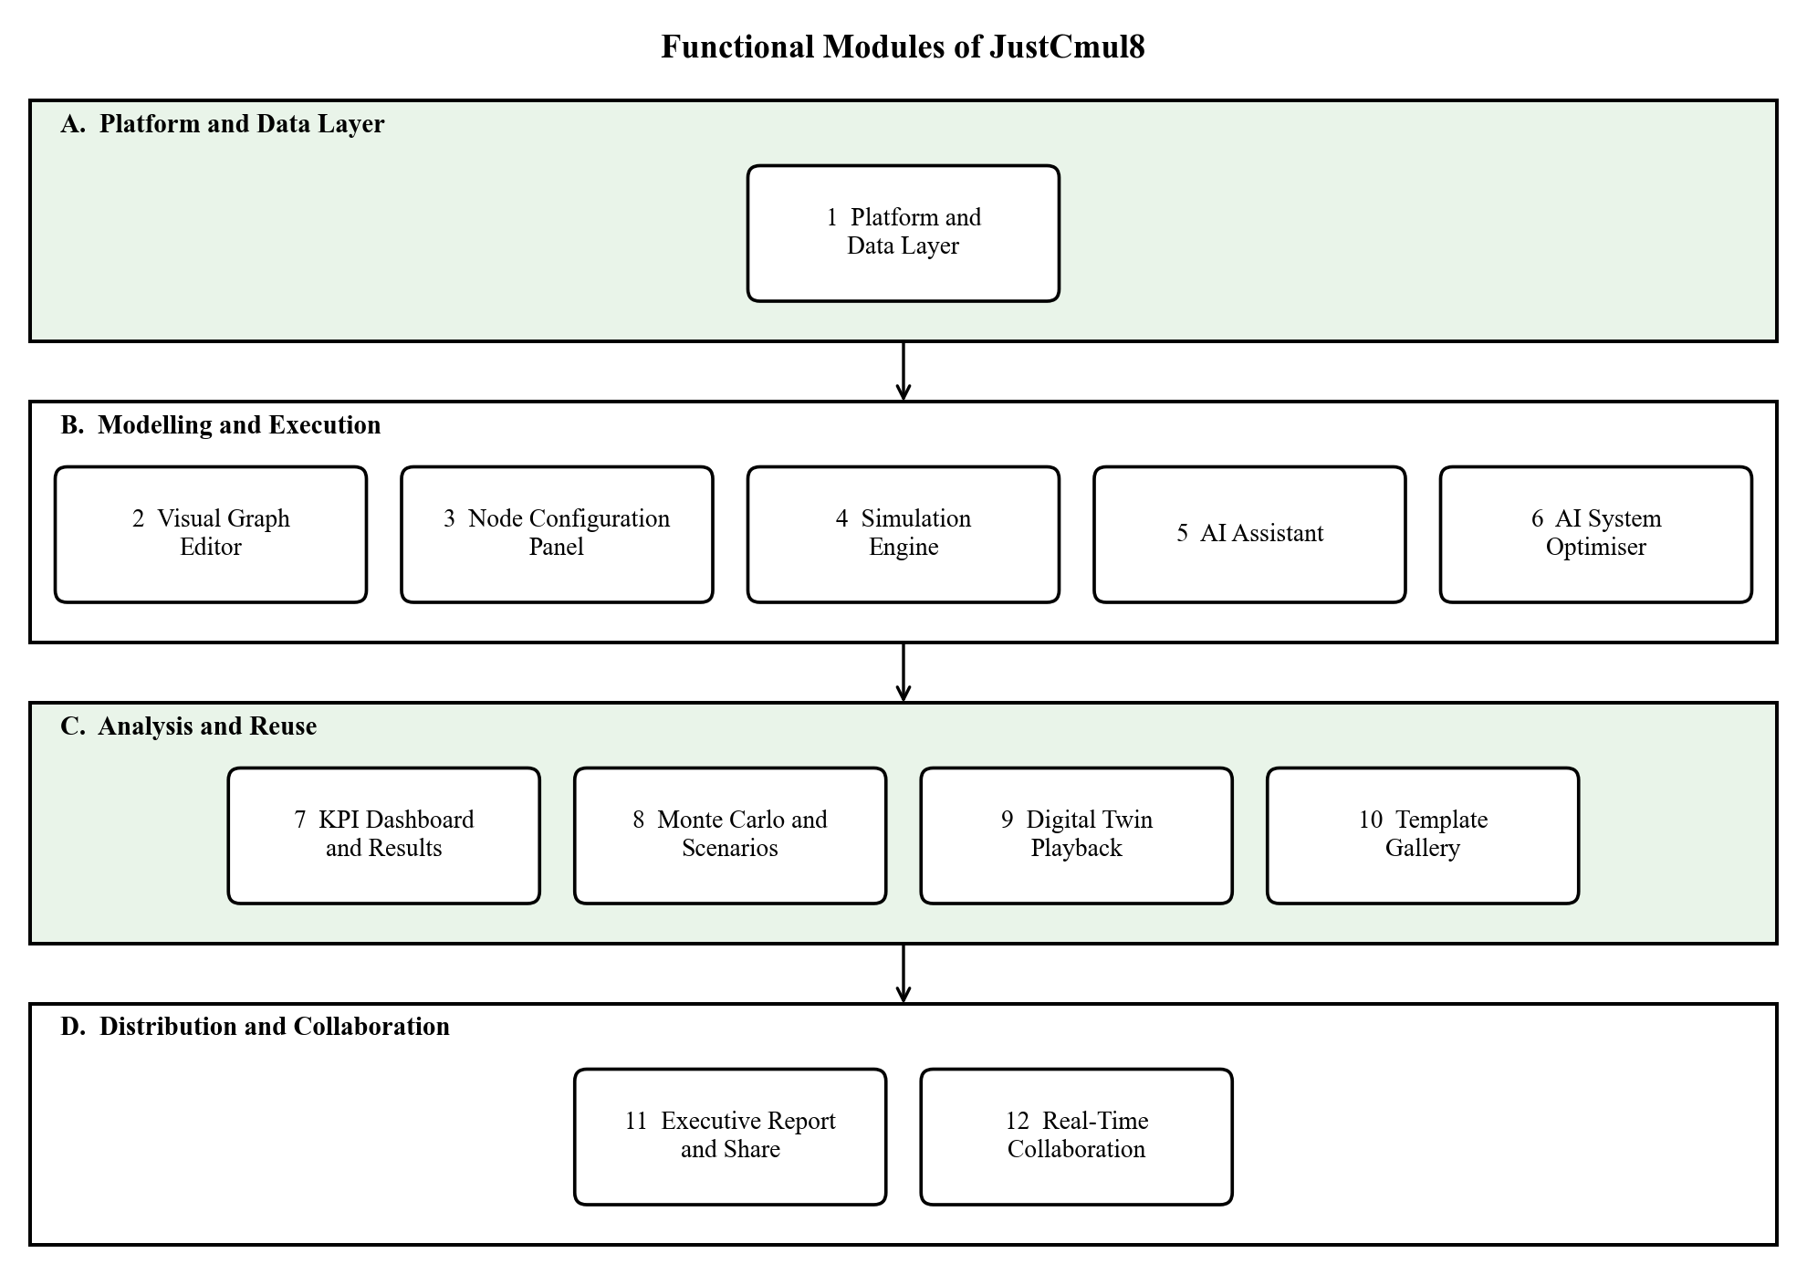
Figure 1.1: Functional Modules of JustCmul8 grouped by area
- Platform and data layer (Module 1): Register and log in with email or via Google/GitHub OAuth, creation, renaming and deletion of projects, handling of sessions with automatic saving to the cloud, profile and preference management.
- The visual graph editor and the node configuration panel (Modules 2 and 3), the SimPy engine, hosted in Pyodide (Modules 2 to 5), the AI assistant that can create a model from natural language, and the AI optimiser that runs on a finished model and suggests a fix (Modules 2 to 6).
- Analysis and reuse: KPI dashboard with bottleneck detection and cost analysis, Monte Carlo, and scenario comparison, animated digital-twin playback, and template gallery (Modules 7 – 10).
- Distribution and collaboration: graph export as JSON, results as CSV, free public share links and real-time presence with collaborative editing (Modules 11 and 12) and executive PDF reports..

Supported: human queue systems, vehicle traffic, liquid and material flow, manufacturing processes, logistics and warehousing, network and signal flow. All six are implemented in one simulation engine and a library of 15 node types can be configured for a wide variety of scenarios.

1.2.3 Out of Scope
Certain abilities have not been included by design in this release in order for the project to be manageable in the academic programme. We list them to help avoid the wrong conclusion that this is just a short list we've forgotten about. Some of these are more frequently referenced in the roadmap of chapter 10.
- Native mobile applications: interface responds well and functions in mobile versions of browsers, though no dedicated Android or iOS app.
- Enterprise services: Single sign-on, LDAP integration, organisation-level administration and subscription billing.
- Learning-management features: the platform is not courseware – it is considered a simulation tool.
- Offline and self-hosted deployment: the application itself is deployed as a cloud application that is accessible through a web application. Industrial hardware integration – no direct tie to IoT device, PLC, sensors, robots.
- Optimisation: Person enters a change to be optimised and the AI optimiser tells the person what change to make; No AI searching the parameter space. In line with a browser-first approach, there isn't a packaged Windows, macOS or Linux build of the desktop version.

1.3 Problem Definition
For manufacturing, health, logistics, transport and services, DES is one of the best known ways of enhancing manufacturing, with very few people using it outside of large organisations. It's practical, rather than theoretical, reasons and they are divided in 4 groups.

1.3.1 The Cost of Commercial Simulation Software
AnyLogic, Arena and Simul8 are all thousands of dollars per seat per year. A department of 60 students enrolled in an operation research course, or the restaurant owner deciding whether or not to install a second service counter, might have an answer that costs more than the question. Consequently those that might afford a hit can have it, while those that cannot do not have it.

1.3.2 The Technical Complexity of Free Alternatives
There are also free frameworks, such as SimPy, which are programming libraries and not yet fully developed applications. A user is required to install Python, learn how to use a virtual environment, understand what the request for accessing a resource must contain, and understand how to correct errors that occur after sending a request. For part of the simulation ideas, part of the Python idioms, needs to be picked up simultaneously—just a lot to ask for someone who is wondering whether to open another counter.

1.3.3 The Limits of Desktop Distribution
There is simulation software that requires installation, configuration and maintenance. People have no right to install anything on others' Laptop or on a Chromebook in a shared college laboratory, or on a company-managed laptop. This is no matter how sophisticated and expensive the tool is or how skilled the person is, a tool that cannot be opened is useless.

1.3.4 The Inadequacy of Static Diagrams and Spreadsheets
Many people will have made two try's and each try's will have failed for the same reason. The maps made with Visio and Lucidchart are descriptive and dry. The only thing not shown in the diagram is the number of the items displayed by the inspector by mid afternoon and this is not attached to a box called “inspection: 5 min”. However, a sheet of paper doesn't compute, and there is no natural way of representing an event queue, or the set of entities that are competing for a resource, or a server that is still processing the next entity entering the resource queue. Neither puts less pressure on the other; and that’s the pressure that makes queues LineUp.

1.3.5 Statement of the Problem
Taken together, these barriers make a technique that may reliably answer routine questions about operations within an organisation that holds a licence and has trained staff, extremely inefficient if not impossible.

1.4 Limitations
All designs are compromises. The following are the restrictions of this release. Each of these stems from a conscious architectural decision made and each is related to an entry in the roadmap of Section 10.3. Client side resources bound model size: the model size and length of a simulation are limited by the memory that the browser can free up for the simulation to be run on the client's device. It is not a speed restriction, but rather a memory restriction.
Elapsed time grows linearly with the number of replications, because Monte Carlo replications are run sequentially (e.g., one at a time, using a single worker); their execution times are independent of each other.
Fist run runtime download: The Pyodide runtime is not downloaded the first time Pyodesk is run and is stored when downloaded afterwards and thus simulation runs in a session take longer to begin. All need connectivity for the cloud: saving, collaboration and AI help. When “loading” a model that is already loaded in, it can still be run independently, but no memory is stored. Project-scoped: Presence and graph operations are sent over a private channel agreed to by the project's row-level security. Editor and viewer permissions through role-based assignments are coming. • In need of human judgment: generated graphs and recommendations are checked and presented for approval; there is no way to ensure they accurately model the described process. One simulation paradigm: the engine is SimPy based, behaviour continuous or agent base, approximating (the container node samples the level on the boundaries of the events). • No native mobile means that the interface is responsive, however it's still cumbersome to place nodes with precision on a touchscreen.

2. Requirement Analysis
The outlines delineated within this chapter are the "how" of the system and the "who. It starts with the Software Requirements Specification, identifies the types of user and outlines the types of functional and non-functional software requirements, item by item in the following chapters, providing an identifier by which each of them can be referred to in the following chapters. It then considers the level of feasibility, the hardware and software implemented to achieve this and then proposes a system along with its advantages.

2.1 User Requirements / SRS / Functional Requirements

2.1.1 Purpose and Overall Description
Every assessment task serves a purpose and has a general description. JustCmul8 is a desktop, tablet, laptop or phone simulation platform, which is accessed via an ordinary browser. It consists of four levels: a User-Interface layer, an Application and Domain-logic layer, a Client-side Execution layer and a Managed Database layer. There is nothing to be installed outside of the browser. The heaviest load is on the client that hosts the interface, the application state and all of the simulation work. Only stores data and authentication, pass-through for real-time and forwards requests to the AI service.

2.1.2 User Classes and Characteristics
Table 2.1: User Classes and Access Levels
User class | Responsibilities | Access level | Skill required
Registered User (Project Owner) | Creates projects, builds and configures models, runs simulations, uses AI, exports and shares results | Full control of owned projects | None (no-code)
Collaborator | Joins a project’s live workspace to view presence, cursors and shared edits | Project-scoped, authorised by row-level security | None
Guest / Public Viewer | Opens a public share link to view a model read-only | Read only; no account required | None

As a result of No Code, none of the classes requires any programming skills. Guest role read-only so that a model can be given for commenting without any chance that something will be accidentally changed.

2.1.3 Operating Environment
- Supported browsers: a modern browser (Google Chrome, Mozilla Firefox, Microsoft Edge or Safari) with WebAssembly support on Windows, macOS, Linux, Android or iOS. This interface adjusts to tablets, desktops and smartphones.
- A supabase-hosted Next server runtime runs the pages and a minimal number of API routes, providing support for production-grade PostgreSQL, authentication, real-time channels and storage.
- Slowdown due to simulative reloading: SimPy runs in the browser in a Web Worker making minimal use of the server's CPU.

2.1.4 Design and Implementation Constraints
- All functionality needed to run in the browser (no installation required on the client-side).
- The security aspect of the database; all were evaluated on a row level, meaning when a user accesses the database they'll only have access to their own or project(s) that are expressly granted to them.
- The interface needed to be easy and fast to use, as its users had little or no experience in programming.
- The architecture needed to be modular and domain and node type driven, accepting new domains and node types without redesigning the bottom layer.
- The most important thing was that secrets (specifically the AI service key) didn't need to be included in the client bundle and didn't need to be placed on the server.

2.1.5 Functional Requirements
The functional requirements are presented in modules. They are repeated in the test cases in Chapter 7.

Table 2.2: Functional Requirements
ID | Module | Requirement
FR-01 | Platform | Users register and log in via email, password or practically the same via Google or GitHub OAuth and they can log out securely.
FR-02 | Platform | The step of signing in is carried forward from one visit to the next and projects are checked first to see if they are protected.
FR-03 | Platform | If a user forgets the password, he/she is sent an e-mail with a link and can opt for a new password.
FR-04 | Platform | Users who are signed in are able to create, open, rename and delete simulation projects, selecting one of the six chosen domains for each project.
FR-05 | Platform | Project graph state will automatically be written to cloud storage – there is no need to press a Save button.
FR-06 | Platform | A dashboard that displays the user's projects, with domain and last modified date, plus profile/s, preferences and account management such as deleting the account.
FR-07 | Graph Editor | Fifteen node types are supported on the canvas which can be placed and dragged, connected and deleted.
FR-08 | Graph Editor | The nodes follow the edges when moved, the canvas can be zoomed, panned and presented to the viewer for a best fit in the window.
FR-09 | Graph Editor | When the graph is not amenable to running, the names of the graph and the offending node are displayed before a run.
FR-10 | Node Configuration | Only the parameters suitable for that node are displayed in a side panel, which is used to edit the parameters for that selected node (arrival rate, capacity, service-time distribution, routing and costs).
FR-11 | Node Configuration | The values of one or more parameters are tested prior to using values by the engine with the node type.
FR-12 | Simulation Engine | There's a Python SimPy script created based on the graph, which is run on the client (which is implemented with Pyodide). The server performs no simulation work.
FR-13 | Simulation Engine | The user assigns simulated duration and its associated time unit before a run in order to: seconds, minutes, hours and days.
FR-14 | Simulation Engine | A run is executed inside a Web Worker, thus avoiding blocking the UI.
FR-15 | Simulation Engine | The user can view progress and status of the run and a stream of log events while the run is in progress, can stop the run, and can adjust to various playback speeds from 0.5× to 10×.
FR-16 | AI Assistant | Natural language based scenario is transformed to a candidate graph of nodes and edges.
FR-17 | AI Assistant | A graph generated is first checked for its validity, then the user can view it and implement it. In addition, a chat history is maintained for each project which will check out the other AI model in the event that the initial one fails.
FR-18 | AI Optimiser | Once a run is complete, the optimiser identifies the problem and proposes a fix to be applied to the run in one operation
FR-19 | KPI Dashboard | Upon a run finish, the utilisation, average and percentile waiting times, throughput and queue lengths at each node will be assigned.
FR-20 | KPI Dashboard | The dashboard indicates the critical node of the wind tunnel, displays Little's law results and displays a composite health score of the system from 0 to 100.
FR-21 | KPI Dashboard | The resource, holding and waiting-penalty cost parameters are used to construct a Cost and ROI analysis.
FR-22 | Monte Carlo | A model can be used for 10, 20, 50 or 100 replications and reported with a 95% confidence interval for that replications - with a baseline compared with a modified scenario.
FR-23 | Digital Twin | The entities are lit up, moving and are 2-D in a playback with play and pause buttons, step and speed controls.
FR-24 | Template Gallery | Starter templates include all 6 domains and will have each create their own project under whoever's name they request to be created in.
FR-25 | Export and Share | The graph is exported as JSON and results as CSV, the created Python script is written in a Jupyter notebook and an executive report is written as a PDF.
FR-26 | Export and Share | Read only public share link can be created and revoked. Either doesn't grant access to edit, or, if the link has been revoked or is invalid, the person clearly notices this.
FR-27 | Collaboration | Users can see each other, including cursors, within the same project; the operations to be performed on the graph are streamed via an authenticated private channel.

2.1.6 Non-Functional Requirements
Table 2.3: Non-Functional Requirements
ID | Category | Requirement
NFR-01 | Performance | Moving nodes around on the canvas should happen immediately, and there shouldn't be any lag when the node is moved and connected to the canvas nor a lag when the dashboard displays a finished run.
NFR-02 | Responsiveness | Running simulation should never stop the interface; runs are queued up and run in a background worker thread.
NFR-03 | Correctness | For reference queues, the simulation should be utilized and simulation waiting time and queue length should closely follow the analytical queuing theory, within a specified tolerance.
NFR-04 | Security | Only salted hashes like these are stored as domain passwords and all traffic is TLS; secret keys will never be sent to the client.
NFR-05 | Access Control | ROW-LEVEL SECURITY is visible for each of the tables and cannot be circumvented by a client modified to get around the authorisation.
NFR-06 | Usability | The user interface should be operational by a first time, non-technical user and is based around the notion of domain language, not simulation jargon.
NFR-07 | Reliability | Project State will automatically stay between sessions and between devices.
NFR-08 | Portability | It will function unchanged across the majority of current web browsers for Windows, macOS, Linux, Android and iOS which support WebAssembly.
NFR-09 | Maintainability | The logic of a simulation remains internal to the worker and domain / node definitions remain in a single repository.
NFR-10 | Data Integrity | The database is a foreign-key constraint database that cascades delete.
NFR-11 | Availability | The availableifted app has a goal of 99% availability for both the front end and the managed back end.

2.1.7 User Personas and Operational Workflow
The interface was designed utilizing three personas. They progress in different ways around the system.
- The student is introduced to the concept of queueing theory in a lecture and wants to observe the M/M/1 behaviour rather than derive it. This individual opens a template, edits the arrival rate to be different, views the result and then compares dashboards. Here, the important thing is that, a useful first result is present within a minute of the arrival.
- The lecturer shows in class how congestion can occur. The model is illustrated with an animated playback, and by providing a share link, students can open and examine copies without having an account later on their own devices.
- The small-business owner is considering installing another service counter. This person is able to give the AI assistant the description of the shop in plain language, accepts the generated graph, performs a Monte Carlo and reads the confidence intervals and reads the cost panel before they spend any money on the shop.
All three have a similar workflow: log in, create a project or open an existing project, build the graph – either manually or with the assistance, then set the node parameters, validate the structure, run the graph, read the analytics, repeat this step, optionally, with different scenario and then export or share the resulting graph. This is done in Chapter 5, when we represent this path as an activity diagram.

2.2 Feasibility Study
Prior to the establishment of the design recommendation, we explored the project on five levels. Technical Feasibility is the most important requirement; if the technical part failed to work, so would the whole architecture.

2.2.1 Technical Feasibility
Next.js, React, TypeScript, Supabase, React Flow, Pyodide and SimPy are all popular, well-documented, and highly supported. This reduces risks of development and facilitates long term maintenance costs.
The main challenge was to get:
a) a python discrete event simulation running in a browser,
b) that it performs quickly enough.
The primary questions were how to get:
a) a python discrete event simulation running in a browser
b) how fast exactly.
They both meet Pyodide's head-on, by compiling the CPython interpreter into WebAssembly code, meaning that SimPy is a Python pod installed on the client. With a prototype spike, we proved to be that as everything else relied on that. Out of that "peaker" we were left with two constraints which we designed with.
The Pyodide runtime is a few megabytes, and is downloaded once and stored. WebAssembly is also run inside the browser's limit on how big its memory can be, so large models are a practical limit when used in a Web Worker; also, using Web Assembly ensures that a large model is not hindering the response of the user. Also, although not quite so much, there was a concern about Canvas rendering, as hundreds of nodes in the DOM can cause problems to render quickly.
We have created the editor with React Flow, which is designed for node based interfaces, and the animated playback (when a lot of entities move together) with Pixi.js which draws given animated objects through WebGL.

2.2.2 Economic Feasibility
This project is low cost, as for the most part most of the components in the project are open source, or only available as a cloud-based service with very generous free tiers. None of the Section 1.3 commercial packages is without licence fee, unlike most of the others listed above, which are completely free.
The speed and cost of simulations on the client are important. The server doesn't have to provide the computing, the user's browser does; so the number and size of simulations has no effect on the cost of the server.
The simulator can handle 1000 of them running a 1 hour simulation at the same time, without causing any extra load on the server as compared to 1000 people reading a regular page. The only recurring costs are the managed database tier and the metered AI quota and the latter is negligible as an AI request is only sent when the user requests for generation/diagnosis.
Table 2.4: Indicative Cost Comparison with Commercial Alternatives
Item | Commercial DES tool | JustCmul8
Software licence | Typically thousands of USD per seat per year | None; open-source stack
Installation and IT effort | Required on every machine | None; runs in the browser
Simulation compute | Local workstation or licensed server | User’s browser; no server cost
Backend hosting | Not applicable or self-managed | Managed free tier during the academic phase
AI assistance | Generally unavailable | Gemini API, metered per explicit request
Training | Formal instruction usually necessary | Not required; no-code interface

Commercial figures are only indicative as vendor price lists are subject to change. The difference is the ‘point’ of the table.

2.2.3 Operational Feasibility
It's simple to implement the platform. The drag and drop interface, combined with the AI assistant means that a person with no programming or simulation knowledge can create a model, there is no software to install, maintain or lose. The users of the project are from somewhat different groups - students, teachers, researchers, and small-business owners - who are already familiar with modern web applications, so formal training and a technical support desk are not necessary. There are some user interface options which aid further. The vocabulary of the domain that is selected for the palettes is used – hence the word “Teller” for a person modelling a bank, or the word “Line Buildup Timeline” for a result tab.

2.2.4 Schedule Feasibility
A plan for development is in accordance with the academic time frame. The development has been broken up into modules, which are created in an order depending on their prerequisites, with the fundamental features built initially and everything else (support features like AI assistance, collaboration, and so on) added afterwards. Testing, debugging and integration are not done after the development, but concurrently. The biggest impact decision was to have the scheduling of the simulation engine proceed concurrently with the work on the backend and to have that work begun in the second week of July, still early enough to react to it. The full schedule of the twenty-four weeks are shown in chapter 3.

2.2.5 Legal and Ethical Feasibility
The legal and ethical feasibility of the project.Legal and ethical feasibility of project. No licensing obligations are remaining as all dependencies are used under open-source licences or are used by free-listing tiers. PostgreSQL Row-Level Security restricts each user to access his/her own projects and passwords are never stored in a recoverable format. When users delete an account it does go through and delete their data. A public share link can be cancelled at any time, after which you can find an explanation on the link instead of the project. AI-generated charts are never just sent off to a person to effect any change to a project, but instead given guidance as to how to proceed.

2.3 Details of Hardware and Software Used
Shows details of Used Hardware & Software There are two different configurations for this and it's easy to mix them up. The one I'm using to build the platform is pretty strenuous since an editor and development server are on the same machine as the browser. The other is what an end user needs which is much less and it's this second one that will determine the extent to which the platform can be adopted.

2.3.1 Development Environment
Table 2.5: Development Hardware and Software Configuration
Component | Specification | Purpose
Processor | Intel Core i5 / AMD Ryzen 5 or higher | Runs the development server, browser and Pyodide runtime concurrently
Memory | 8 – 16 GB RAM | Editor, browser with several tabs and local build processes together
Storage | 256 GB SSD or larger | Sources, Node.js dependency tree and build artefacts
Display | 1920 × 1080 or higher | Canvas, configuration panel and dashboard side by side
Operating system | Windows 11 | Primary development platform
Network | Stable broadband connection | Package installation, Supabase and AI API access
Editor | Visual Studio Code with TypeScript and ESLint | Primary development environment
Version control | Git with a GitHub remote | Source history, branching and collaborative development
API testing | Postman | Verification of API routes
Runtime | Node.js LTS with npm | Dependency management and the Next.js build pipeline
Verification | Python 3 with SimPy | Native harness used to verify the engine against queueing theory
Browser tooling | Chrome DevTools | Profiling, memory inspection and performance measurement

2.3.2 Target Client Requirements
In a web application (on client side), no special hardware is required. Any decent desktop, laptop, tablet or smartphone that has a latter version of a browser will work. One consequence of this is that the architecture: Since the engine is not done on the server, the Web Worker path is provided to keep the user interface usable in the case of very large models that will be running slower on a machine with less memory.
Table 2.6: Minimum and Recommended Client Requirements
Requirement | Minimum | Recommended
Browser | Current Chrome, Edge, Firefox or Safari with WebAssembly | Latest evergreen release of Chrome or Edge
Memory | 4 GB RAM | 8 GB RAM or more for large models
Processor | Dual-core | Quad-core or better
Display | 1366 × 768 | 1920 × 1080 or higher
Network | Stable connection for loading and persistence | Broadband for real-time collaboration
Local installation | None | None

2.3.3 Software and Technology Stack
Table 2.7: Technology Stack with Justification
Layer | Technology | Reason for selection
Frontend framework | Next.js 16 (App Router) | File-based routing, server rendering and API routes in one framework
UI library | React 19 | Component model suited to a complex, highly interactive editor
Language | TypeScript | Static typing across the code base, catching parameter mismatches at compile time
Styling | Tailwind CSS v4 | Utility-first styling giving consistent spacing and a coherent theme
Graph editor | React Flow (@xyflow/react) | Production-grade node-based canvas with handles and edge routing
Graph layout | Dagre | Automatic layered layout for generated and template graphs
Simulation engine | Python SimPy via Pyodide (WebAssembly) | A real DES engine executing client-side
State management | Zustand | Lightweight store with slice-based separation
Charts | Recharts | Declarative, composable charts for the KPI dashboard
2D animation | Pixi.js | WebGL rendering for the digital-twin playback
AI service | Google Gemini (via a model router) | Structured generation of graphs and diagnoses from natural language
Database and auth | Supabase (PostgreSQL, Auth, Realtime) | Managed Postgres with Row-Level Security, OAuth and WebSocket channels
Reporting | jsPDF, html-to-image | Client-side generation of executive PDF reports
Animation and scroll | Framer Motion, Lenis | Transition choreography and smooth scrolling on the landing page
Icons | Lucide React | Consistent icon set covering all node types

2.4 Proposed System and Advantages of the Proposed System

2.4.1 The Proposed System
The system we propose is JustCmul8 – a simulation platform based on discrete events to exist in the browser. The user is able to drag nodes onto a canvas in the protocol, to complete the node parameters on forms, to press Run and read the answer on the plain language. The graph is translated behind the button into a real SimPy program that is compiled to WebAssembly and then executed in a Web Worker, by CPython. Out of it comes a layer of analytics where performance metrics (power metrics, verification, ranking of constraint, cost) are calculated, approved and sorted, then recommendations, costs, and an animated replay of the constraint.
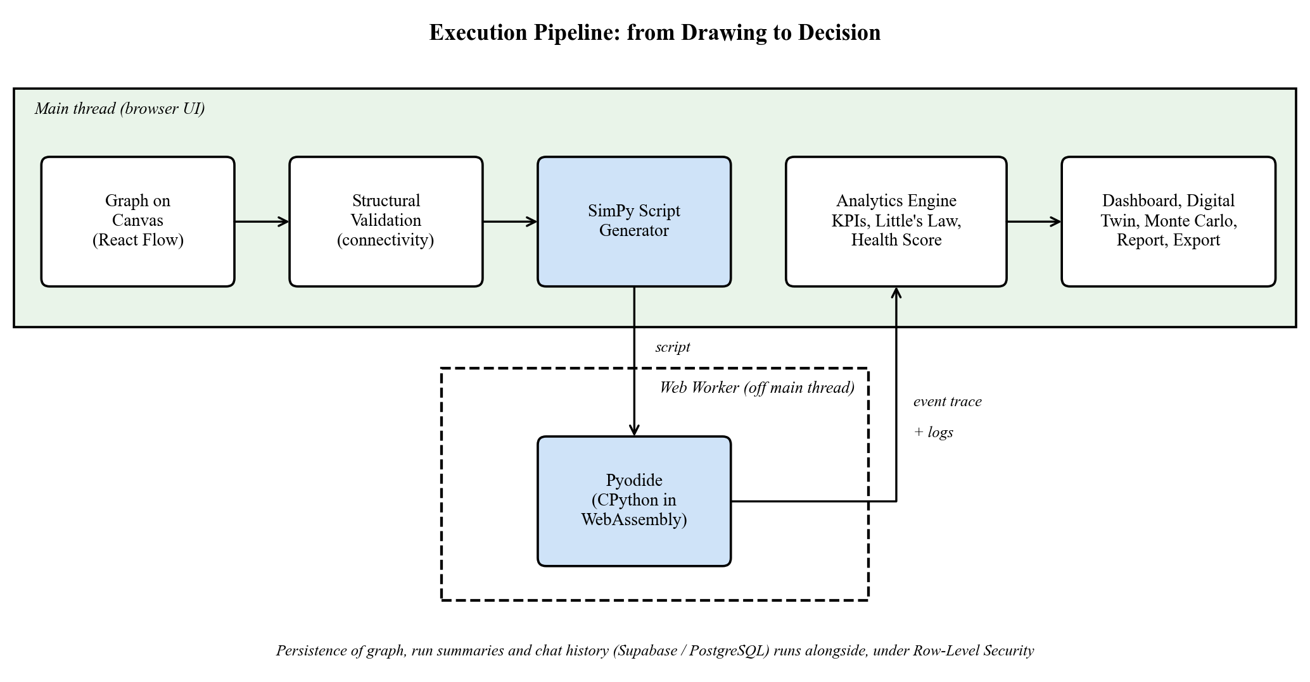
Figure 2.1: Execution Pipeline of the Proposed System

2.4.2 Comparison with Existing Approaches
Table 2.8: Comparison of the Proposed System with Existing Approaches
Capability | Commercial DES tools | SimPy library | Diagram tools / spreadsheets | JustCmul8
Free to use | No | Yes | Partly | Yes
No installation | No | No | Yes | Yes
No programming needed | Partly | No | Yes | Yes
Executes real DES | Yes | Yes | No | Yes (SimPy)
Runs in the browser | Rarely | No | Yes | Yes
AI-assisted modelling | Rarely | No | No | Yes
Confidence intervals (Monte Carlo) | Yes | Manual coding | No | Yes, one click
Live collaboration and sharing | Limited | No | Yes | Yes
Readable generated code | No | Yes | No | Yes (inspector and notebook)

2.4.3 Advantages of the Proposed System
The proposed system has the following advantages:
- Free, no setup required: it's free but only requires a "url" link from any laptop, lab machine and/or Chromebook. Reliable results – numbers are supplied by SimPy and not an imitation, and engine validated with queueing theory.
- No-code modelling: domain vocabulary, form based configuration and a template gallery makes it possible for a first-user to get to a result in a minute.
- Workflow assisted with AI: simple text to a runnable model and a completed run to a concrete, costed recommendation.
- Topics include: Monte Carlo confidence intervals allowing for uncertainty in the answer; showing an apparent improvement is larger than the noise.
- Transparent and repeatable: Code generated in Python is readable in code inspector and output can be published as a jupyter notebook for any to be able to re-run a result independently.
- Easy-to-understand output: bottleneck flags, a system health score, a flow-balance check, a traffic heatmap, an entity tracer and an animated digital twin transform the numbers into pictures.
- Security enforced by the database: Access controls determined by the database and share links are opaque, read-only and revocable.
- Useful to scale: computation runs on the client side: it is not costly to the host depending on the usage rate.
- Easy to extend: Each domain's vocabulary, palette, layout and templates is defined in one registry and addition of new domains and node types does not affect the engine.

3. PROJECT PLANNING
A large concept won't grow until it is broken right down in steps that are high on achievement. This chapter presents how we organised the work for JustCmul8: the activities, the time that we devoted to each of these activities, the graphical representation of the planned development path, the resources needed, and the development model adopted.

3.1 List of Activities / Tasks
Create a list of activities/tasks.Plan Activities/tasks. The sequence of which we arranged the activities followed the typical process of the Software Development Life Cycle (SDLC), namely initiation and analysis, design, software development, testing, software documentation and deployment. It was divided into three blocks of twenty-eight steps or activities each, with each step or activity having an estimated time and a dependency history that had been noted.These were broken down into three sets of twenty-eight activities each, with the activity having an estimated duration, and with a recorded dependency history for each activity. Twenty-four working weeks are covered in full from the 1st July 2026 till the last week at the end of December 2026.
Mapping dependencies was useful to perform 2 things. It prevented us from developing a module until prerequisites had been worked out, but gave us a clue about which activities were independent so that they could be run concurrently, thus providing a shorter total time without a decrease in quality. The most significant information was regarding the Simulation Engine which will run in the second week of July in conjunction with the back end development work. The most significant technical challenge in the project was running Python SimPy on the browser with Pyodide and WebAssembly, assuming that these technologies work for these “exotic” use cases.To execute Python SimPy on the Browser through Pyodide and WebAssembly was the greatest technical risk of the project in and of itself, as well as the assumption that the AI assistant KPI dashboard and Monte Carlo analysis and digital twin will work in these “exotic” use cases. The early start-time enabled some time to correct all the compatibility issues, to verify accuracy with previously established analytical results and to iron out interface that other modules would use.
There must be an explanation about module numberings. The schedule below breaks down the project synopsis into the eleven modules and was the plan at the start.The modules in the project synopsis are broken down into the eleven modules in the schedule below, which is as it was when we started this project out: Authentication, Project Management, Visual Graph Editor, Node Configuration Panel, Simulation Engine, AI Assistant, KPI Dashboard, Template Gallery, Export and Share, User Profile and Settings, Real-Time Collaboration. While building, we reorganised the delivered system into twelve modules (Chapter 4).
The three features that were too small to be a part of the first "Platform and Data Layer," namely the AI System Optimiser, Monte Carlo and Scenario Comparison, and the Digital Twin Playback, were individual Modules.Authentication, Project Management, and Profile are all part of a single Platform and Data Layer while three features that outgrew their original scope (the AI System Optimiser, Monte Carlo and Scenario Comparison, and the Digital Twin Playback) became Modules in their own right. The activity list records the plan as made, then, Chapter 4 records the system as delivered.
Table 3.1: List of Activities and Tasks with Dependencies
Sr. | Task / Activity | Phase | Duration | Depends on
1 | Project Initiation | Initiation / Analysis | 2 weeks | None
2 | Requirement Gathering | Initiation / Analysis | 3 weeks | None
3 | Literature Survey | Initiation / Analysis | 2 weeks | Project Initiation
4 | System Analysis | Initiation / Analysis | 2 weeks | Requirement Gathering
5 | UI/UX Design | Design | 3 weeks | System Analysis
6 | Database Design | Design | 3 weeks | System Analysis
7 | Module: Authentication | Development | 3 weeks | Database Design
8 | Module: Project Management | Development | 3 weeks | Authentication
9 | API Development | Development | 5 weeks | Database Design
10 | Backend Development | Development | 8 weeks | API Development
11 | Module: Visual Graph Editor | Development | 4 weeks | UI/UX Design, Project Management
12 | Module: Node Configuration Panel | Development | 3 weeks | Visual Graph Editor
13 | Frontend Development | Development | 9 weeks | UI/UX Design
14 | Module: Simulation Engine | Development | 8 weeks | Early parallel track; runs ahead of backend
15 | Module: AI Assistant | Development | 4 weeks | Simulation Engine
16 | Integration | Development | 5 weeks | Modules 1 – 6 of the plan
17 | Module: KPI Dashboard | Development | 3 weeks | Simulation Engine
18 | Module: Template Gallery | Development | 3 weeks | Visual Graph Editor
19 | Module: Export and Share | Development | 3 weeks | KPI Dashboard
20 | Module: User Profile and Settings | Development | 3 weeks | Authentication
21 | Module: Real-Time Collaboration | Development | 4 weeks | Visual Graph Editor
22 | Unit Testing | Testing | 5 weeks | Modules in progress
23 | Integration Testing | Testing | 3 weeks | Integration complete
24 | Bug Fixing | Testing | 3 weeks | Integration Testing
25 | User Acceptance Testing (UAT) | Testing | 2 weeks | Bug Fixing
26 | Documentation | Documentation | 23 weeks | Continuous, alongside every module
27 | Final Review and Deployment | Deployment | 4 weeks | User Acceptance Testing

The phases work out as follows.
Prior to coding we defined the objectives, the target users and requirements, reviewed the several commercial and open-source tools mentioned in Section 1.3, compiled the results into a specification.
Schema is described in Chapter 5, and workspace layout, organisation of node palette and behaviour of the configuration panel was provided by design (interface design).
Development was a major part which was also spread across three parallel streams. Authentication, project management and data layer were covered by backend and API stream. The simulation stream included the engine, the AI assistance and the KPI dashboard and templates. The front end stream focused on the graph editor, configuration panel, export, profile and collaboration.
Testing: early testing of the units occurs before modules are complete, defects in early modules get corrected as subsequent modules are written. After integration testing, comes bug fixing, and then user acceptance testing.
Documentation: written 23 of the 24 weeks, keeping up with the work.
Deployment: last review followed by upload to the Hosting Platform.

3.2 Timeline for Each Task
Task 3.2 has a time line. A list of planned starting and ending weeks for activities is provided. Weeks are numbered such that W1 is the first week in the Calendar month.
Table 3.2: Planned Timeline of Each Task (July W1 – December W4, 2026)
Sr. | Task / Activity | Duration | Start | End
1 | Project Initiation | 2 weeks | Jul W1 | Jul W2
2 | Requirement Gathering | 3 weeks | Jul W1 | Jul W3
3 | Literature Survey | 2 weeks | Jul W2 | Jul W3
4 | System Analysis | 2 weeks | Jul W3 | Jul W4
5 | UI/UX Design | 3 weeks | Jul W4 | Aug W2
6 | Database Design | 3 weeks | Jul W4 | Aug W2
7 | Module: Authentication | 3 weeks | Aug W1 | Aug W3
8 | Module: Project Management | 3 weeks | Aug W2 | Aug W4
9 | API Development | 5 weeks | Aug W1 | Sep W1
10 | Backend Development | 8 weeks | Aug W1 | Sep W4
11 | Module: Visual Graph Editor | 4 weeks | Aug W2 | Sep W1
12 | Module: Node Configuration Panel | 3 weeks | Aug W3 | Sep W1
13 | Frontend Development | 9 weeks | Aug W2 | Oct W2
14 | Module: Simulation Engine | 8 weeks | Jul W2 | Sep W1
15 | Module: AI Assistant | 4 weeks | Sep W2 | Oct W1
16 | Integration | 5 weeks | Sep W3 | Oct W3
17 | Module: KPI Dashboard | 3 weeks | Sep W3 | Oct W1
18 | Module: Template Gallery | 3 weeks | Sep W4 | Oct W2
19 | Module: Export and Share | 3 weeks | Oct W1 | Oct W3
20 | Module: User Profile and Settings | 3 weeks | Oct W1 | Oct W3
21 | Module: Real-Time Collaboration | 4 weeks | Oct W2 | Nov W1
22 | Unit Testing | 5 weeks | Sep W4 | Oct W4
23 | Integration Testing | 3 weeks | Oct W4 | Nov W2
24 | Bug Fixing | 3 weeks | Nov W1 | Nov W3
25 | User Acceptance Testing (UAT) | 2 weeks | Nov W3 | Nov W4
26 | Documentation | 23 weeks | Jul W1 | Dec W3
27a | Final Review | 2 weeks | Dec W1 | Dec W2
27b | Deployment | 2 weeks | Dec W3 | Dec W4

Project Milestones
Table 3.3: Project Milestones and Completion Criteria
Milestone | Target | Completion criterion
M1: Requirements baselined | Jul W3 | Functional and non-functional requirements approved by the guide
M2: Literature survey complete | Jul W3 | Comparable tools evaluated and the technology stack fixed
M3: Design frozen | Aug W2 | Interface layout and database schema approved
M4: Engine proof of concept | Sep W1 | A SimPy model executing in the browser with output verified against theory
M5: Core modelling path working | Sep W1 | A graph can be built, configured and executed end to end
M6: Analytics operational | Oct W1 | KPI dashboard rendering utilisation, wait time and throughput
M7: Feature complete | Nov W1 | All scheduled modules implemented and integrated
M8: Testing signed off | Nov W4 | Unit, integration and acceptance testing passed
M9: Deployed | Dec W4 | Application live on the hosting platform and report submitted

The most important milestone is M4. We have put in place early, as it eliminates the largest technical risk of the project, and every future milestone assumes that Python can run in browser.

3.3 Gantt Chart and Activity Network Diagram

3.3.1 Gantt Chart
Each activity on a Gantt chart is a horizontal bar over a calendar, meaning that its length can be readily read from the chart, as can its overlap with other activities. It's also used by software teams to plan tasks, allocate resources, and monitor progress. Its essence is that it slices up a project into bite-sized portions with a realistic amount of time, and shows up any skirmishes early enough to avoid them.
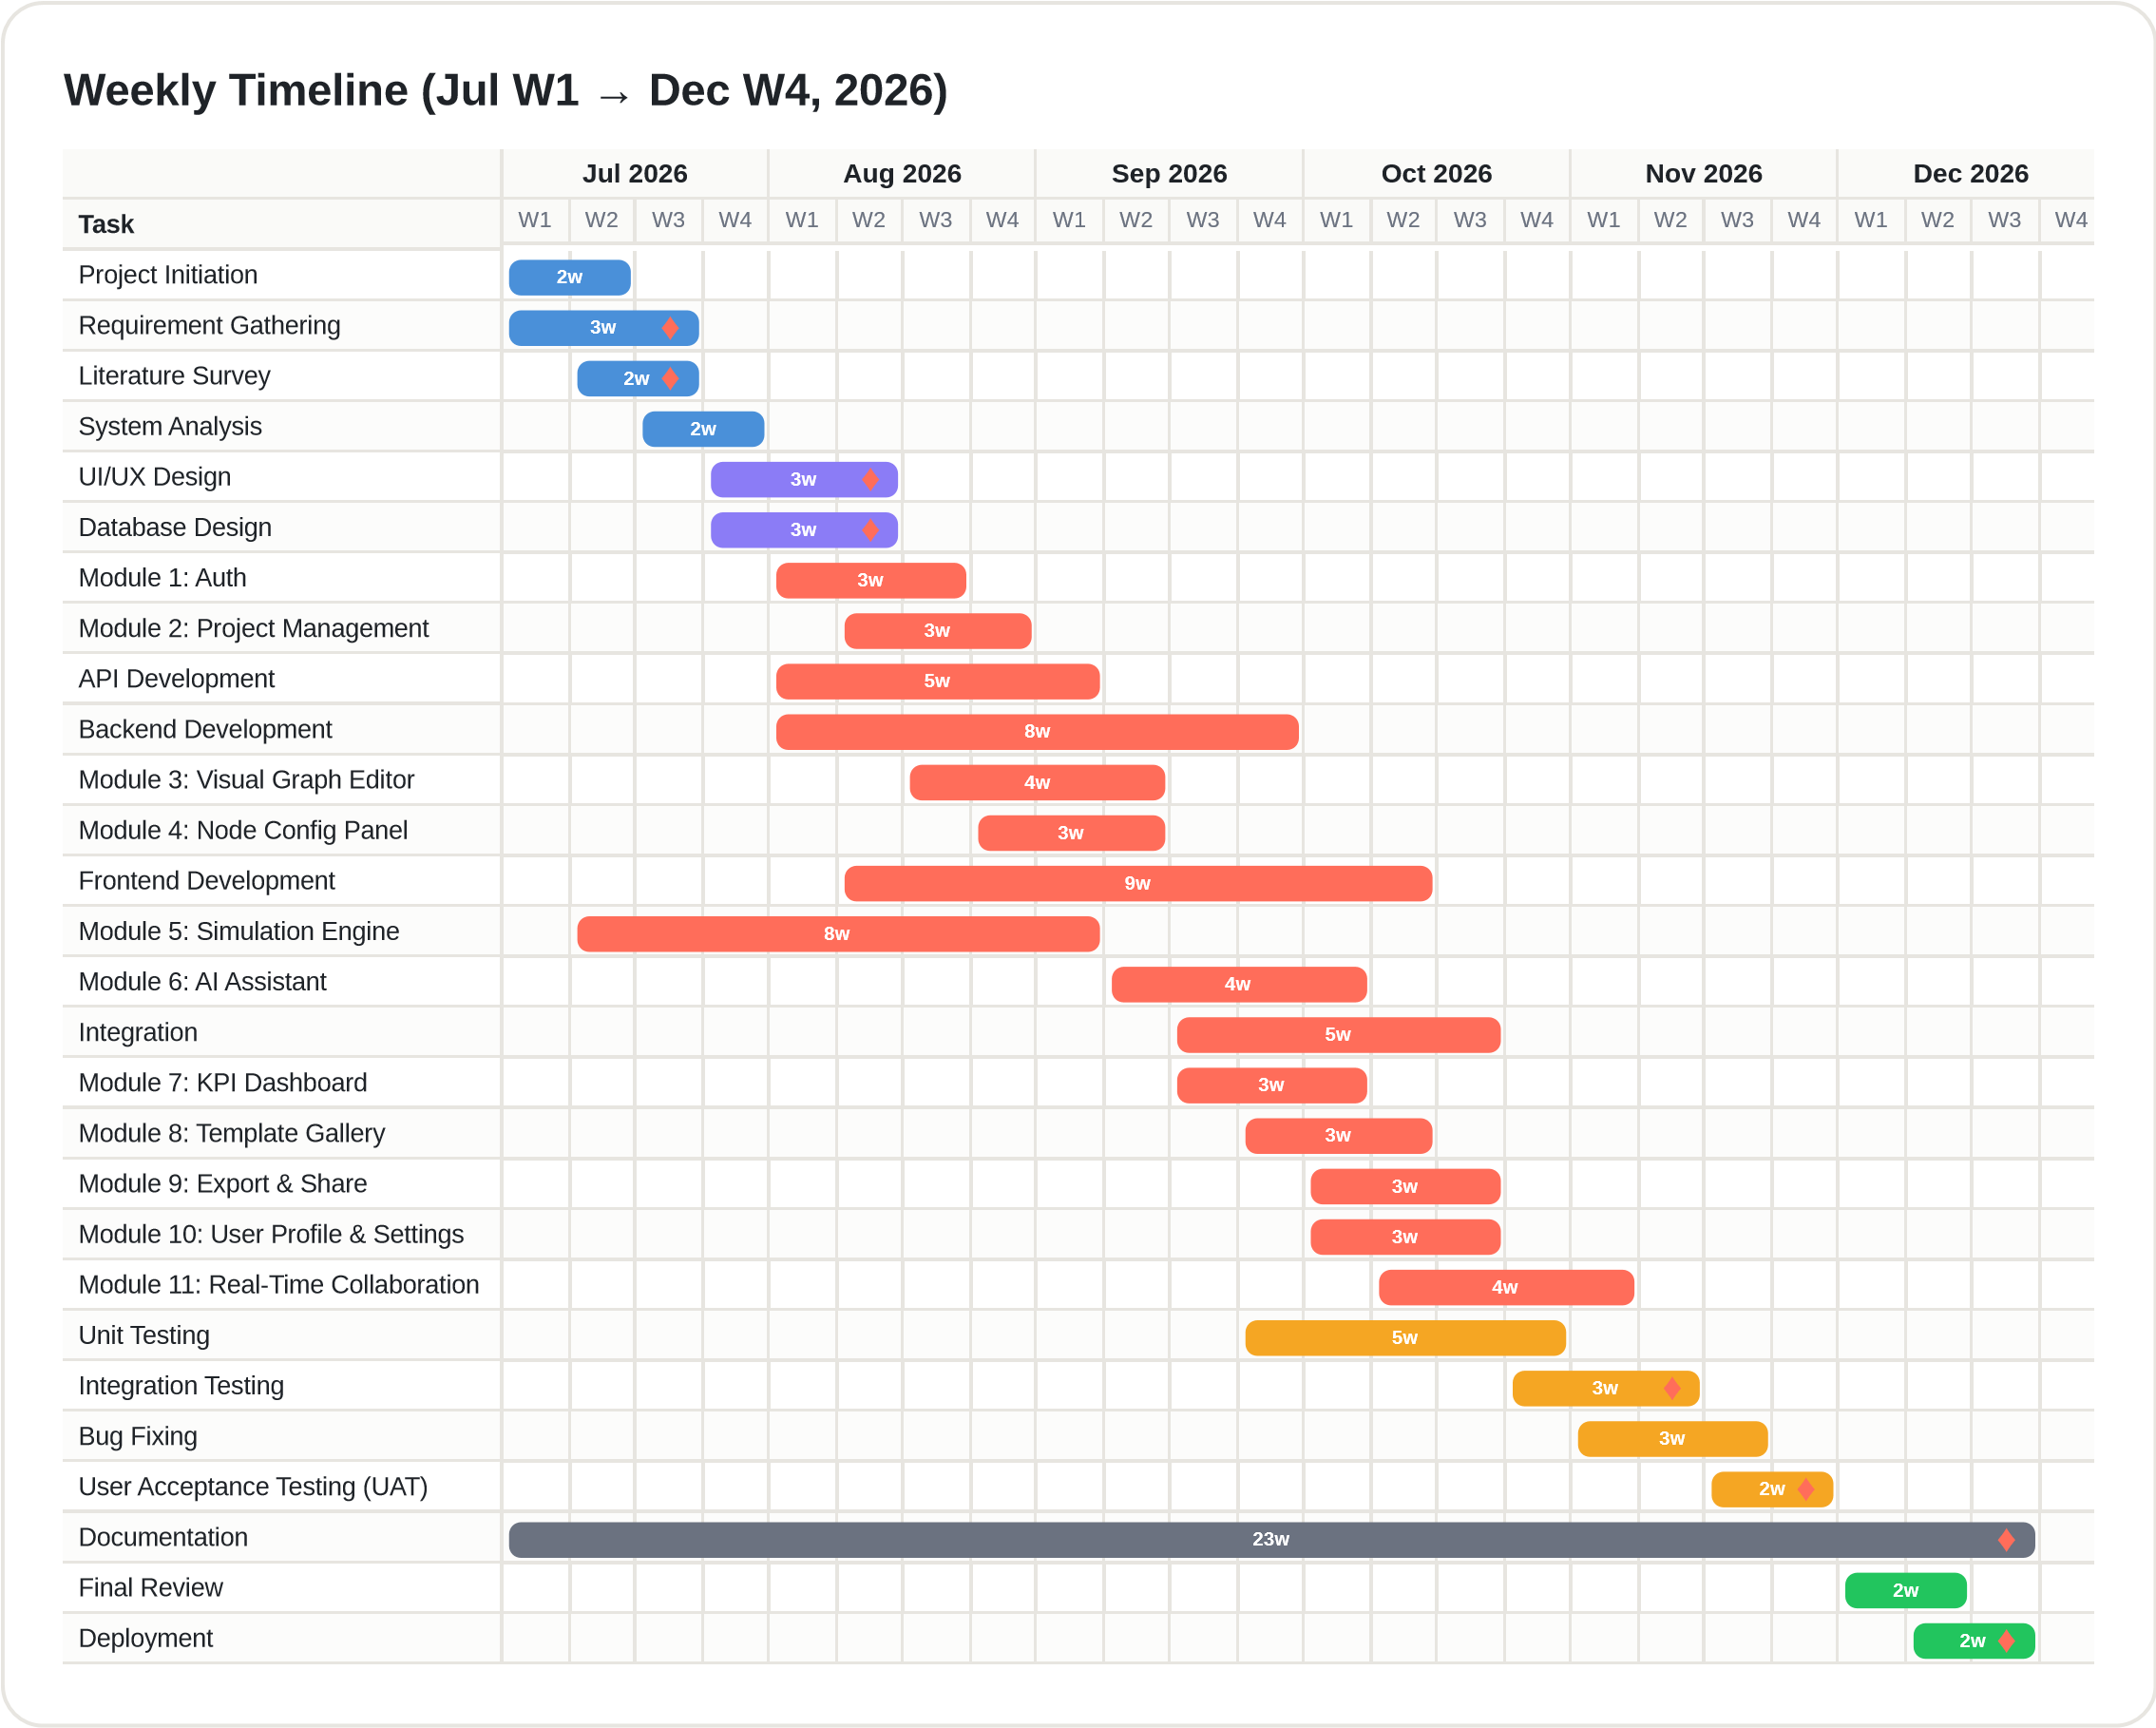
Figure 3.1: Weekly Gantt Chart of the JustCmul8 Development Schedule (July W1 – December W4, 2026)
The bars are organized by phase and each bar is a different shade of the life cycle's phase. The opening four bars are used for initiation and analysis, establishing objectives, requirements and technology decisions that the design is based upon, that fill July. The next two bars are interface and database design, covered in some three weeks, from late July. The bulk of the chart is taken up by development. The two foundation modules are followed by two work modules, API and backend, which sit next to the very point on which the user performs his working, visual graph editor and node configuration panel.
The simulation engine bar needs the closest look. It begins in the 2nd week of July and overlaps backend development, due to the reason explained in Section 3.1. The AI unit is brought with the engine settling and the various parts delivered through September and October, with each following a certain prerequisite. On purpose, testing bars overlap with development bars, as testing begins before each module is complete. Mostly spoken, the documentation covered almost the entire period in one long bar, the last two bars are the final review and deployment in December.

3.3.2 Activity Network Diagram
An activity network diagram is a behavioural model that displays the flow of activities through a project including the order of the activities, decision points, and parallel routes within the network. A Gantt chart is used to show the start and finish times of jobs; the network shows the logical order of jobs, along which parallel paths, and under which decision. We used activity nodes, control flow, decision nodes, fork and join bars, start and end markers to draw it in UML notation.
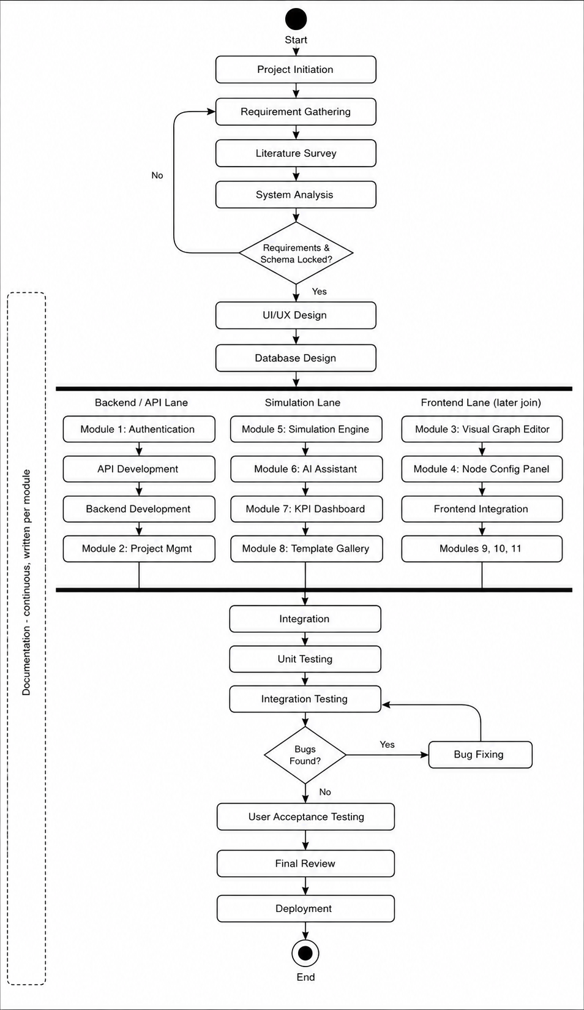
Figure 3.2: Activity Network Diagram of the JustCmul8 Development Lifecycle
Project initiation, gathering requirements, literature review and system analysis are the first tasks performed in the flow of the flow. The following decision node checks if the requirements and the database schema are locked or not. Otherwise, requirements come first, then the start of design – and after both are confirmed design can begin. Development is a fork in three parallel lines. Authentication, API development, backend development and project management are present on the Backend and API lane. The simulation lane holds the simulation engine followed by the AI assistant, KPI dashboard and template gallery. The front end lane contains the graph editor, configuration panel, front end integration, export, profile and collaboration. The three lanes will be united again by a join bar for system integration. Starting with unit tests, then integration tests, where another decision node checks if defects were found. If so, they will have to return to bug fixing and return to integration testing, and it will continue in this manner until the build is clean. Only at this point is the flow in the final user acceptance and deployment review. Supporting Documentation for all phases side by side.

3.3.3 Critical Path
The critical path is the path through a project that determines the project's latest possible finish date. It then enters into the Requirement Gathering, System Analysis, Database Design, API and Backend Development, Integration, Integration Testing, Bug Fixing, UAT, Final Review and Deployment processes. Any activity on the chain delays delivery and activities off the chain like the Template Gallery and Profile and Settings have float and can absorb delays. If this is scheduled AFTER the backend, it will be critical, too - it won't get on the path, and will protect the last date. These 2 diagrams complement each other. In total, they present the calendar and the development method used for JustCmul8.

3.4 Resource Planning
Resource planning identifies the people, equipment, software and services required and when they are required. The two CK members were most agreeable that Most of the planning occurred around the human effort: the time of the team members. For this reason, JustCmul8 utilizes open source stack and free tier cloud services.

3.4.1 Human Resources
Table 3.4: Human Resources and Responsibilities
Resource | Role | Responsibilities
Ms. Jinal Gujar | Project Guide | Review of requirements, design and drafts; validation of milestones; academic guidance
Khushi Singh (261713) | Developer, Analyst and Documenter | Requirements and design documents; Platform and Data Layer; configuration panel; AI assistant; KPI dashboard; digital twin; report and share; testing support
Mohit Gupta (261715) | Developer, Architect and Tester | System architecture; graph editor; simulation engine; AI optimiser; Monte Carlo; templates; real-time collaboration; verification harness; deployment
Both members | Team | Requirement analysis, database design, integration, testing, user acceptance and the project report

3.4.2 Hardware, Software and Service Resources
Table 3.5: Hardware, Software a
nd Service Resources
Category | Resource | Cost basis
Hardware | Two development laptops (8–16 GB RAM, SSD); college laboratory machines for cross-machine collaboration testing | Owned / provided by the college
Development software | VS Code, Git, GitHub, Node.js, Postman, Python and SimPy, Chrome DevTools | Free
Frameworks and libraries | Next.js, React, TypeScript, Tailwind CSS, React Flow, Zustand, Recharts, Pixi.js, Pyodide | Open source
Backend services | Supabase (database, authentication, realtime) | Free tier
AI service | Google Gemini API | Free tier / metered usage
Hosting | Vercel (Next.js hosting and preview deployments) | Free tier
Project management | GitHub issues and project board | Free tier

3.4.3 Effort Allocation
One man-month = 6 p.m. at 2 people.2 people x 6 months = nominal 12 p.m. The table splits up that effort in phases in accordance to the schedule presented in Section 3.2.
Table 3.6: Planned Effort Allocation by Phase
Phase | Weeks | Share of effort | Principal activity
Initiation and Analysis | 4 | 10% | Requirements, literature survey, technology assessment
Design | 3 | 10% | Interface design, database design, architecture
Development | 18 | 45% | Twelve modules, API and backend, integration
Testing | 9 | 20% | Unit, integration, security, acceptance testing
Documentation | continuous | 10% | Module documents and this report
Deployment | 4 | 5% | Final review, configuration, release

3.5 Proposed Software Development Model
We used an iterative and incremental approach that takes the combination of waterfall and agile approaches. There are two aspects of this project which drew us there. Firstly, the conditions were relatively consistent throughout the beginning. The problem domain of interest is well understood, and tools that we saw in Section 1.3 already outlined some of the expected characteristics. When the Agile movement's standard of living is such that requirements continue to come in during the development process, then providing pure agile will fail to justify its existence; and, at the academic phase of development, there is little need for the formal documentation required by waterfall. Secondly, there was only one technical risk. At the beginning, whether SimPy could be executed in a Browser using Pyodide was a question mark, and a lot of other things were linked to it. With hard waterfall, people would've waited until after they'd implemented something, but by that time, there would be a false assumption in the design. Thus we put in an early prototype iteration cycle and made the engine a spike to test the modules that would require it to be detailed later.
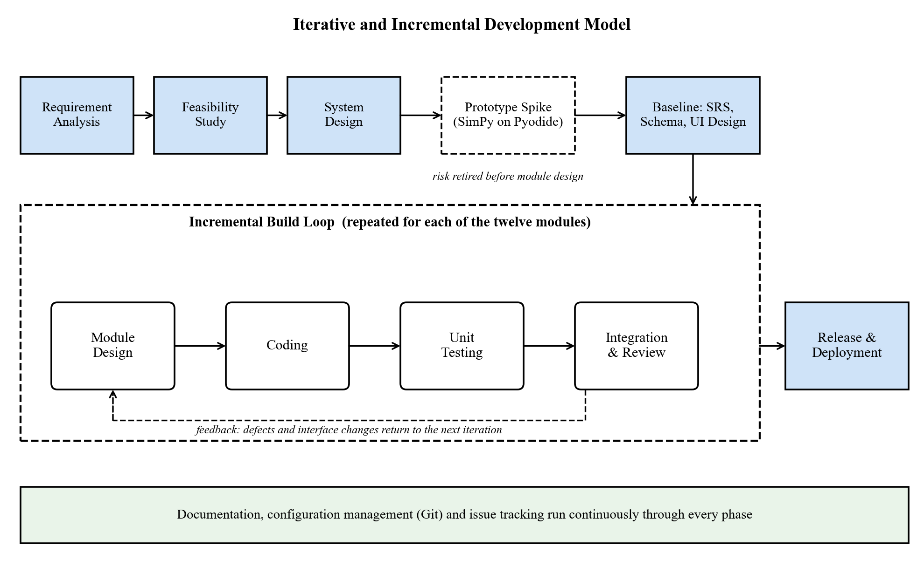
Figure 3.3: Iterative and Incremental Development Model adopted for JustCmul8
For practical work, analysis and design were continued in a waterfall manner, and there is no implementation of the requirement specification, and schema is implemented before workflow and requirements. The implementation then started per module and each module passed through the design cycle, coding, test and integration cycles before the next. Testing was conducted all the way through and documentation created for each module.
Table 3.7: Phases of the Adopted Life-Cycle Model
Phase | Activities performed | Outcome
Requirement analysis | Elicitation of needs, study of comparable tools, identification of functional and non-functional requirements | Approved requirement specification (Section 2.1)
Feasibility study | Assessment of technical, economic, operational, schedule, legal and ethical viability | Confirmation that the browser-hosted approach was achievable
System design | Architecture, database schema, interface layout and UML modelling | Design documents and diagrams (Chapter 5)
Prototyping (iterative) | Spike implementation of the Pyodide and SimPy execution path, verified against analytical results | Retirement of the dominant technical risk at milestone M4
Implementation (incremental) | Module-by-module construction across three parallel streams, each with its own design-code-test cycle | Twelve delivered modules (Chapter 4)
Testing | Unit, structural, analytical, integration, security and acceptance testing alongside development | Verified system (Chapter 7)
Deployment | Final review, environment configuration, database policies, release | Live application on the hosting platform
Documentation | Continuous recording of analysis, design, implementation and test outcomes | This report and module documents

Table 3.8: Why the Iterative and Incremental Model Was Preferred
Model | Strength | Weakness for this project
Waterfall | Clear stages and documentation | Defers discovery of the engine risk until late implementation
Pure Agile / Scrum | Adapts to changing requirements | Requirements were stable; formal documentation is required
Spiral | Explicit risk analysis in each loop | Heavyweight for a two-person team
Iterative and Incremental (adopted) | Early risk retirement, testable increments, disciplined documentation | Requires interface stability between modules, managed by the worker boundary

There is one consequence of this model of which it is worth recording. Some modules have been created which consume the output of the engine, so the format of its output has evolved as the modules have come along. The Monte Carlo analysis requested some "per-run" statistics, and the digital twin requested a "per entity" journey trace. These additions were both inexpensive, as the engine was trimmed by the worker boundary, which is what the layered design was designed to provide.

4. SOFTWARE MODULES
JustCmul8 is made up of twelve software modules. They each have one thing they are required to do, each has an interface with the other and each has been developed and tested independently before being integrated. One by one, the chapter reviews each of the modules and offers a brief description of what it is, how it was applied, to which standards in section 2.1 does it address, and who authored it. Finally it concludes with hardware points that follow in response to simulation runs on the client.
Figure 4.1: Module Structure of JustCmul8
Table 4.1: Module Overview and Requirement Coverage
No. | Module | Primary responsibility | Requirements
1 | Platform and Data Layer | Authentication, project lifecycle, cloud persistence, profile | FR-01 to FR-06
2 | Visual Graph Editor | Canvas-based construction of the simulation graph | FR-07 to FR-09
3 | Node Configuration Panel | Parameter and cost entry with per-type validation | FR-10, FR-11
4 | Simulation Engine | Code generation and in-browser SimPy execution | FR-12 to FR-15
5 | AI Assistant | Natural-language generation of candidate models | FR-16, FR-17
6 | AI System Optimiser | Bottleneck diagnosis and one-click corrective fixes | FR-18
7 | KPI Dashboard and Results | Metric computation, verification, visualisation, cost and ROI | FR-19 to FR-21
8 | Monte Carlo and Scenario Comparison | Replicated runs, confidence intervals, baseline comparison | FR-22
9 | Digital Twin Animated Playback | Animated 2D entity flow with transport controls | FR-23
10 | Simulation Template Gallery | Reusable starter models across six domains | FR-24
11 | Executive Report and Share | PDF, CSV, JSON, notebook export and share links | FR-25, FR-26
12 | Real-Time Collaboration | Live presence, cursors and graph-operation broadcast | FR-27

4.1 Module 1: Platform and Data Layer
Purpose: In this module, the user is determined, they may own something and their work puts forward into where. It is required for all the other modules since a project can't be created, shared or saved if there is no one to own it. On top of Supabase, it acts as a foundational layer where you can handle authentication, project management, cloud storage and account settings all in the same place.
Functional responsibilities.
- One-click Google or Github OAuth login and registration Password & email (also available for registration).
- Signed-in Cookies are persisted between visits: A signed-in session will persist between visits. Middleware intercepts protected routes for project data fetch: Middleware filters protected routes for project data fetch.
- Passed reset via email link, in-signed password change, secure sign-out and cascading account deletion through all the things they possess.
- Creating a project in one of the six domains (optionally based on a template) and changing the name or deletion of projects.
- The graph has been automatically saved into the cloud storage as the user edits it without having to click on save.
- A list of projects with display names and domain on a dashboard and settings page with the default display name, avatar and domain for simulation.
Implementation Sign-in is controlled by Supabase Auth and the application will never have any plaintext password besides the one entered in the sign-in form. Next.js Middleware refresh sessions & secures protected routes. A key design rule is that authorisation is not a part of the client. Every table has a PostgreSQL RRSS policy that verify if the user identity is the same as the one that requests the access. If it is not, the client that prepared the request can't retrieve the other users' rows even if it constructs the request by hand. It creates a profile row whenever a new user registers and each child table is defined as “CASCADE” for deletion, which means that it deletes its data when the account is deleted.
Requirements covered | Principal source files | Developed by
FR-01 to FR-06 | app/login, signup, forgot-password, update-password, auth/callback, dashboard, settings; middleware.ts; lib/supabase; api/account/delete; supabase/schema.sql | Khushi Singh (261713)

4.2 Module 2: Visual Graph Editor
Purpose. It's the place the place where modelling takes place and for which most of the platform's no code promise comes. Direct manipulation can be used to write a process as a directed graph.
Functional responsibilities.
- A canvas with drag-and-drop nodes, with a palette of nodes from which to pick.
- 15 different type of nodes in 6 different simulation domains each having their own icon, colour and connection handles.
- Relationships between node handles (directed edges) can be created and deleted, and edges re-routed directly as node handles move.
- Plus zooming, panning and fitting to view, and selecting and removing nodes, edges. Structural validation prior to run, whereby graphs that can't run are filtered out, and the offending node is named.
- Automatic arrangement of created and template generated graphs following a strategy selected for every domain.
Implementation. React Flow provides the viewport transform and handles the placement, model-based connection and the edge routing in the canvas. That would have filled much of the time if we had written our own. Custom node components are used to produce each of the fifteen types. Labels are from a domain registry which means that a bank modeller will see “Teller” and a factory modeller will see “Machine”, though both refer to the same resource node under the hood. The correct but hard-to-understand diagrams were obtained by using one generic layout; instead, automatic layout includes Dagre with a strategy selected for each domain.
Requirements covered | Principal source files | Developed by
FR-07 to FR-09 | components/workspace/NodeCanvas.tsx, NodePalette.tsx; lib/simulation/layoutEngine.ts, simTypeRegistry.ts | Mohit Gupta (261715)

Table 4.2: The Fifteen Node Types Supported by the Simulation Engine
Node type | Behaviour | Typical domains
source | Generates entities at intervals drawn from a chosen distribution | All six
queue | A waiting line of finite or infinite capacity under FIFO, LIFO or priority discipline | All six
resource | A capacity-limited server that entities seize, hold for a sampled service time, then release | All six
service | A single processing step with its own duration | Manufacturing, logistics
decision | Routes entities down one of several outbound edges by assigned probabilities | All six
sink | Terminates an entity’s journey and records its completion statistics | All six
container | Holds a level of bulk material or liquid, sampled at event boundaries | Liquid / material flow
store | A buffer of distinguishable items (SimPy Store, priority and filter variants) | Manufacturing, logistics
event_trigger | Monitors a condition and fires an event when it is met | Network, manufacturing
priority_resource | A preemptive resource: a higher-priority arrival displaces a lower one | Human queues, healthcare
channel | A transmission medium with propagation delay | Network and signal flow
broadcaster | Duplicates an entity to every outbound edge (one-to-many fan-out) | Network and signal flow
any_of | Waits on several concurrent events and proceeds when the first completes (SimPy AnyOf) | Network, manufacturing
all_of | Waits until every concurrent event has completed (SimPy AllOf) | Manufacturing, logistics
interrupter | Interrupts an in-progress process, modelling breakdowns and abandonment | Manufacturing, human queues

The first six node types are considered as the standard Discrete Event vocabulary and are sufficient for most models. The other nine describe aspects not expressible by the set: Continuous levels; Typed buffers; Preemption; Propagation delay; Fan-out; Event synchronisation. The two synchronisers correspond directly to the AnyOf and AllOf in SimPy and it is possible to wait on multiple events in a generated script without writing any scheduling code.
Table 4.3: The Six Simulation Domains and Their Vocabularies
Domain | Typical scenarios | Example node labels
Human Queues | Banks, clinics, ticket counters, reception desks | Teller, Counter, Waiting Area, Customer Arrival
Vehicle Traffic | Junctions, toll plazas, fuel stations, car washes | Approach, Signal, Toll Booth, Pump
Liquid / Material Flow | Tanks, pipelines, mixing and bottling plants | Reservoir, Pipe, Valve, Mixer
Manufacturing Lines | Assembly lines, machining cells, inspection bays | Machine, Buffer, Inspection, Assembly
Logistics / Warehousing | Depots, sorting hubs, order fulfilment | Inbound Dock, Picking, Packing, Dispatch
Network / Signal | Packet routing, message buses, sensor networks | Transmitter, Router, Link, Receiver

4.3 Module 3: Node Configuration Panel
Purpose. Placing a node says what it is; configuring it says how it behaves. This module collects the parameters that turn a bare topology into a runnable model, using ordinary form controls and no scripting field.
Functional responsibilities.
- A side panel that opens for the selected node and shows only the fields that fit its type.
- Entry of arrival rates, service-time distributions and their parameters, capacities, queue disciplines, routing probabilities and propagation delays.
- A choice among the five probability distributions, with the parameter fields changing to suit.
- Entry of cost parameters (resource hourly rate, holding cost and waiting-penalty cost) that the Cost and ROI analysis uses.
- Checking every value against the node type, with each change passed straight to the underlying model.
Implementation. A node’s configuration is stored as a JSON object shaped by that node type’s schema. This keeps the database schema stable when node types are added and still allows type-specific validation. Validation runs when a value is entered and again before a run. Messages name the offending node and say what to do about it, because showing a raw engine exception to a non-technical user would defeat the point of a no-code interface.
Requirements covered | Principal source files | Developed by
FR-10, FR-11 | components/workspace/NodePropertiesPanel.tsx; lib/simulation/types.ts | Khushi Singh (261713)

4.4 Module 4: Simulation Engine
Purpose. The engine is the technical heart of the project. It turns the visual graph into an executable discrete event simulation and runs it wholly inside the browser on a genuine Python engine.
Functional responsibilities.
- Compiling the node-and-edge graph into a Python SimPy script that reflects the configured parameters.
- Running that script on the client through the Pyodide WebAssembly runtime, with no simulation computation on the server.
- A Web Worker execution path that keeps the interface responsive during a run.
- Taking the simulated duration and time unit (seconds, minutes, hours, days) before a run, and streaming periodic state snapshots and log events to the interface as it proceeds.
- A live Python code inspector that shows the generated script and exports it as a Jupyter notebook.
Implementation. A run has four stages. The graph is validated structurally. The code generator walks it and writes a SimPy script in which each node becomes a resource, store or process and each edge becomes a routing decision. The script goes to the worker, where Pyodide executes it. The resulting event trace returns to the main thread for analysis. Each resource uses the matching SimPy primitive (Resource, PriorityResource, Store, PriorityStore, FilterStore or Container). We kept the generated script readable on purpose. It shows in the code inspector and exports as a notebook, so a student can look at the Python that their diagram produced and run it again independently. That makes the platform a teaching aid for SimPy and lets anyone verify a published result.
Requirements covered | Principal source files | Developed by
FR-12 to FR-15 | lib/simulation/codeGenerator.ts, pyodideEngine.ts, pyodideWorker.ts, clientEngine.ts, jupyterExport.ts; components/workspace/CodeInspectorPanel.tsx | Mohit Gupta (261715)

4.5 Module 5: AI Assistant
Purpose. This module lowers a conceptual barrier, not a technical one. Someone who does not know how to draw a process as a graph can describe it in plain English and get a candidate model back.
Functional responsibilities.
- Turning a natural-language scenario into a candidate graph of nodes and edges with plausible parameters.
- Validating the generated graph (valid node types, no orphaned edges) before it is offered.
- A preview and an explicit accept step, so the live project never changes without consent.
- Help with simulation concepts and with the user’s own model in non-technical language, with chat history kept for each project.
- Automatic fall-back to another AI model when the preferred one is down.
Implementation. Requests pass through Next.js API routes to Google Gemini, which keeps the API key on the server and out of the client bundle. The system prompt lists the available node types with their parameter schemas and includes the current graph. Putting the node registry in the prompt is what limits the model to graphs the engine can run. A model router holds a priority list of models, sorts failures into unavailable, rate-limited and empty response, and marks an unhealthy model for a while so later requests skip it. Generated graphs are validated by graph operations before display and arranged by the layout engine.
Requirements covered | Principal source files | Developed by
FR-16, FR-17 | components/workspace/AIChatPanel.tsx; app/api/ai/chat and generate; lib/ai/systemPrompt.ts, graphOps.ts, modelRouter.ts, textFormat.ts | Khushi Singh (261713)

4.6 Module 6: AI System Optimiser
Purpose. Module 5 helps a user build a model; this one helps them act on it. After a run it reads the computed metrics, explains which node is holding the system back and why, and proposes a specific change that a single action can apply.
Functional responsibilities.
- Post-run inspection of utilisation, waiting times and flow through each node.
- A diagnosis of the constraining node, worded so that a non-specialist can act on it.
- A concrete corrective change, such as more capacity at a resource, rerouting at a decision node or a larger buffer.
- A one-click Apply Fix action, carried out as an ordinary graph edit.
- Keeping the graph from before the change so its effect can be compared in Module 8.
Implementation. The optimiser works from analytics output and not from the raw event trace, so its advice cites computed utilisation and queue statistics instead of impressions. A flow-analysis step first works out which node it makes structural sense to change, since adding capacity to a node that is not the constraint achieves nothing. Only that candidate is sent to the language model for explanation. The proposal is always shown for approval, so the optimiser advises and never acts on its own.
Requirements covered | Principal source files | Developed by
FR-18 | app/api/ai/optimize/route.ts; lib/ai/flowAnalysis.ts, graphOps.ts | Mohit Gupta (261715)

4.7 Module 7: KPI Dashboard and Results
Purpose. An event trace is not an answer. This module turns the raw output of a run into the performance indicators a decision needs, and lays them out so the constraining node stands out without further analysis.
Functional responsibilities.
- Computing and showing utilisation, average and percentile waiting times, throughput and queue length for each node.
- Finding the bottleneck node automatically and flagging it clearly.
- A Flow and Balance Check that applies Little’s Law to confirm the run is consistent, and a composite 0–100 system health score.
- Interactive tabs: Executive Summary, Flow and Balance Check, Traffic Heatmap, Line Buildup Timeline, Station Counters, Person / Item Journey, Live Activity Log and Cost and ROI.
- A Cost and ROI panel that puts the run in money terms, so a proposed change can be judged by whether it pays for itself.
Implementation. The analytics are TypeScript modules with no React dependency, so they can be unit-tested alone. The system health score is a weighted composite: completion rate (35%), utilisation balance (30%), queueing stability judged by Little’s Law (20%) and tail latency (15%). The bottleneck is the resource or queue node with the highest average waiting time in the run. Percentiles come from the real per-entity samples and are not estimated, and a conservation check confirms that work-in-progress equals arrivals minus completions.
Requirements covered | Principal source files | Developed by
FR-19 to FR-21 | lib/simulation/analyticsEngine.ts, resolveKpiMetrics.ts; components/workspace/SimResultsPanel.tsx, AdvancedResultsDashboard.tsx, results-dashboard/* | Khushi Singh (261713)

Table 4.4: Key Performance Indicators and Their Computation
Metric | Definition | Input data
Utilisation | Fraction of run time for which a resource was occupied | Accumulated busy-seconds per resource
Average waiting time | Mean interval between joining a queue and being served | Queue entry and service-start times per entity
Percentile waiting time | 50th, 90th, 95th and 99th percentiles of the waiting distribution | Real per-entity waiting samples
Throughput | Entities completing the model per unit of simulated time | Sink completion counts and run duration
Average queue length | Time-weighted mean number of entities waiting | Periodic depth snapshots
Little’s Law check | Compares L with λW and reports the discrepancy and stability verdict | Arrivals, completions, work-in-progress, mean time in system
System health score | 0–100 composite: completion 35, utilisation balance 30, stability 20, tail latency 15 | Outputs of the above
Total system cost | Resource, holding and waiting-penalty costs over the run | Cost parameters from Module 3

4.8 Module 8: Monte Carlo and Scenario Comparison
Purpose. One stochastic run is a single observation, not an estimate. This module repeats the run and reports the range in which the true behaviour lies, and then lets two configurations be compared against that measure of uncertainty.
Functional responsibilities.
- Running a model over 10, 20, 50 or 100 replications, each an independent run.
- Computing the mean, standard deviation and 95% confidence interval of every metric across replications.
- Drawing the intervals as bands, so that significance can be seen and not merely inferred.
- Placing a baseline scenario beside a modified one and reporting the difference for each metric.
- Progress reporting during a long analysis, so the user always has feedback.
Implementation. The runner pushes replications through the same engine as a single run and aggregates them with the standard-error formula of Section 1.1.2. It also exposes a scenario-comparison function that pairs the baseline kept before an applied fix with the current configuration. The aggregation is plain TypeScript, so it is easy to test and does not depend on the interface.
Requirements covered | Principal source files | Developed by
FR-22 | lib/simulation/monteCarlo.ts, monteCarloRunner.ts; components/workspace/MonteCarloPanel.tsx | Mohit Gupta (261715)

4.9 Module 9: Digital Twin Animated Playback
Purpose. Numbers describe congestion, and animation shows it. This module replays a finished run as a moving two-dimensional picture of entities passing through the model, which shows where a system is failing much faster than a chart does.
Functional responsibilities.
- Animated playback of entities flowing through the nodes and edges of the model.
- Highlighting of queue congestion, so lines that are building up can be seen as they grow.
- Video-style transport controls: play, pause, step and speed selection from 0.5× to 10×.
- Scrubbing to any point in the run without executing the model again.
Implementation. Playback is drawn with Pixi.js on WebGL and not with DOM elements, because animating several hundred moving entities through the DOM slows down unacceptably. The animation is driven by the recorded entity journeys and not by re-running the model. Scrubbing and speed changes are therefore immediate, and what is on screen matches exactly the run whose metrics are displayed.
Requirements covered | Principal source files | Developed by
FR-23 | components/workspace/DigitalTwinCanvas.tsx, PlaybackControls.tsx; lib/simulation/timelineSelectors.ts | Khushi Singh (261713)

4.10 Module 10: Simulation Template Gallery
Purpose. A blank canvas puts off a first-time user. This module offers working models in all six domains so that a user can start from something that already runs and change it, which is a gentler introduction than building from nothing.
Functional responsibilities.
- A gallery of starter graphs grouped by domain, each with a description.
- Instantiating a template, which fills a project with its nodes, edges and default parameters.
- Creating a fully independent copy, so edits can never flow back into the source template.
- Free editing of every parameter after instantiation.
Implementation. Templates are declared in the simulation type registry next to each domain’s node palette and layout strategy. A domain is therefore defined in one place, and adding one does not mean touching many components. Instantiation copies the template’s nodes and edges into the new project instead of referring to them, so independence holds by construction.
Requirements covered | Principal source files | Developed by
FR-24 | components/workspace/TemplateGallery.tsx; lib/simulation/simTypeRegistry.ts | Mohit Gupta (261715)

4.11 Module 11: Executive Report and Share
Purpose. Work that cannot leave the platform is worth little. This module carries models and results outward, whether for archiving, for analysis elsewhere or for showing to someone who will never log in.
Functional responsibilities.
- One-click generation of a PDF executive report with a written summary, a canvas snapshot and KPI tables.
- Export of the project graph as JSON and of run results as CSV.
- Export of the generated Python script as a Jupyter notebook, for independent reproduction.
- Creation of a read-only public share link that never gives edit access.
- Revocation of a share link, after which the URL shows an explanatory notice.
Implementation. PDF generation runs on the client with jsPDF, and html-to-image captures the canvas. No document-rendering service is needed, so the architecture keeps its property of zero server compute. Share links are opaque random tokens. Public access goes only through two narrow database functions: one returns the name, domain and graph of a single shared project, and the other reports whether a token is active, revoked or invalid. Anonymous visitors therefore never get direct table access, and the read-only guarantee is enforced by the database and not by hiding controls in the interface.
Requirements covered | Principal source files | Developed by
FR-25, FR-26 | lib/simulation/pdfReportGenerator.ts, reportGenerator.ts, jupyterExport.ts; components/workspace/ShareExportModal.tsx, ShareViewer.tsx, ShareLinkUnavailable.tsx; app/api/projects/[id]/share and export; app/share/[token] | Khushi Singh (261713)

4.12 Module 12: Real-Time Collaboration
Purpose. Teams now expect any modern design tool to work with several people at once, and this module supplies that: you see who else is in the workspace and what they are doing, much as in Canva or Figma.
Functional responsibilities.
- Live presence: a row of avatars showing who is in the project right now.
- Live cursors: each collaborator’s pointer drawn on the canvas in their own colour, labelled with their name.
- Broadcasting graph operations (node and edge changes and node-data edits) to the other connected clients.
- Awareness of selection and editing, meaning which node a collaborator has selected or is editing.
- Database-level authorisation of the project channel, so that only entitled users can join.
Implementation. Collaboration uses Supabase Realtime channels over WebSockets. Each project has a private channel named after its identifier. Before joining, the client confirms it can read the project through Row-Level Security, and a realtime policy separately authorises the channel at the database. Presence uses the channel’s presence state, while cursor positions and graph operations travel as broadcast messages. Cursor positions are temporary and never stored, since they mean nothing once a session ends.
Requirements covered | Principal source files | Developed by
FR-27 | lib/realtime/usePresence.ts; components/workspace/LiveCursor.tsx | Mohit Gupta (261715)

4.13 Hardware Modules and Considerations
JustCmul8 needs no custom hardware. Even so, running simulations on the client and not the server gives the user’s own machine a job it would not otherwise have, and we want to state that clearly.
Table 4.5: Hardware Roles in the Deployed System
Element | Role in the system | Consequence of the design
Client CPU | Executes the WebAssembly runtime and the entire simulation | Determines run duration; large models are slower on weaker machines
Client memory | Holds the Pyodide runtime, the graph, the event trace and the rendered canvas | Sets the practical ceiling on model size and replication count
Client GPU | Renders the digital-twin playback through WebGL | Enables smooth animation of many simultaneous entities
Network link | Carries persistence, collaboration and AI requests only | Simulation continues to run on an intermittent connection
Application server | Serves the application and a small number of API routes | Carries no simulation load, so hosting cost is independent of usage intensity
Database server | Managed PostgreSQL storing projects, runs, chats and shares | Sized by data volume rather than by computational demand

The last two rows restate the economic argument of Section 2.2.2 in hardware terms. Neither server takes part in the computation, so the infrastructure for a thousand users running simulations is about what a thousand users viewing a static page would need. That is what keeps the platform sustainable without a licence fee.

4.14 Individual Work Justification
The project was done by two people. Requirements analysis, architecture, database design, integration, testing and this report were shared work. The twelve modules were split equally, six each. Every module was designed, implemented, unit-tested and documented by its owner and reviewed by the other member. The split is summarised below.
Table 4.6: Division of Work between Team Members
Module | Owner | Justification of contribution
1 Platform and Data Layer | Khushi Singh (261713) | Authentication flows, session middleware, dashboard, settings, database schema and Row-Level Security policies
2 Visual Graph Editor | Mohit Gupta (261715) | React Flow canvas, custom node components, palette, layout engine and structural validation
3 Node Configuration Panel | Khushi Singh (261713) | Type-specific forms, distribution controls, cost parameters and value validation
4 Simulation Engine | Mohit Gupta (261715) | SimPy code generator, Pyodide worker, execution pipeline and the verification harness
5 AI Assistant | Khushi Singh (261713) | Chat interface, prompt design, graph generation, model router and history
6 AI System Optimiser | Mohit Gupta (261715) | Flow analysis, bottleneck diagnosis, one-click fix and cost-aware recommendation
7 KPI Dashboard and Results | Khushi Singh (261713) | Analytics engine, Little’s Law check, health score, dashboard tabs and Cost and ROI
8 Monte Carlo and Scenario Comparison | Mohit Gupta (261715) | Replication runner, confidence intervals and scenario comparison
9 Digital Twin Playback | Khushi Singh (261713) | Pixi.js renderer, entity journeys, transport controls and timeline
10 Template Gallery | Mohit Gupta (261715) | Domain registry, six-domain template library and instantiation
11 Executive Report and Share | Khushi Singh (261713) | PDF report generation, JSON/CSV/notebook export, share links and read-only viewer
12 Real-Time Collaboration | Mohit Gupta (261715) | Presence channel, live cursors and graph-operation broadcast

Both of us contributed to the specification, the design diagrams, the test cases and the report. Reviewing each other’s modules is what let the pieces be integrated with few defects.

5. SYSTEM ANALYSIS AND DESIGN
This chapter covers the analysis and design of JustCmul8, moving from the outside of the system to the inside. The context diagram draws the boundary. Data flow diagrams break down the processes within it. Entity relationship and class diagrams describe the data and the objects, and behavioural diagrams show how those objects interact while the system runs. Two physical topics close the chapter: the database tables and the deployment topology.

5.1 Context Diagram
The context diagram (data flow diagram level 0) fixes the system boundary. JustCmul8 appears as one process, surrounded by the external entities that exchange data with it, and nothing inside is broken down. Its job is to settle what belongs to the system and what does not before internal structure is discussed.
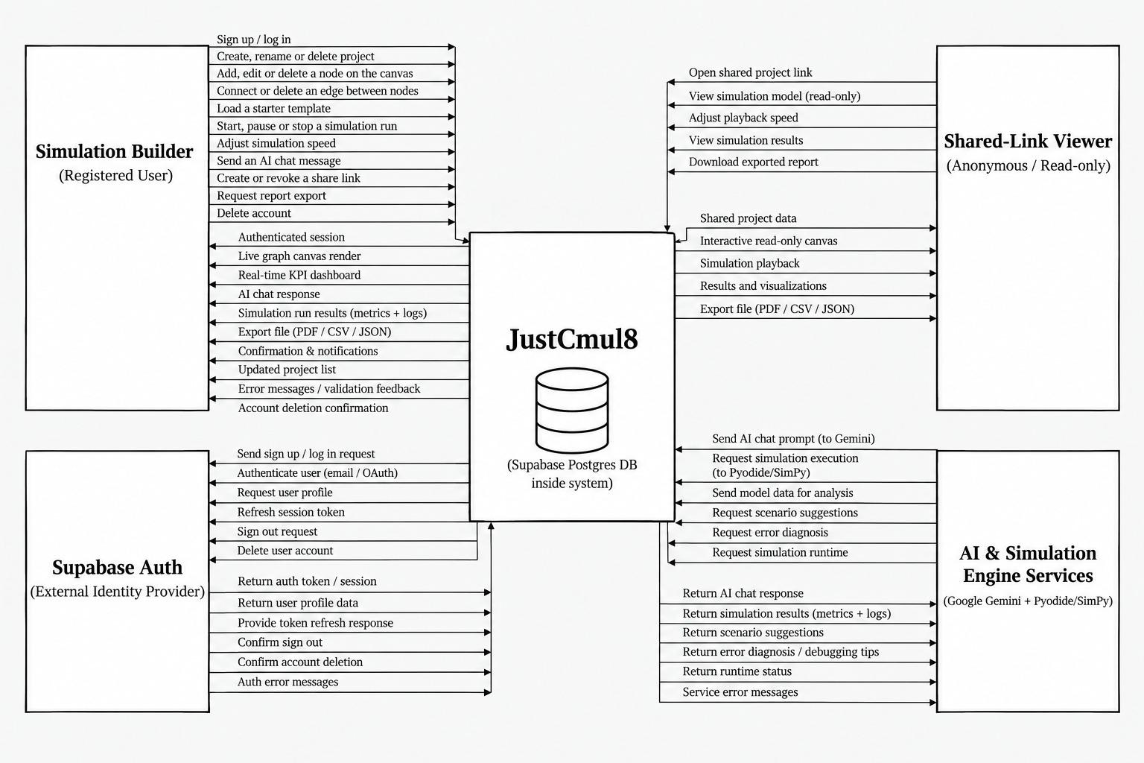
Figure 5.1: Context Diagram (DFD Level 0) for JustCmul8
Four external entities touch the system. The Simulation Builder is the registered user who creates and runs models. This entity sends in flows for signing up and logging in, creating, renaming and deleting projects, adding, editing and deleting nodes and edges, loading starter templates, starting and stopping runs, changing simulation speed, sending AI chat messages, creating and revoking share links, requesting report exports and deleting the account. Flows going back carry the authenticated session, the live canvas rendering, the real-time KPI dashboard, AI responses, run results with metrics and logs, export files, confirmations, the updated project list and validation feedback.
The Shared-Link Viewer is an anonymous visitor who holds a public share URL. This entity opens a shared project, views the model read-only, changes playback speed, views results and downloads an exported report. The two user entities are deliberately unequal: no flow from the Shared-Link Viewer changes stored state.
Supabase Auth is the external identity provider. The system sends it sign-up and login requests, profile queries, session refreshes, sign-out requests and account-deletion instructions, and gets back tokens, sessions, profile data and confirmations. Keeping authentication outside the boundary shows that JustCmul8 hands credential handling to someone else and does not build it. The AI and Simulation Engine Services entity stands for the Google Gemini API and for the Pyodide and SimPy runtime delivered over a CDN. The PostgreSQL database sits inside the boundary, because the application provisions and governs it and does not simply consume it as an independent third party.

5.2 DFD, ERD, Class Diagram and State Transition Diagram

5.2.1 Data Flow Diagram, Level 1
The level-1 diagram splits the single process of the context diagram into seven functional processes and adds the data stores that they read and write.
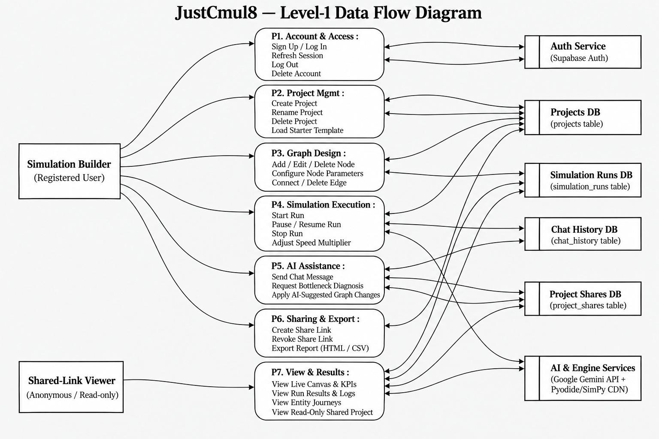
Figure 5.2: Level-1 Data Flow Diagram for JustCmul8
Process P1, Account and Access, deals with sign-up, log-in, session refresh, log-out and account deletion, and talks to the external authentication service. P2, Project Management, covers creating, renaming and deleting projects and loading starter templates, and reads and writes the Projects store. P3, Graph Design, adds, edits and deletes nodes, sets node parameters and connects or removes edges, saving every change to the same store.
P4, Simulation Execution, starts and stops runs and changes the speed multiplier. It reads the graph from the Projects store, drives the external engine services and writes run records to the Simulation Runs store. P5, AI Assistance, sends chat messages, asks for bottleneck diagnosis and applies AI-suggested graph changes; it exchanges data with the Gemini service and logs the exchanges in the Chat History store. P6, Sharing and Export, creates and revokes share links and produces exports, writing to the Project Shares store. P7, View and Results, serves the live canvas and KPIs, run results and logs, entity journeys and the read-only shared view. It is the only process that the anonymous Shared-Link Viewer can reach, so the read-only guarantee comes from the structure of the design and not from convention.

5.2.3 Entity Relationship Diagram
The entity relationship diagram shows how persistent data is organised and how the entities relate. It uses Chen notation: rectangles for entities, ellipses for attributes and diamonds for relationships, with cardinality marked.
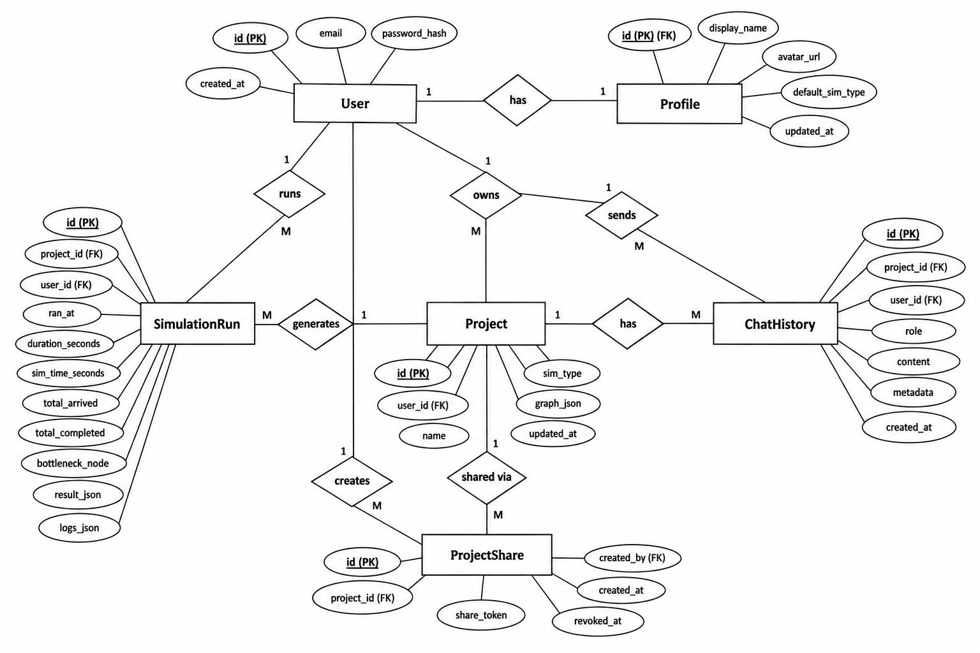
Figure 5.4: Entity Relationship Diagram for the JustCmul8 Database
The User entity sits at the centre and has a one-to-one relationship with Profile, which stores the display name, avatar URL, default simulation type and update timestamp. Keeping the profile apart from the credential record separates presentation data from authentication data. A User owns many Projects, and each project has an identifier, an owner, a name, a simulation type, the graph (kept as a JSON document) and an update timestamp. A User also runs many SimulationRuns, sends many ChatHistory messages and creates many ProjectShares. Each Project produces many runs, has many chat entries and is shared through many share records.
The SimulationRun entity keeps the run timestamp, wall-clock duration, simulated duration, totals arrived and completed, the identified bottleneck node and the result and log payloads. The bottleneck is stored as an attribute of the run instead of being recomputed on request, so an old run keeps the diagnosis made at the time. ProjectShare holds an opaque share token with creation and revocation timestamps. A revoked share stays as a row with a revocation timestamp and is not deleted. That is how the system can tell a withdrawn link from one that never existed, and show the viewer an explanation in place of a bare error.

5.2.4 Class Diagram
The class diagram shows the object model as implemented in TypeScript, with each class, its typed attributes, its operations and its associations.
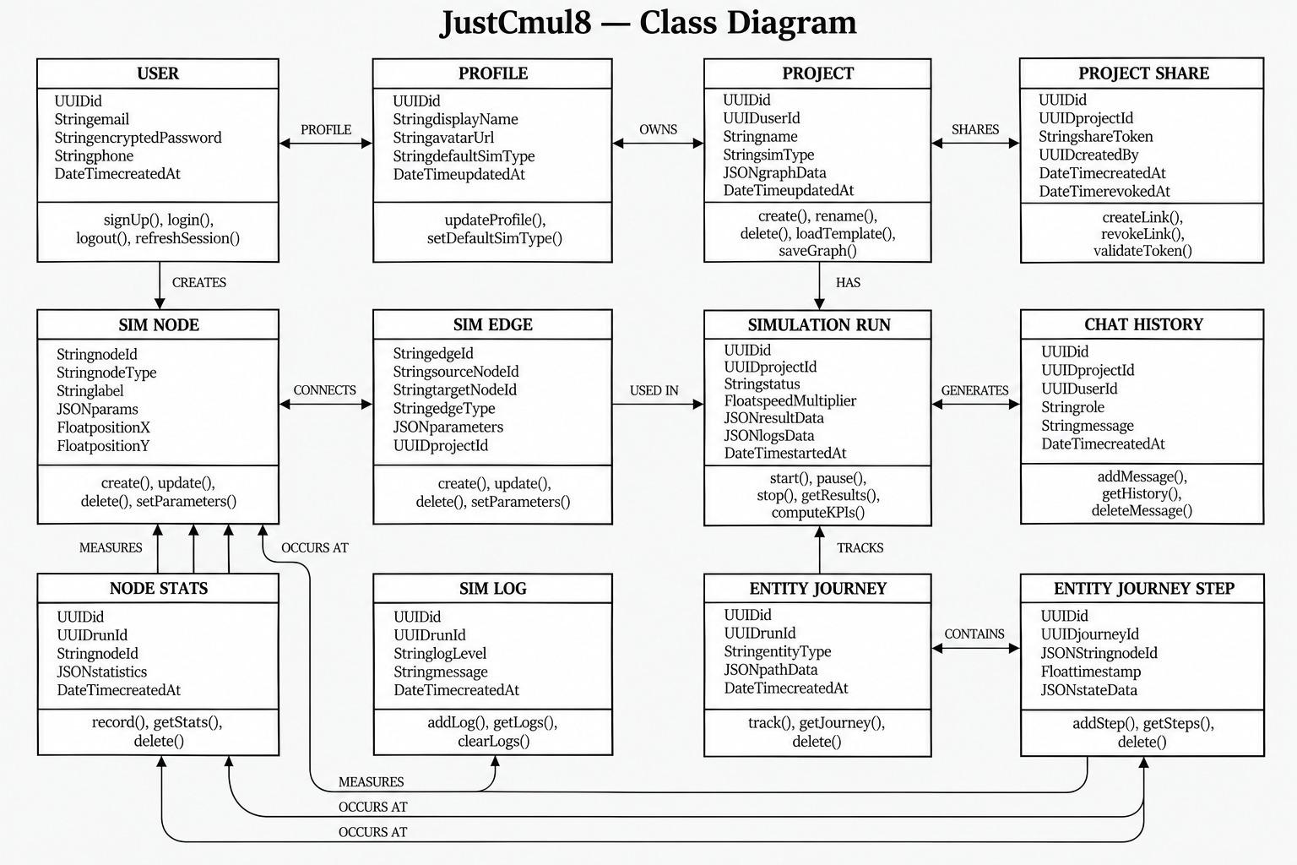
Figure 5.5: Class Diagram of the JustCmul8 Object Model
The top row holds the account and project classes: User, Profile, Project and ProjectShare. The associations read “User has a Profile”, “User owns Projects” and “Project is shared through ProjectShare”. The middle row holds the graph and execution classes. SimNode has the node identifier, type, label, a JSON parameter object and canvas coordinates. SimEdge joins two nodes. SimulationRun has status, speed multiplier, and result and log payloads. ChatHistory records each AI exchange. Keeping parameters as JSON, not as fixed columns, lets fifteen node types with quite different parameters share one class and avoids a sparse schema.
The bottom row holds the measurement classes: NodeStats, SimLog, EntityJourney and EntityJourneyStep. The journey and step classes exist for the digital-twin playback. Each step carries a timestamp and a node reference, so the animation can be rebuilt and scrubbed without running the simulation again.

5.2.5 State Transition Diagram
The state transition diagram follows the life of a node while a model runs. At any instant every node is in exactly one of these states, and the event scheduler causes the transitions.
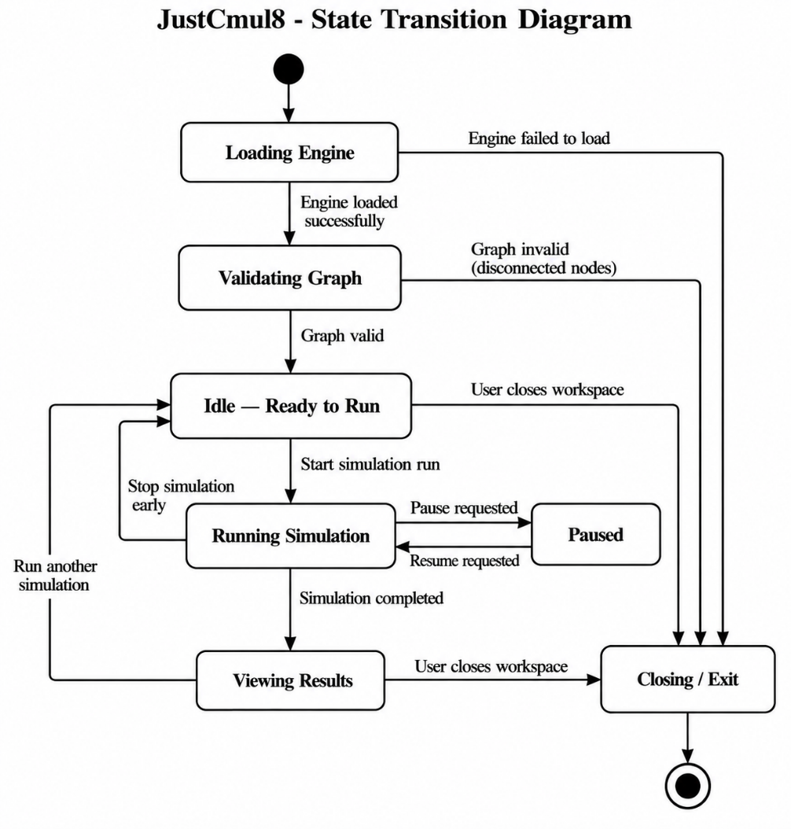
Figure 5.6: State Transition Diagram for a Node During Simulation Execution
A node starts in IDLE with no entity to process. When an entity arrives, the node moves to QUEUED, where the entity waits for capacity. Once the resource is free, the node enters PROCESSING and holds the entity for a service time sampled from the configured distribution. When that ends the node goes to COMPLETED and the entity is routed onward; if nobody else is waiting, the node drops back to IDLE.
Two unusual transitions leave PROCESSING. If the downstream node cannot take the entity, the node goes to BLOCKED and stays there until capacity is released. Blocking is how congestion travels backwards through a model, and having it as a separate state lets the analytics layer tell a node that is slow from one that is merely held up by the node after it. The other transition leads to FAILED, which happens when a process is interrupted by an interrupter node, by preemption at a priority resource or by a runtime error. The state model maps straight onto SimPy semantics: QUEUED is an outstanding resource request, PROCESSING is a timeout while the resource is held, BLOCKED is a pending put on a downstream store, and FAILED is a raised Interrupt.

5.3 Use Case Diagram
The use case diagram names the actors and the services the system offers each of them. It describes functionality from outside, as what an actor can accomplish, and not from inside, as how it is done.
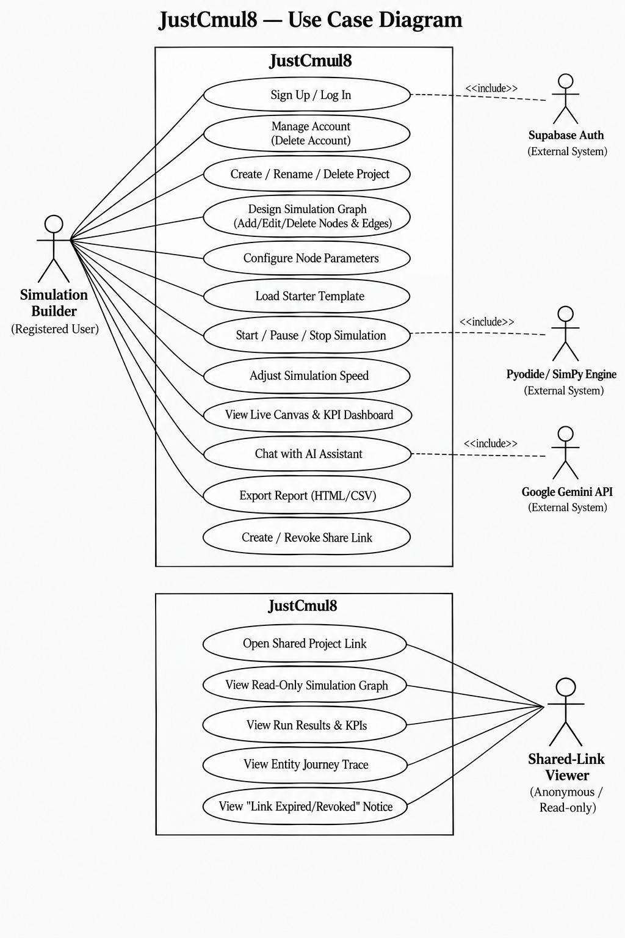
Figure 5.7: Use Case Diagram for JustCmul8
There are two human actors. The Simulation Builder, a registered user, can sign up or log in, manage the account (including deleting it), create, rename and delete projects, design the simulation graph, set node parameters, load a starter template, start and stop a simulation, change the speed, watch the live canvas and KPI dashboard, chat with the AI assistant, export a report and create or revoke a share link. The Shared-Link Viewer is an anonymous actor whose use cases sit in a separate boundary: opening a shared project link, viewing the read-only graph, viewing results and KPIs, viewing the entity journey trace, and viewing the notice shown when a link has expired or been revoked. That last use case is easy to forget, and leaving it out makes for a poor experience, so we modelled it explicitly and did not treat it as an error path.
Three external systems take part through include relationships. Supabase Auth is included by sign-up and log-in, the Pyodide and SimPy engine by starting and stopping a simulation, and the Google Gemini API by chatting with the assistant. We used include and not extend because in each case the external interaction has to happen for the use case to finish.

5.3.1 Use Case Specifications
Table 5.1: Use Case Specification: Run Simulation
Field | Description
Use case ID | UC-01
Use case name | Run Simulation
Primary actor | Simulation Builder
Secondary actor | Pyodide / SimPy engine
Precondition | The user is authenticated, a project is open and the graph contains at least one source and one sink
Main flow | 1. The user sets the duration and time unit.  2. The user starts the run.  3. The system validates the graph structurally.  4. The system generates the SimPy script.  5. The worker executes the script through Pyodide.  6. Progress and log events stream to the interface.  7. The system computes KPIs and ranks the bottleneck.  8. The dashboard renders the results and the run is saved.
Alternative flow | 3a. Validation fails: the system names the disconnected node, explains the fault and aborts before execution.  5a. The runtime raises an error: the error is shown with the relevant log entries.  5b. The user stops the run: execution halts.
Postcondition | On success a run record with KPI results and logs is persisted
Requirements | FR-12, FR-13, FR-14, FR-15, FR-19, FR-20

Table 5.2: Use Case Specification: Generate Model via AI
Field | Description
Use case ID | UC-02
Use case name | Generate Simulation Model from Natural Language
Primary actor | Simulation Builder
Secondary actor | Google Gemini API
Precondition | The user is authenticated and a project is open
Main flow | 1. The user describes the scenario in plain English.  2. The system composes a prompt from the description, the node registry and the current graph.  3. The request is proxied through the server to Gemini.  4. The response is parsed into candidate nodes and edges.  5. The candidate graph is validated.  6. The graph is laid out and shown as a preview.  7. The user accepts and the graph is written to the project.
Alternative flow | 5a. Validation fails on an unknown node type or orphaned edge: the candidate is rejected and the user is invited to rephrase.  7a. The user discards the preview: the project is unchanged.  3a. The preferred model is unavailable: the router falls back to the next model; if all fail, an explanatory message is shown and manual construction remains available.
Postcondition | Either the project contains the accepted graph or it is entirely unmodified
Requirements | FR-16, FR-17

Table 5.3: Use Case Specification: Share Project Read-Only
Field | Description
Use case ID | UC-03
Use case name | Share Project through a Public Link
Primary actor | Project Owner
Secondary actor | Shared-Link Viewer (anonymous)
Precondition | The user owns the project
Main flow | 1. The owner requests a share link.  2. The system generates an opaque token and stores it against the project.  3. The link is presented for copying.  4. A viewer opens the link without authenticating.  5. The system validates the token and renders the project read-only.
Alternative flow | 5a. The token has been revoked: the viewer sees an explanatory notice.  5b. The token is unrecognised: access is refused.  2a. The owner later revokes the link: the revocation timestamp is set and later requests fall to 5a.
Postcondition | The viewer has read access to that project alone, with no ability to modify anything
Requirements | FR-26

Table 5.4: Use Case Specification: Collaborate in Real Time
Field | Description
Use case ID | UC-04
Use case name | Live Collaboration in a Project
Primary actor | Collaborator
Secondary actor | Supabase Realtime, other collaborators
Precondition | Two or more authenticated users with access have the same project open
Main flow | 1. Each client verifies its access to the project and joins the project’s private channel.  2. Presence state and cursor positions are broadcast continuously.  3. A user modifies a node or edge.  4. The change is broadcast as a graph operation.  5. Every other client applies the operation and re-renders.
Alternative flow | 1a. The user has no access to the project: the channel is not joined.  5a. A client disconnects: its presence indicator is removed.
Postcondition | Connected clients display the same graph and can see one another’s presence
Requirements | FR-27

5.4 Architecture Design
JustCmul8 uses a layered architecture in which each layer depends only on the one below it. What is unusual is the execution layer. In a conventional web application the computation happens on the server, but here it happens on the client, and nearly every consequence discussed in this report comes from that reversal.
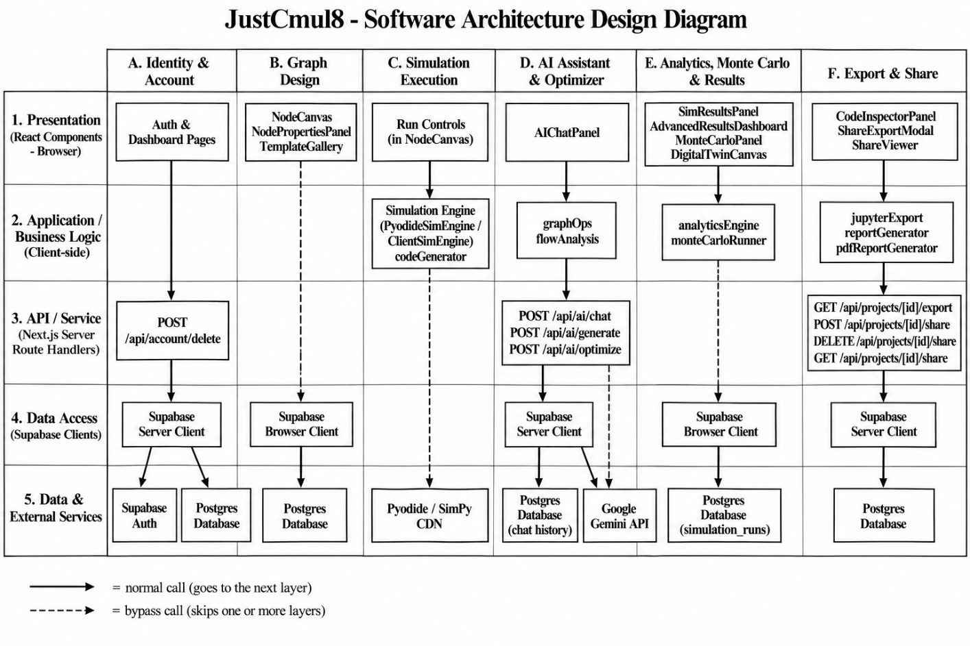
Figure 5.8: Architecture Design of JustCmul8
The presentation layer uses Next.js 16, React 19 and Tailwind CSS. It contains the landing and authentication pages, the dashboard, the workspace shell that hosts the canvas and panels, and the read-only share viewer. It has no business logic: it displays state and passes on what the user wants to do.
The application and state layer holds the Zustand slices: the graph store, the simulation store, the interface store and the presence store. Because they are separate slices, a change in playback position does not make components that only watch the graph render again, which matters when the canvas has hundreds of nodes.
The domain and service layer contains the TypeScript modules that do the real work: the code generator that turns a graph into SimPy, the analytics engine that computes KPIs, the Monte Carlo runner and the report and export modules. They are plain modules with no React dependency, so each can be unit-tested alone.
The execution layer runs in a Web Worker, off the main thread. It holds the Pyodide WebAssembly runtime and the SimPy engine, whose event priority queue orders the scheduled events. Its isolation is what satisfies the requirement that the interface never freezes.
The persistence and external services layer consists of Supabase Auth, PostgreSQL with Row-Level Security, Supabase Realtime and the Gemini API. We put authorisation at this lowest layer, and not in the presentation layer where it would be most visible, because that makes it impossible to bypass. A request that reaches the database carries the user’s identity and is filtered there, whatever the client believes it may do.

5.5 Activity, Component and Collaboration Diagrams

5.5.1 Activity Diagram: End-to-End User Workflow
Chapter 3 gave an activity network of the development lifecycle. The diagram here shows a different flow: the path a user takes through the running system, from authentication to export. Swimlanes separate the Simulation Builder, the system, Supabase Auth, the Pyodide and SimPy engine and the Gemini API, so it is clear who is responsible for each activity.
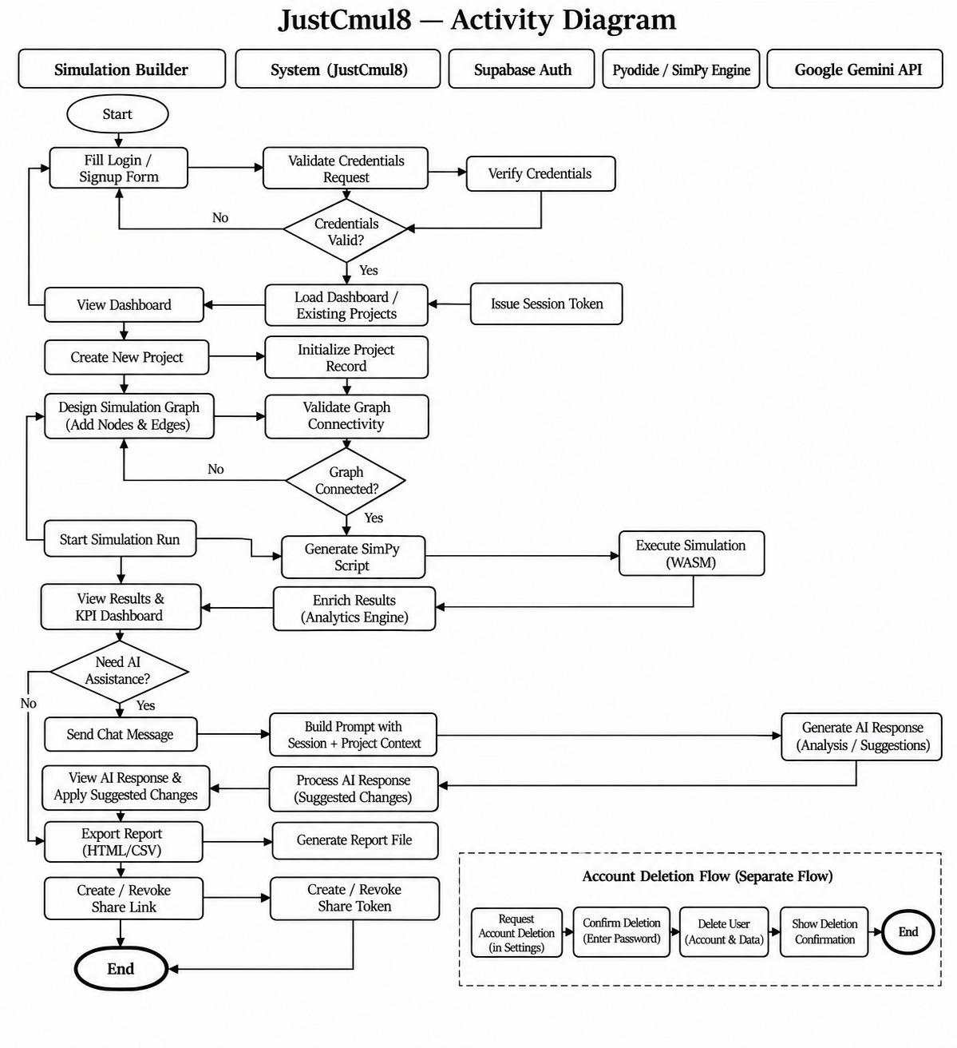
Figure 5.9: Activity Diagram of the End-to-End User Workflow
The flow begins with the user filling in the login or sign-up form. The system asks Supabase Auth to verify the credentials, and a decision node checks whether they are valid; if not, control goes back to the form. On success a session is issued and the dashboard loads with the user’s projects. The user creates a project and designs the graph, and the system validates connectivity. A second decision node sends control back to the design activity if the graph is not connected, and that loop keeps an unrunnable model away from the engine.
Once the graph is valid, the user starts the run. The system generates the SimPy script and passes it to the engine lane, where it runs as WebAssembly. Results come back to the system lane, where the analytics engine enriches them, and the user looks at the KPI dashboard. A third decision node asks whether AI assistance is wanted. If it is, the system builds a prompt with the project context, Gemini replies with analysis or suggestions, and the user may apply them, which returns control to the design activity. If not, the flow goes on to exporting a report and creating or revoking a share link before it reaches the end node. Account deletion is drawn as its own flow, because it is not part of modelling and must not be reachable by accident from inside it.

5.5.2 Component Diagram
The component diagram shows the implementation units of the system and how they depend on one another, grouped by the environment in which each one runs.

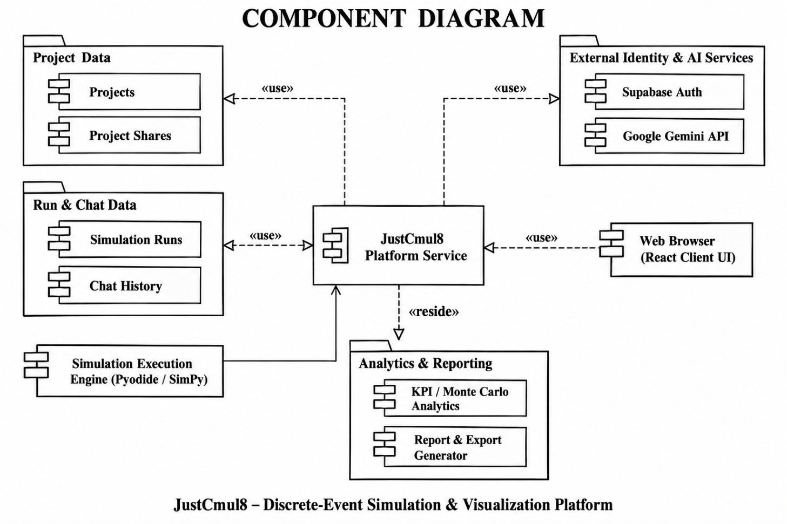
Figure 5.10: Component Diagram of the JustCmul8 Implementation
The browser client runtime has the interface components (the graph editor on React Flow, the configuration panel, the KPI dashboard on Recharts and the Pixi.js digital twin), the Zustand store, the service modules for code generation and analytics, and the export engine. Interface components depend on the store and not on each other, so a panel can be replaced or moved without touching the rest. The simulation thread is a separate group because it runs in a Web Worker. It holds the Pyodide runtime and the SimPy engine and talks to the client only by message passing, so a long simulation cannot block rendering. The server group contains the Next.js API routes (the AI routes and the share and export routes). They exist for the few operations that must not run on the client, mainly holding the Gemini API key. The external group contains the managed services.

5.5.3 Collaboration Diagram
The collaboration diagram shows the objects involved in one simulation run and the messages they pass, numbered in the order they occur.
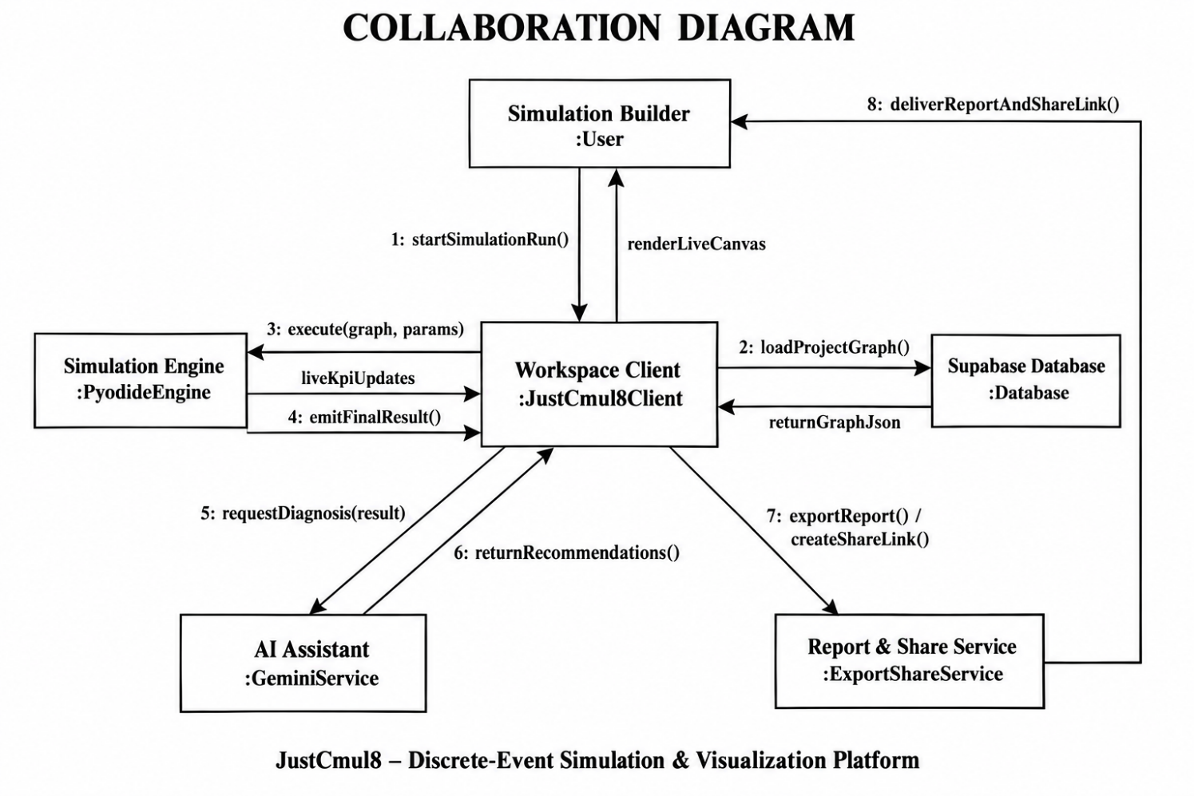
Figure 5.11: Collaboration Diagram for the Simulation Run Interaction
The interaction starts when the workspace interface calls startRun on the store with the run configuration (message 1). The store calls buildScript on the code generator and passes the current graph (2). The generated script is posted to the simulation worker (3), a message that crosses the thread boundary. Inside the worker, runPython is called on the Pyodide runtime (4), which returns the result payload (5). The trace is forwarded to the main thread, where the analytics engine receives it (6), renders KPIs on the dashboard (7) and writes the computed results into the store (8). The store saves the run through the Supabase client (9), and the dashboard shows the identified bottleneck (10). Two properties stand out. The store sits between the interface and the services, so any component that watches it sees a consistent view of the run. And saving happens after analysis, so a run is stored with its computed metrics in a single write.

5.6 Table Design
The database is a managed PostgreSQL instance. Every primary key is a UUID generated by the database. Foreign keys cascade on deletion wherever the child cannot outlive the parent, and every application table has a Row-Level Security policy. Structures whose shape depends on type (the graph, result payloads and log collections) are stored as JSONB, which keeps the relational schema small and stable and still queryable. The graph, meaning nodes with their parameters and positions plus edges, is kept as a single JSONB document on the project, which makes loading and export fast.

5.6.1 Tables
Table 5.5: Table: auth.users (managed by Supabase Auth)
Column | Data type | Constraints | Description
id | uuid | PRIMARY KEY | Unique user identifier, referenced by every application table
email | text | UNIQUE | Login email address
encrypted_password | text | None | Salted hash of the password; never stored in plain text
raw_user_meta_data | jsonb | None | Registration metadata, including the full name
created_at | timestamptz | DEFAULT now() | Account creation timestamp

Table 5.6: Table: public.profiles
Column | Data type | Constraints | Description
id | uuid | PRIMARY KEY, FK → auth.users(id) ON DELETE CASCADE | Shares the user’s identifier (one-to-one)
display_name | text | None | Name shown in the interface and on collaborator cursors
avatar_url | text | None | Profile image location
default_sim_type | text | DEFAULT 'human_queue' | Domain preselected for new projects
updated_at | timestamptz | DEFAULT now() | Last modification timestamp

Table 5.7: Table: public.projects
Column | Data type | Constraints | Description
id | uuid | PRIMARY KEY, DEFAULT gen_random_uuid() | Unique project identifier
user_id | uuid | NOT NULL, FK → auth.users(id) ON DELETE CASCADE | Owning user
name | text | NOT NULL | Display name
sim_type | text | NOT NULL, DEFAULT 'human_queue' | One of the six simulation domains
graph_json | jsonb | DEFAULT {nodes: [], edges: []} | The graph: nodes, parameters, positions and edges
updated_at | timestamptz | DEFAULT now() | Last modification timestamp

Table 5.8: Table: public.simulation_runs
Column | Data type | Constraints | Description
id | uuid | PRIMARY KEY | Unique run identifier
project_id | uuid | NOT NULL, FK → projects(id) ON DELETE CASCADE | Project that was simulated
user_id | uuid | NOT NULL, FK → auth.users(id) ON DELETE CASCADE | User who initiated the run
ran_at | timestamptz | DEFAULT now() | Run timestamp
duration_seconds | integer | None | Wall-clock execution time
sim_time_seconds | numeric | None | Simulated duration modelled
total_arrived | integer | None | Entities generated
total_completed | integer | None | Entities that reached a sink
bottleneck_node | text | None | Node identified as the constraint in this run
result_json | jsonb | None | Per-node metrics and aggregate KPIs
logs_json | jsonb | None | Sampled log events

Table 5.9: Table: public.chat_history
Column | Data type | Constraints | Description
id | uuid | PRIMARY KEY | Unique message identifier
project_id | uuid | NOT NULL, FK → projects(id) ON DELETE CASCADE | Project the exchange concerns
user_id | uuid | FK → auth.users(id) ON DELETE CASCADE | User who sent the message
role | text | NOT NULL, CHECK IN ('user', 'assistant') | Originator of the message
content | text | NOT NULL | Message text
metadata | jsonb | None | Model identifier and any graph payload the reply produced
created_at | timestamptz | DEFAULT now() | Message timestamp

Table 5.10: Table: public.project_shares
Column | Data type | Constraints | Description
id | uuid | PRIMARY KEY | Unique share record
project_id | uuid | NOT NULL, FK → projects(id) ON DELETE CASCADE | Project being shared
share_token | text | NOT NULL, UNIQUE, random 128-bit hex default | Opaque token embedded in the public URL
created_by | uuid | NOT NULL, FK → auth.users(id) ON DELETE CASCADE | Owner who created the link
created_at | timestamptz | DEFAULT now() | Creation timestamp
revoked_at | timestamptz | NULL while active | Revocation timestamp

5.6.2 Access Policies, Functions and Indexes
Table 5.11: Row-Level Security Policies
Table | Operations | Policy condition
projects | SELECT, INSERT, UPDATE, DELETE | auth.uid() = user_id
simulation_runs | SELECT, INSERT, DELETE | auth.uid() = user_id
chat_history | SELECT, INSERT, DELETE | auth.uid() = user_id
project_shares | ALL | auth.uid() = created_by
profiles | SELECT, INSERT, UPDATE | auth.uid() = id
realtime.messages | SELECT | Channel topic must be “project:” followed by a project the user owns

The schema holds some objects that carry behaviour as well as the tables and policies. get_shared_project(token) is a security-definer function that returns the name, domain and graph of one project when the given token is active. get_share_status(token) returns invalid, revoked or active. Anonymous visitors may execute these two functions and nothing else; they never get direct access to any table. handle_new_user() is a trigger function that inserts a profile row each time a new authentication user is created. Indexes on projects(user_id), projects(updated_at DESC), chat_history(project_id), chat_history(user_id) and project_shares(share_token) keep dashboard and share lookups fast.

5.6.3 Referential Integrity
- profiles.id → auth.users.id (one-to-one, cascading)
- projects.user_id → auth.users.id (cascading)
- simulation_runs.project_id → projects.id (cascading); simulation_runs.user_id → auth.users.id (cascading)
- chat_history.project_id → projects.id (cascading); chat_history.user_id → auth.users.id (cascading)
- project_shares.project_id → projects.id (cascading); project_shares.created_by → auth.users.id (cascading)
We applied cascading deletion wherever a child row means nothing without its parent. Because of that, deleting an account is a single operation that really removes the user’s data and does not leave orphans behind.

5.7 Architecture / Deployment Diagram
The deployment diagram shows the physical nodes on which the system runs and the protocols that link them.
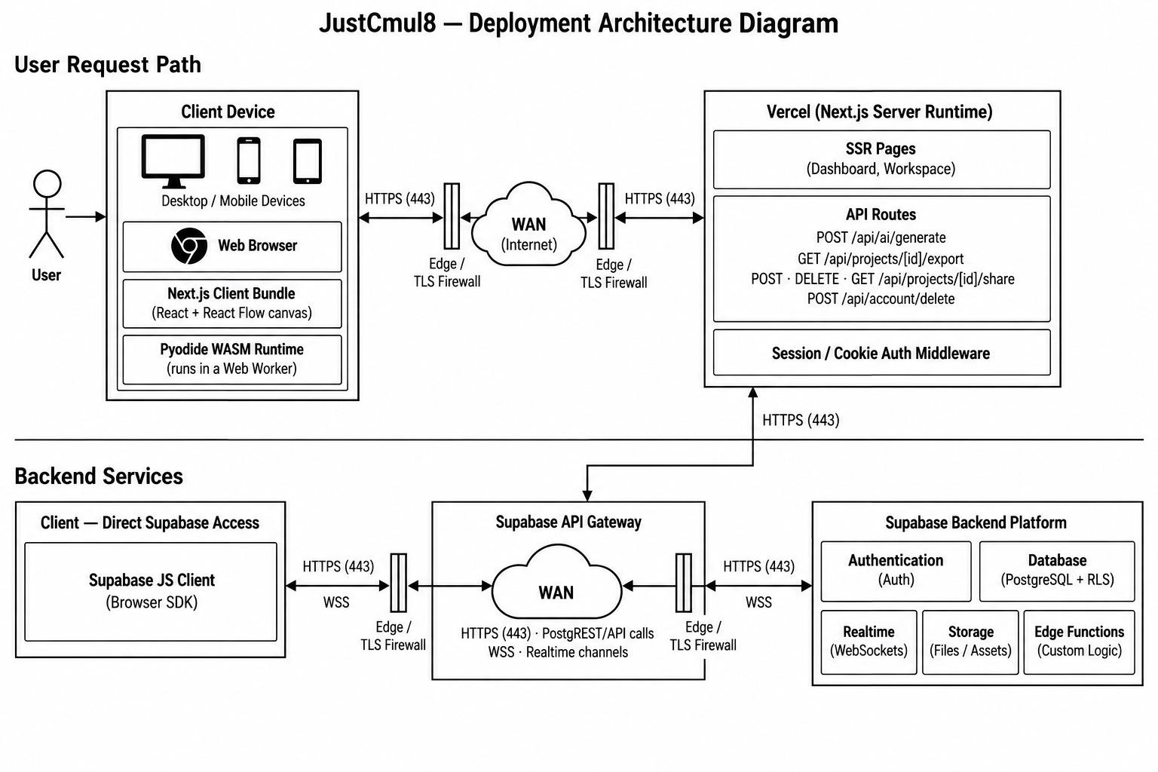
Figure 5.12: Deployment Architecture of JustCmul8
The client device hosts a web browser that runs the Next.js client bundle, containing the React application and the React Flow canvas, and beside it the Pyodide WebAssembly runtime executing in a Web Worker. The diagram makes the main architectural point plain: the simulation runtime is deployed on the user’s own device and not in a data centre.
Requests go over HTTPS, through edge TLS protection and the public internet, to the Vercel platform, which runs the Next.js server runtime. That runtime serves the dashboard and workspace pages and exposes the API routes (AI generation, chat and optimisation, project export, sharing and account deletion). It also applies session middleware. The backend services tier contains the Supabase API gateway, which is reached both from the Next.js server and directly from the browser through the Supabase client. Behind the gateway are authentication, PostgreSQL with Row-Level Security and the realtime WebSocket service.
Letting the browser reach the database directly, and not proxying every read through the application server, is safe only because Row-Level Security is enforced inside PostgreSQL. The server is kept for operations that truly need a secret, chiefly holding the Gemini API key. That keeps the deployment small and, together with client-side simulation, makes the running cost of the platform nearly independent of how heavily it is used.

6. SYSTEM IMPLEMENTATION AND METHODOLOGY
This chapter explains how the design of Chapter 5 became working software. It covers the methodology we followed, the technologies and the key algorithms, how each module and the database were implemented, how the user interface was designed, and the code fragments that show the system best.

6.1 Development Methodology
Implementation followed the iterative and incremental model of Section 3.5. We proved the engine first as a prototype spike and checked it against analytical queueing results, and only then built the modules that consume it. Each module then went through its own cycle of design, coding, unit testing and integration.
- Version control: Git with a GitHub remote. We committed in small, described steps, so the history reads as a record of the project.
- Code review: whoever did not write a module reviewed it before it was merged.
- Type safety: TypeScript throughout, so a mismatch between a node’s parameters and the code that uses them is caught at compile time.
- Separation of concerns: analytics, code generation, Monte Carlo and export are plain TypeScript modules with no interface dependency, which makes them testable on their own.
- Verification first: a separate native harness checks the simulation engine against closed-form queueing results before any interface work relies on its output.
- Continuous documentation: module documents were written beside the code and later merged into this report.

6.2 Technologies Used
Section 2.3.3 gave the technology stack with reasons. Here we describe how each technology is used in the implementation.
- Next.js 16 and React 19 handle routing, server-side rendering of the landing and authentication pages, and the API routes that proxy the AI service and issue share tokens. The workspace itself is a client-rendered single-page application.
- TypeScript covers all application and service code. The SimPy program is produced as Python text by a TypeScript module.
- React Flow implements the canvas, node handles, edges, viewport and selection, and Dagre arranges generated and template graphs.
- Pyodide loads CPython compiled to WebAssembly inside a Web Worker. The generated script runs with runPythonAsync, and results come back through callback functions registered in the Python global namespace.
- SimPy provides the event scheduler, resources, stores, containers and interrupts that the generated model is built on.
- Zustand keeps application state in slices, Recharts draws the dashboard charts and Pixi.js renders the digital twin. Framer Motion and Lenis give transitions and smooth scrolling on the landing page.
- Supabase supplies authentication (email and OAuth), PostgreSQL with Row-Level Security, and Realtime channels for presence and broadcast.
- Google Gemini is reached through a model router that keeps a priority list of models and a short-lived health record for each.
- jsPDF and html-to-image produce the executive report and capture the canvas in the browser.
- Tailwind CSS v4 styles the interface consistently through utility classes and design tokens.

6.3 Algorithms and Techniques Used

6.3.1 Graph Representation and Validation
The simulation model is a directed graph, held in memory as an adjacency list, which maps each node identifier to the list of its outbound neighbours. Simulation graphs are sparse, since a node usually has one or two successors. An adjacency matrix grows with the square of the node count no matter how few edges exist, so it would waste space. The list also suits how the engine works: routing an entity needs the successors of one node, and the list hands them over directly. Before a run, the interface walks the graph from its nodes using a visited set and reports any node that cannot be reached. A disconnected model is then refused with a message that names the node, and does not fail inside the engine.
Table 6.1: Complexity of Graph Operations on the Adjacency List
Operation | Complexity | Where it is used
Add node / add edge | O(1) | Placing and connecting nodes on the canvas
Retrieve successors | O(deg v) | Routing an entity onward
Graph traversal | O(V + E) | Connectivity validation before a run
Space occupied | O(V + E) | Whole-graph representation

6.3.2 Event Scheduling
The event queue is the central structure of any discrete event simulator. It holds events scheduled for future simulated times, and the engine keeps taking out the earliest one and processing it. SimPy builds it as a binary min-heap keyed on event time, so inserting and extracting each take logarithmic time in the number of queued events. A sorted list would make extraction constant but insertion linear, and an unsorted list does the reverse. The heap balances the two. Ties in event time are broken by a counter that only increases, so events due at the same instant are handled in the order they were created. JustCmul8 gets this behaviour from SimPy and does not reimplement it, which is exactly the reuse the architecture is meant to allow.

6.3.3 Random Variate Generation
Variability comes from sampling inter-arrival and service times from the five distributions in Table Table 1.2. In the generated script the exponential distribution uses random.expovariate(1/mean). The normal distribution uses random.gauss truncated at zero, since a negative service time has no physical meaning. The uniform distribution spans mean ± 50 per cent, and the deterministic distribution returns the mean unchanged. Routing at decision nodes uses cumulative-probability sampling: a uniform variate is drawn and compared with the running sum of the configured route probabilities. Source nodes can spread arrivals over several successors in round-robin order.

6.3.4 Metric Computation
Utilisation is found by accumulating busy-seconds. Whenever the number of busy servers changes, the time since the last change is multiplied by the previous busy count and added to a running total. Utilisation is that total divided by capacity times run duration. Waiting time is the gap between an entity joining a queue and starting service, and percentiles come from the real per-entity samples. To keep memory bounded on long runs, entity logs are reservoir-sampled: we keep a uniform random sample of whole entity journeys and not just the first part of the run, which would bias the tail percentiles.
The Little’s Law check compares the time-averaged number of entities in the system with the arrival rate multiplied by the mean time in the system. It reports the percentage discrepancy and classifies the run as steady-state, transient or accumulating backlog. The bottleneck is the resource or queue node with the highest average waiting time. The system health score is a weighted composite of four components, as set out in Table Table 4.4:
Health = Completion (35%) + Utilisation balance (30%) + Stability (20%) + Tail latency (15%)
A maximum utilisation above 88 per cent, and again above 95 per cent, reduces the utilisation component step by step. An unstable or inconsistent Little’s Law result lowers the stability component, and a 99th-percentile wait more than five times the median lowers the tail component.

6.3.5 Monte Carlo Confidence Intervals
For each metric we compute the mean and the sample standard deviation across replications, and the 95 per cent confidence interval is:
CI = x̄ ± 1.96 × ( s / √n )
where x̄ is the sample mean, s the sample standard deviation and n the number of replications.
The half-width shrinks with the square root of n, so four times as many replications halve the interval. That is why the interface offers presets of 10, 20, 50 and 100 and not a free-entry field.

6.3.6 AI Model Routing
The AI features go through a model router and not a hard-coded model. The router keeps a priority list of Gemini models and sorts every failure into unavailable, rate-limited or empty response. A failing model is marked unhealthy for a short time-to-live, so later requests skip it and go straight to the next candidate. The assistant thus fails over automatically without the user doing anything, and a model that the provider retires does not take the feature down. Generated graphs are validated before display, and every recommendation is put forward for approval.

6.3.7 Presence and Broadcast
Collaboration relies on two channel mechanisms. Presence tracks who is in the project: each client publishes a small payload (identifier, name, colour, selected and edited node) and receives the merged state of everyone else. Broadcast carries short-lived messages, namely cursor positions and graph operations, to the other clients, which ignore messages that they sent themselves. Cursor colours are derived from the user identifier, so the same person always shows up in the same colour.

6.4 Module-wise Implementation
The table relates each module to the size of its implementation. Line counts cover the module’s source files and come from the delivered code base.
Table 6.2: Module-wise Implementation Summary
Module | Principal implementation | Approx. lines
1 Platform and Data Layer | Auth pages, dashboard, settings, middleware, Supabase clients, account deletion route | ≈ 3,850 (app/)
2 Visual Graph Editor | NodeCanvas (951), NodePalette, layoutEngine, simTypeRegistry (715) | ≈ 1,900
3 Node Configuration Panel | NodePropertiesPanel (1,109), shared types (514) | ≈ 1,600
4 Simulation Engine | codeGenerator (783), pyodideEngine/Worker, clientEngine, CodeInspectorPanel | ≈ 1,300
5 AI Assistant | AIChatPanel (962), chat and generate routes, systemPrompt, graphOps (739), modelRouter (370) | ≈ 2,750
6 AI System Optimiser | optimize route (182), flowAnalysis (268) | ≈ 450
7 KPI Dashboard and Results | analyticsEngine (806), resolveKpiMetrics, SimResultsPanel (1,047), AdvancedResultsDashboard, eight result tabs | ≈ 4,400
8 Monte Carlo and Scenarios | monteCarlo (132), monteCarloRunner, MonteCarloPanel (778) | ≈ 970
9 Digital Twin Playback | DigitalTwinCanvas (366), PlaybackControls, timelineSelectors | ≈ 510
10 Template Gallery | TemplateGallery (135), templates in simTypeRegistry | ≈ 850
11 Executive Report and Share | pdfReportGenerator (235), reportGenerator, jupyterExport, share modal, viewer, share/export routes | ≈ 700 (excl. API routes)
12 Real-Time Collaboration | usePresence (143), LiveCursor | ≈ 160

6.5 Database Implementation
The schema lives in one SQL script that can be run repeatedly, because every statement uses IF NOT EXISTS or a guarded block. Tables come first, then Row-Level Security is enabled on each, policies are added in guarded blocks, and indexes, functions and the profile trigger finish the script. The excerpt shows the projects table and its policies; the other tables follow the same pattern.
Listing 6.1: Projects table and Row-Level Security policies
CREATE TABLE IF NOT EXISTS public.projects (
id uuid primary key default gen_random_uuid(),
user_id uuid not null references auth.users(id) on delete cascade,
name text not null,
sim_type text not null default 'human_queue',
graph_json jsonb default '{"nodes": [], "edges": []}'::jsonb,
updated_at timestamptz default now()
);

ALTER TABLE public.projects ENABLE ROW LEVEL SECURITY;

CREATE POLICY "Users can view their own projects"
ON public.projects FOR SELECT USING (auth.uid() = user_id);
CREATE POLICY "Users can update their own projects"
ON public.projects FOR UPDATE
USING (auth.uid() = user_id) WITH CHECK (auth.uid() = user_id);

Public sharing never gives anonymous users access to a table. A share token is looked up inside a security-definer function, which returns only the fields needed to draw the project:
Listing 6.2: Read-only public access through a security-definer function
CREATE OR REPLACE FUNCTION public.get_shared_project(token text)
RETURNS TABLE (name text, sim_type text, graph_json jsonb) AS $$
SELECT p.name, p.sim_type, p.graph_json
FROM public.projects p
JOIN public.project_shares s ON s.project_id = p.id
WHERE s.share_token = token AND s.revoked_at IS NULL
LIMIT 1;
$$ LANGUAGE sql SECURITY DEFINER STABLE;

GRANT EXECUTE ON FUNCTION public.get_shared_project(text)
TO anon, authenticated;

6.6 User Interface Design
The interface rests on three ideas: plain language, low cognitive load and familiar interaction. Words come from the user’s field and not from simulation theory. A bank model offers a “Teller” and a “Waiting Line”, a factory model a “Machine” and a “Buffer”, and the result tabs are named after what they show: Executive Summary, Traffic Heatmap, Line Buildup Timeline, Station Counters, Person / Item Journey, Live Activity Log and Cost and ROI. The workspace has three regions. A node palette sits on the left, the canvas in the middle, and on the right a contextual panel that switches between node configuration, AI chat, results and Monte Carlo analysis depending on what the user is doing.
The landing page states the offer, which is simulation with no installation, no licence and no code, and leads to registration. The visual identity uses a restrained neutral palette with one accent, smooth scrolling and some motion for polish, and a responsive layout keeps the interface usable on tablets and phones. Error messages are written as instructions that name the offending node and say how to fix it.
[ SCREENSHOT PLACEHOLDER ]
Insert a screenshot of the JustCmul8 landing page (hero section with headline and call-to-action buttons).
Figure 6.1: Landing Page
[ SCREENSHOT PLACEHOLDER ]
Insert a screenshot of the Login / Sign-up page showing email fields and the Google and GitHub sign-in buttons.
Figure 6.2: Registration and Login Screens
[ SCREENSHOT PLACEHOLDER ]
Insert a screenshot of the Project Dashboard listing the user’s projects with domain, last-modified time and the New Project control.
Figure 6.3: Project Dashboard
[ SCREENSHOT PLACEHOLDER ]
Insert a screenshot of the Workspace: node palette on the left, canvas with a connected model in the centre, toolbar with Run controls at the top and a side panel on the right.
Figure 6.4: Workspace with the Visual Graph Editor
[ SCREENSHOT PLACEHOLDER ]
Insert a screenshot of the Node Configuration Panel for a Resource node (capacity, service-time distribution, cost parameters).
Figure 6.5: Node Configuration Panel
[ SCREENSHOT PLACEHOLDER ]
Insert a screenshot of the Template Gallery showing starter models grouped by the six domains.
Figure 6.6: Template Gallery

6.7 Important Code Snippets
Here we reproduce the pieces of code that best show how the system works. Each comes straight from the delivered source and has a short explanation.

6.7.1 Distribution Sampling in the Generated SimPy Script
The generated program has one sampling function that every source and resource calls. It shows how the five distributions of Table Table 1.2 are realised, including the truncation of the normal distribution at zero.
Listing 6.3: Distribution sampler in the generated script (codeGenerator.ts)
def sample(dist_type, mean, std=None):
if dist_type == "exponential":
return random.expovariate(1.0 / mean) if mean > 0 else 0
elif dist_type == "uniform":
return random.uniform(mean * 0.5, mean * 1.5)
elif dist_type == "normal":
s = std if std is not None else mean * 0.3
return max(0, random.gauss(mean, s))
elif dist_type == "deterministic":
return max(0, mean)
elif dist_type == "poisson":
return random.expovariate(1.0 / mean) if mean > 0 else 0

6.7.2 Resource Service with Busy-Time Accounting
This fragment is the heart of the model: an entity waits, seizes a server, is served for a sampled time and releases the server. Busy time is added up whenever the busy count changes, which makes the reported utilisation exact and not sampled. The comment records a correction we made to the design. The next hop is returned to the caller so that the server is released before the entity moves on, which stops the server being held for the rest of the entity’s journey.
Listing 6.4: Resource service and utilisation accounting (excerpt)
def do_resource_service(env, eid, node_id, cfg, s, resources,
queued_at, queue_stats=None):
params = cfg["params"]
wait_time = env.now - queued_at
s["waits"].append(wait_time)
if s["busyCount"] > 0:
s["busy_seconds"] += (env.now - s["last_busy_change"]) * s["busyCount"]
s["last_busy_change"] = env.now
s["busyCount"] += 1
svc_time = sample(params.get("serviceDistribution", "exponential"),
params.get("serviceTimeMean", 1))
yield env.timeout(svc_time)
s["busy_seconds"] += (env.now - s["last_busy_change"]) * s["busyCount"]
s["last_busy_change"] = env.now
s["busyCount"] -= 1
s["entitiesOut"] += 1
return get_next_target(node_id) # caller releases the server first

6.7.3 Running Python in the Browser
The worker gets a start message, generates the script from the graph, registers two callbacks in Python’s global namespace and runs the script. The callbacks are ordinary JavaScript functions, so the Python code can stream ticks and hand over its result with no network traffic.
Listing 6.5: Executing the generated SimPy script in the Web Worker (pyodideWorker.ts)
case "start": {
const { python } = generateSimPyScript(
params.graph, params.durationSeconds, params.tickIntervalSeconds);

pyodide.globals.set("emit_sim_tick", (tickJson: string) => {
if (!stopped) emit(JSON.parse(tickJson));
});
pyodide.globals.set("emit_sim_result", (resultJson: string) => {
if (!stopped) emit(JSON.parse(resultJson));
});

await pyodide.runPythonAsync(python); // SimPy runs in WebAssembly
break;
}

6.7.4 Confidence Interval Computation
Listing 6.6: Monte Carlo 95% confidence interval (monteCarlo.ts, abbreviated)
export function computeConfidenceInterval(samples: number[]): RunStatistic {
const n = samples.length;
const mean = samples.reduce((a, b) => a + b, 0) / n;
const variance =
samples.reduce((a, b) => a + (b - mean) ** 2, 0) / (n - 1);
const stdDev = Math.sqrt(variance);
const marginOfError = 1.96 * (stdDev / Math.sqrt(n));
return {
mean,
ciLower: Math.max(0, mean - marginOfError),
ciUpper: mean + marginOfError,
stdDev, samples,
};
}

6.7.5 System Health Score
Listing 6.7: Composite system health score (analyticsEngine.ts, abbreviated)
const completionScore = Math.min(1, completed / arrived) * 35;

let utilScore = 30; // utilisation balance
if (maxUtil > 0.95) utilScore = 15; // severe bottleneck
else if (maxUtil > 0.88) utilScore = 22;

let stabilityScore = 20; // Little's Law consistency
if (!littlesLaw.isStable) stabilityScore = 5;
else if (littlesLaw.discrepancyPercent > 20) stabilityScore = 12;

let tailScore = 15; // tail latency
if (waitStats.p99 > waitStats.p50 * 5) tailScore = 8;

return clamp(Math.round(completionScore + utilScore +
stabilityScore + tailScore), 10, 100);

Taken together, the fragments show the shape of the platform: a small, readable SimPy program produced from a diagram, a worker that runs it without touching the network, analytics that turn its output into checkable indicators, and a database that decides who may see what.

7. SYSTEM TESTING
A simulator can be easy to use and still give wrong answers, so testing carries extra weight in this project. Interface tests can show that a button works, but only a comparison with independent mathematics can show that the numbers behind it are right. We therefore tested in two halves: verification of the engine against analytical results and invariants, and functional testing of the application around it. The chapter describes the strategy, the units under test, the test cases, the approach and the results.

7.1 Testing Strategy
Testing ran beside development and not after it, for the reason given in Chapter 3: a defect in an early module is cheaper to fix while the modules built on it are still being written. The strategy is layered, with fast, narrow tests at the bottom and broader, slower checks above them.
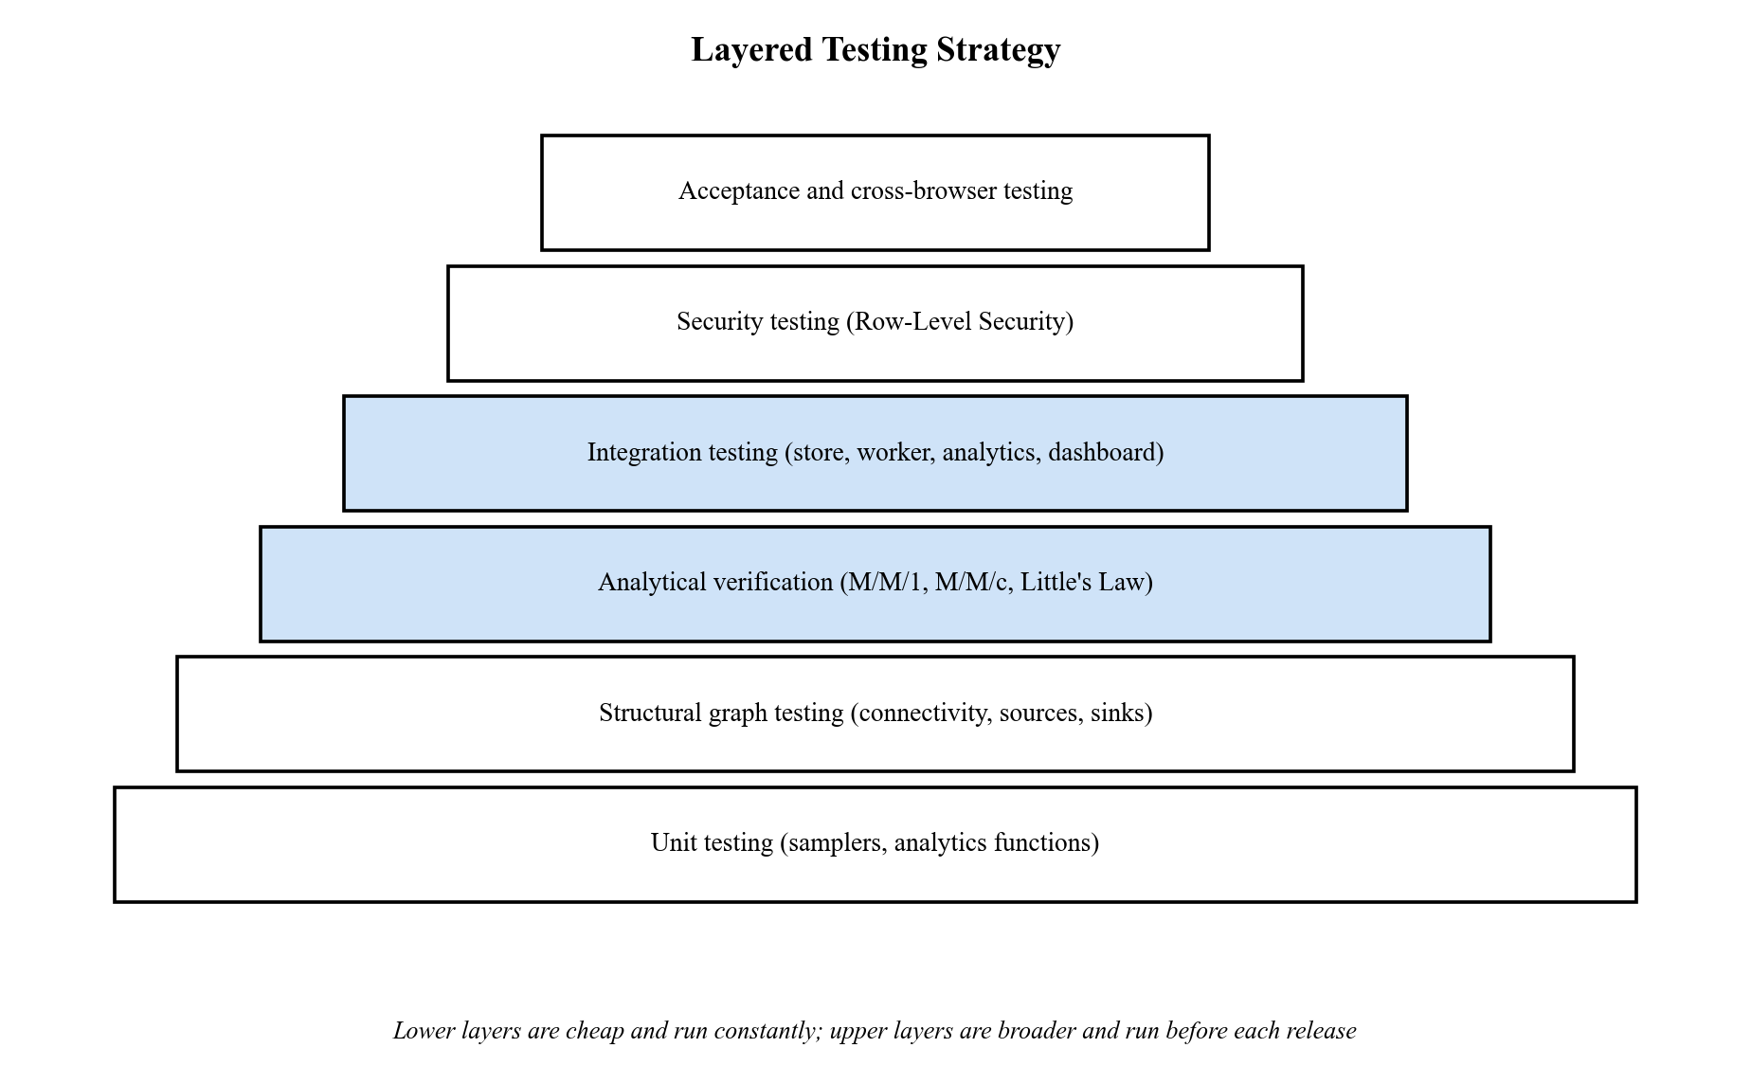
Figure 7.1: Layered Testing Strategy for JustCmul8
- Unit testing runs the pure TypeScript modules, namely the samplers and the analytics functions, in isolation.
- Structural graph testing checks that invalid models (no blocks, no connections, unreachable nodes) are refused before execution, with a message that names the fault.
- Analytical verification is the most valuable layer. The engine’s output for reference queues is compared with closed-form M/M/1 and M/M/c results and with Little’s Law.
- Invariant testing applies conservation and flow-balance laws to a complex multi-stage model that has no closed-form answer.
- Integration testing covers the paths that cross module boundaries: store, code generator, worker, analytics and dashboard.
- Security testing attacks authorisation directly at the database and bypasses the interface.
- Cross-browser and acceptance testing checks that behaviour is the same across browsers and that a first-time user gets a result without a tutorial.

7.2 Testable Units
Table 7.1: Testable Units and the Techniques Applied to Them
Unit | Location | What is tested | Technique
Distribution samplers | codeGenerator.ts (generated sample), distributions.ts | Mean, spread and truncation of each of the five distributions | Statistical unit test
Code generator | lib/simulation/codeGenerator.ts | Every node type produces valid, executable SimPy | Execution of generated script
Analytics engine | lib/simulation/analyticsEngine.ts | Utilisation, waits, percentiles, Little’s Law, health score | Known-answer test; analytical oracle
Monte Carlo aggregation | lib/simulation/monteCarlo.ts | Mean, standard deviation and 95% interval | Known-answer test
Graph validation | NodeCanvas.tsx (validateGraphConnectivity) | Empty, unconnected and partially connected graphs | Boundary and negative testing
Graph operations | lib/ai/graphOps.ts | Validation of AI-generated graphs | Negative testing with malformed input
Model router | lib/ai/modelRouter.ts | Fail-over between models on error classes | Fault injection
Database policies | supabase/schema.sql | Row-Level Security and share functions | Direct-request security testing
Presence channel | lib/realtime/usePresence.ts | Join authorisation, presence, cursor broadcast | Multi-session integration test
Export modules | pdfReportGenerator.ts, jupyterExport.ts | Content of PDF, CSV, JSON and notebook exports | Output inspection

7.3 Test Case Design with Reference to the Project
We designed two families of test cases. Engine verification cases take their expected results from queueing theory and produce numerical outcomes. Functional test cases for the application state expected behaviours that trace back to the requirements of Section 2.1.

7.3.1 Engine Verification Cases
The verification suite runs the generated SimPy script verbatim, with five independent replications per benchmark over 36,000 simulated seconds, and compares the results with theory. B1 is an M/M/1 queue at utilisation 0.8. B1v repeats it without an explicit queue node. B2 is an M/M/3 queue, and B3 is a deliberately saturated queue. B4 checks how time units are handled, and B5 checks Little’s Law. Each deviation is judged against a tolerance stated in advance.
Table 7.2: Engine Verification Test Cases and Results
ID | Benchmark | Metric | Theory | Simulated | Dev. | Tol. | Result
E-01 | B1 M/M/1 | Utilisation ρ | 0.8000 | 0.7979 | −0.27% | ±3.5% | Pass
E-02 | B1 M/M/1 | Queue wait Wq | 4.000 | 4.005 | +0.13% | ±3.5% | Pass
E-03 | B1 M/M/1 | System time W | 5.000 | 5.004 | +0.08% | ±3.5% | Pass
E-04 | B1 M/M/1 | Queue length Lq | 3.200 | 3.188 | −0.39% | ±3.5% | Pass
E-05 | B1 M/M/1 | Percentiles from real samples (4,000 points) | real | real | n/a | n/a | Pass
E-06 | B1 M/M/1 | WIP conservation (arrived − completed) | 3.8 | 3.8 | n/a | n/a | Pass
E-07 | B1 M/M/1 | Source node arrivals reported | 28,584 | 28,584 | n/a | n/a | Pass
E-08 | B1v (no queue) | Utilisation ρ | 0.8000 | 0.7979 | −0.27% | ±3.5% | Pass
E-09 | B1v (no queue) | Queue wait Wq | 4.000 | 4.005 | +0.13% | ±3.5% | Pass
E-10 | B1v (no queue) | System time W | 5.000 | 5.004 | +0.08% | ±3.5% | Pass
E-11 | B1v (no queue) | System WIP L | 4.000 | 3.980 | −0.51% | ±3.5% | Pass
E-12 | B2 M/M/3 | Utilisation per server | 0.8000 | 0.7983 | −0.21% | ±4.0% | Pass
E-13 | B2 M/M/3 | Queue wait Wq (Erlang-C) | 1.079 | 1.101 | +2.09% | ±4.0% | Pass
E-14 | B2 M/M/3 | System time W | 2.079 | 2.100 | +1.03% | ±4.0% | Pass
E-15 | B3 saturated | Total arrivals | 1,200 | 1,181 | −1.55% | ±5.0% | Pass
E-16 | B3 saturated | Total completed | 600 | 603.2 | +0.53% | ±5.0% | Pass
E-17 | B3 saturated | Utilisation ρ | 1.000 | 0.9968 | −0.32% | ±2.0% | Pass
E-18 | B3 saturated | Final WIP within 600 ± 70 | 530–670 | 578.2 | n/a | 2σ | Pass
E-19 | B3 saturated | Little’s Law verdict (accumulating backlog) | backlog | backlog | n/a | n/a | Pass
E-20 | B3 saturated | Health score degrades below 70 | < 70 | 45.8 | n/a | n/a | Pass
E-21 | B4 time units | Run horizon identical in seconds, minutes, hours | 3,600 | 3,600 / 3,600 / 3,600 | n/a | n/a | Pass
E-22 | B4 time units | Tick interval identical across units | 3.6 | 3.6 / 3.6 / 3.6 | n/a | n/a | Pass
E-23 | B4 time units | Arrival-count spread across units | < 1% | 0.000% | n/a | n/a | Pass
E-24 | B4 time units | Tick granularity for a 5 s run | ≤ 0.1 s | 0.05 s (100 ticks) | n/a | n/a | Pass
E-25 | B5 Little’s Law | Discrepancy between L and λW | < 5% | 2.41% | n/a | n/a | Pass
E-26 | B5 Little’s Law | Time-averaged true WIP | 4.000 | 3.982 | −0.46% | ±8.0% | Pass
E-27 | B5v (no queue) | Little’s Law discrepancy | < 5% | 2.41% | n/a | n/a | Pass
E-28 | B5v (no queue) | Time-averaged true WIP | 4.000 | 3.982 | −0.46% | ±8.0% | Pass

7.3.2 Invariant Cases for a Complex Multi-Stage Model
Benchmark B6 is a hospital-flow model with a triage station and a probabilistic decision node that sends 70 per cent of patients to minor treatment and 30 per cent to major treatment, ending in two sinks. We ran it with and without patient abandonment (reneging), at an arrival rate of 1.2 per second over 7,200 simulated seconds. No closed-form answer exists for it, so the test asserts invariants, which are laws that every correct simulation must obey.
Table 7.3: Invariants Asserted for the Complex Model (Benchmark B6)
ID | Invariant | Meaning
I1 | Conservation residual ≥ 0 and below 5% of arrivals | Arrived = completed + reneged + dropped + stuck; nothing is created or lost
I2 | Flow balance at every node | Entities in = entities out + current depth
I3 | Decision split equals the configured probability | 70/30 routing is honoured (observed 0.700 with abandonment on, 0.687 off)
I4 | Total completed equals the sum over all sinks | Sink accounting is complete
I5 | Throughput clears offered load (≥ 95%) | Stable stations serve what they are offered
I6 | Per-station utilisation approximates ρ | Triage ≈ 0.72, minor ≈ 0.70, major ≈ 0.72

7.3.3 Functional Test Cases
The functional cases below cover every module, and each one names the requirement it verifies. The Status column is for the tester to fill in as each case is run (Pass or Fail, with the date).
Table 7.4: Functional Test Case Design
ID | Module | Test scenario and input | Expected output | Req. | Status
TC-01 | Platform | Register with a valid, unused email and a compliant password | Account created, profile row inserted, session started | FR-01
TC-02 | Platform | Register with an already-registered email | Registration refused with a clear message | FR-01
TC-03 | Platform | Register with a weak password | Submission blocked; requirement shown | FR-01
TC-04 | Platform | Log in with correct credentials | Session issued; dashboard loads the user’s projects | FR-01
TC-05 | Platform | Log in with a wrong password | Access refused without revealing which field was wrong | FR-01
TC-06 | Platform | Sign in with Google and with GitHub OAuth | Account linked; session established | FR-01
TC-07 | Platform | Open a workspace URL while logged out | Redirected to login before any data is fetched | FR-02
TC-08 | Platform | Request a password reset and set a new password | Email link works; new password accepted | FR-03
TC-09 | Platform | Create a project in a chosen domain | Project appears on the dashboard with the domain | FR-04
TC-10 | Platform | Rename and delete a project | Name changes; deletion removes project and its runs and chats | FR-04
TC-11 | Platform | Move a node, then reload the page | Position persisted without an explicit save | FR-05
TC-12 | Platform | Query another user’s project by identifier | Row-Level Security returns no rows | NFR-05
TC-13 | Platform | Delete the account after confirmation | User row and all owned data removed | FR-06
TC-14 | Graph Editor | Place each of the fifteen node types | Every node renders with correct icon, handles and defaults | FR-07
TC-15 | Graph Editor | Connect two nodes and move one | Edge created and re-routes live | FR-08
TC-16 | Graph Editor | Delete a mid-graph node | Node and incident edges removed together | FR-07
TC-17 | Graph Editor | Run an empty canvas / an unconnected graph | Run refused; message explains the fault | FR-09
TC-18 | Graph Editor | Run a graph with a node unreachable from the rest | Run refused; the disconnected node is named | FR-09
TC-19 | Node Config | Enter capacity 0 or a negative value | Value rejected with a corrective message | FR-11
TC-20 | Node Config | Switch the service distribution | Parameter fields change to match | FR-10
TC-21 | Node Config | Enter routing probabilities not summing to one | Warning shown before the run | FR-11
TC-22 | Engine | Run a valid single-server model | Run completes; arrivals, completions and KPIs reported | FR-12
TC-23 | Engine | Run the same model with duration in seconds, minutes and hours | Equivalent horizons produce equivalent results | FR-13
TC-24 | Engine | Interact with the canvas during a long run | Interface remains responsive | FR-14
TC-25 | Engine | Stop a run part-way; change playback speed | Run halts; speed changes apply | FR-15
TC-26 | Engine | Open the code inspector and export the notebook | Readable SimPy shown; .ipynb downloads and runs | FR-25
TC-27 | AI Assistant | Describe “a clinic with two doctors and a waiting room” | Valid graph proposed with source, queue, resource, sink | FR-16
TC-28 | AI Assistant | Inject a response with an unknown node type | Candidate rejected by validation; not displayed | FR-17
TC-29 | AI Assistant | Generate, then discard the preview | Project remains unmodified | FR-17
TC-30 | AI Assistant | Make the preferred model unavailable | Router falls back to the next model | FR-17
TC-31 | AI Optimiser | Diagnose a deliberately under-provisioned server | Correct node identified with a capacity recommendation | FR-18
TC-32 | AI Optimiser | Apply the suggested fix | Graph updated as an ordinary edit | FR-18
TC-33 | KPI Dashboard | Three-stage line with one slow stage | Slow stage flagged as bottleneck | FR-20
TC-34 | KPI Dashboard | Open the Flow and Balance Check for a stable model | Little’s Law discrepancy shown with a steady-state verdict | FR-20
TC-35 | KPI Dashboard | Enter cost parameters and open Cost and ROI | Total cost and the return of a change are reported | FR-21
TC-36 | Monte Carlo | Run 20 replications | Mean, standard deviation and 95% interval per metric | FR-22
TC-37 | Monte Carlo | Apply a fix, then compare baseline and scenario | Per-metric difference shown with both intervals | FR-22
TC-38 | Digital Twin | Play back a completed run; scrub and change speed | Entities animate; position changes without re-running | FR-23
TC-39 | Templates | Instantiate one template from each domain | Canvas pre-populated; every template runs unmodified | FR-24
TC-40 | Templates | Instantiate, then modify the new project | Source template unchanged | FR-24
TC-41 | Export / Share | Export graph as JSON and results as CSV | Files download with correct content | FR-25
TC-42 | Export / Share | Generate the executive PDF report | PDF contains summary, canvas snapshot and KPI tables | FR-25
TC-43 | Export / Share | Open a share link in a private window | Project renders read-only with no editing controls | FR-26
TC-44 | Export / Share | Attempt a direct write using only a share token | Refused by the database | FR-26
TC-45 | Export / Share | Open a revoked share link | Explanatory notice shown instead of an error | FR-26
TC-46 | Collaboration | Open one project in two sessions | Presence and live cursors appear in both | FR-27
TC-47 | Collaboration | Try to join a project channel without access | Channel not joined | FR-27
TC-48 | Cross-browser | Run one model on Chrome, Edge, Firefox and Safari | Consistent metrics; canvas and playback render correctly | NFR-08
TC-49 | Responsiveness | Load the workspace at a phone viewport | Layout adapts; panels remain reachable | NFR-08
TC-50 | Profile | Change display name and default domain | Values persist and apply to new projects | FR-06

7.4 Test Approach
- Oracle-based testing. For the engine, expected values come from mathematics and not from an earlier run: closed-form M/M/1 and Erlang-C results, Little’s Law and conservation laws. This avoids a test that only records whatever the code happens to do today.
- Replication and confidence. Every analytical benchmark runs five independent replications and reports a 95% interval, so a pass reflects how the engine behaves and not the luck of one run.
- Tolerance discipline. Tolerances were fixed beforehand and differ by benchmark: tighter for utilisation, looser for waiting times, which vary more.
- Invariant testing. Where no closed-form answer exists, we assert laws that must always hold.
- Negative and boundary testing. Zero and negative parameters, zero duration, empty graphs, unreachable nodes and malformed AI responses were fed in on purpose.
- Adversarial security testing. Authorisation was tested with requests sent straight to the database, skipping the interface: reading another user’s project, writing with only a share token, and joining a channel without access.
- Cross-environment testing. One model is run on several browsers and the metrics compared, and layout is checked at phone widths.
- User acceptance testing. People matching the personas of Section 2.1.7 are asked to build and run a model without instructions. The aim is to confirm that a first result is reachable without a tutorial, which is the real test of the no-code claim.
- Defect management. Each defect is logged as an issue in the project tracker, fixed, re-tested and linked to the change that closed it.
Entry and exit criteria. A module enters integration testing once its unit tests pass and it has been reviewed. The build leaves testing when every engine verification case passes, no high-severity defect is open, and every functional test case has been run and recorded.

7.5 Test Results and Validation

7.5.1 Engine Verification Results
All 28 of 28 analytical checks passed. In the M/M/1 benchmark the simulated utilisation was 0.7979 against a theoretical 0.8000, the mean queue wait 4.005 s against 4.000 s and the mean system time 5.004 s against 5.000 s. The 95% confidence interval of each estimate contained the theoretical value. In the three-server benchmark the simulated queue wait was 1.101 s against an exact Erlang-C value of 1.079 s, a deviation of 2.09 per cent and within the ±4 per cent tolerance. In the hospital-flow model all 22 of 22 invariants held, with and without patient abandonment. No deviation from theory exceeded 2.1 per cent.
Two things from this exercise are worth recording. The exact Erlang-C probability of waiting for three servers at an offered load of 2.4 is 0.6472, which gives an exact waiting time of 1.0787 s, so we scored the benchmark against the exact value and not against a rounded figure from a planning brief. And the saturated benchmark showed that the analytics react correctly to overload: the health score fell to 45.8 and the Little’s Law verdict became accumulating backlog, so a failing system is reported as failing.

7.5.2 Edge-Case Probes
We also ran a set of edge-case probes to see how the engine behaves at the limits of its inputs.
Table 7.5: Edge-Case Probes and Observed Behaviour
Probe | Observed behaviour
Zero service time | Run completes; 39 completed with utilisation 0.000, as expected
Zero duration | Rejected by the engine with a clear error
Zero arrival rate | Recorded for input-validation hardening: the sampler falls back to a default rate
Recurring schedule at time zero | A guard prevents an unbounded zero-delay loop
Very long run (28,714 entities) | Completed in 3.65 s; log retention capped at 20,000 events using an entity reservoir
Floating-point accumulation over 36,000 ticks | Simulated clock reached exactly 36,000.0
Multiple sinks | Both sinks counted (240 + 240 = 480 completed)
Two resources in series (ρ = 0.5 each) | Backlog of 2 over 1,768 arrivals; the first stage remains seized while the entity is in the second stage (blocking after service), which the model documents

7.5.3 Validation against Requirements
Validation asks whether we built the right system. The traceability table links each group of requirements to the evidence behind it.
Table 7.6: Requirements Traceability
Requirement group | Evidence
FR-01 – FR-06 Platform | Functional cases TC-01 – TC-13, TC-50; database policies and cascade rules in schema.sql
FR-07 – FR-11 Editor and configuration | Cases TC-14 – TC-21; graph validation module
FR-12 – FR-15 Engine | Engine cases E-01 – E-28; functional cases TC-22 – TC-26
FR-16 – FR-18 AI | Cases TC-27 – TC-32; graph validation and model router
FR-19 – FR-21 Analytics | Engine cases E-01 – E-28; invariants I1 – I6; cases TC-33 – TC-35
FR-22 Monte Carlo | Cases TC-36 – TC-37; confidence-interval unit test
FR-23 – FR-24 Playback and templates | Cases TC-38 – TC-40
FR-25 – FR-26 Export and share | Cases TC-41 – TC-45; security-definer share functions
FR-27 Collaboration | Cases TC-46 – TC-47; channel authorisation policy
NFR-03 Correctness | All 28 analytical checks within tolerance; 22 of 22 invariants
NFR-05 Access control | TC-12, TC-44, TC-47

8. RESULTS AND DISCUSSION
This chapter shows what the system produces and what the results mean. It starts with the outputs a user sees, then analyses the numerical results from the verification exercise, and ends with an evaluation of performance.

8.1 System Output
The delivered interface is documented below screen by screen, in the order a user meets the results of a run. Each entry says what the screen shows, and a placeholder marks where the matching screenshot from the running application should go.
When a run finishes, the Executive Summary shows the headline figures (arrivals, completions, throughput, the flagged bottleneck and the 0–100 system health score) with a plain-English diagnosis and suggested actions. A non-specialist can read the answer without having to interpret a chart.
[ SCREENSHOT PLACEHOLDER ]
Insert a screenshot of the Executive Summary tab showing the KPI tiles, system health score and the plain-English diagnosis.
Figure 8.1: Executive Summary Tab of the Results Dashboard
The Flow and Balance Check applies Little’s Law and a conservation check to see whether the run is consistent with itself. It reports the gap between L and λW and labels the system steady-state, transient or accumulating backlog.
[ SCREENSHOT PLACEHOLDER ]
Insert a screenshot of the Flow & Balance Check tab showing the Little’s Law verification and stability verdict.
Figure 8.2: Flow and Balance Check (Little’s Law Verification)
The Traffic Heatmap lays the load carried by each node and edge over the model, so congested stations can be spotted at a glance.
[ SCREENSHOT PLACEHOLDER ]
Insert a screenshot of the Traffic Heatmap tab showing the model with congestion highlighted.
Figure 8.3: Traffic Heatmap
The Line Buildup Timeline plots queue length against simulated time and shows whether a queue is stable, cyclical or growing without limit.
[ SCREENSHOT PLACEHOLDER ]
Insert a screenshot of the Line Buildup Timeline tab showing queue length against simulated time.
Figure 8.4: Line Buildup Timeline
Station Counters list the utilisation, average and percentile waiting times, throughput and queue depth of every node.
[ SCREENSHOT PLACEHOLDER ]
Insert a screenshot of the Station Counters tab showing per-node utilisation, waiting time and throughput.
Figure 8.5: Station Counters
The Person / Item Journey tab follows one entity through the model and lists each node it visited with the time it waited and was served. It is the tool for tracing an odd figure back to the events that produced it.
[ SCREENSHOT PLACEHOLDER ]
Insert a screenshot of the Person / Item Journey tab tracing one entity through the model.
Figure 8.6: Person / Item Journey (Entity Tracer)
The Cost and ROI tab puts the run into money: resource cost over busy time, holding cost weighted by queue length, and the waiting penalty. When a change has been proposed, it says whether the saving repays the cost.
[ SCREENSHOT PLACEHOLDER ]
Insert a screenshot of the Cost & ROI tab showing resource, holding and waiting cost.
Figure 8.7: Cost and Return-on-Investment Panel
The Monte Carlo panel runs 10, 20, 50 or 100 replications and shows progress as each one finishes. Every metric is drawn as a mean with a shaded 95 per cent confidence band, and the baseline-versus-scenario view sets two configurations side by side.
[ SCREENSHOT PLACEHOLDER ]
Insert a screenshot of the Monte Carlo panel showing confidence-interval bands and the baseline-versus-scenario comparison.
Figure 8.8: Monte Carlo Analysis with 95% Confidence Bands
The Digital Twin replays the run as moving entities on a WebGL canvas. Queue congestion is highlighted, and controls allow play, pause, step, scrub and speed changes.
[ SCREENSHOT PLACEHOLDER ]
Insert a screenshot of the Digital Twin playback with entities moving and the transport controls visible.
Figure 8.9: Digital Twin Animated Playback
The AI Assistant takes a description in plain English and returns a candidate graph as a preview. The user has to accept it before the project changes. The same panel answers questions about simulation concepts and about the user’s own model.
[ SCREENSHOT PLACEHOLDER ]
Insert a screenshot of the AI Assistant panel with a plain-English prompt and the generated graph preview.
Figure 8.10: AI Assistant Generating a Model from a Description
The AI Optimiser says which node is holding the system back and why, in terms of the computed statistics. Its Apply Fix action carries out the proposed change as an ordinary graph edit.
[ SCREENSHOT PLACEHOLDER ]
Insert a screenshot of the AI Optimiser showing the diagnosis and the Apply Fix action.
Figure 8.11: AI System Optimiser Recommendation
The Python Code Inspector shows the SimPy script generated from the current graph, so any result can be reproduced independently. One action exports it as a Jupyter notebook.
[ SCREENSHOT PLACEHOLDER ]
Insert a screenshot of the Python Code Inspector showing the generated SimPy script and the notebook export button.
Figure 8.12: Python Code Inspector
In a shared session, each collaborator’s cursor is drawn in their own colour with their name, and a presence row shows who is in the project.
[ SCREENSHOT PLACEHOLDER ]
Insert a screenshot of two browser windows in the same project showing live cursors and the presence avatars.
Figure 8.13: Real-Time Presence and Live Cursors
The Export dialog offers the graph as JSON, results as CSV, the script as a notebook and the full executive report as PDF. It also manages the public share link, with controls to create, copy and revoke it.
[ SCREENSHOT PLACEHOLDER ]
Insert a screenshot of the Export and Share dialog and the first page of a generated PDF executive report.
Figure 8.14: Export, Share and Executive PDF Report
A visitor who opens a share link without an account sees the model read-only, with every editing control missing. If the link has been revoked, an explanatory notice replaces the project.
[ SCREENSHOT PLACEHOLDER ]
Insert a screenshot of the read-only shared view opened from a public link (and, if possible, the revoked-link notice).
Figure 8.15: Read-Only Shared View
The Settings screen handles the display name and avatar, password change, the default simulation domain for new projects, and account deletion, which needs confirmation and cascades through all owned data.
[ SCREENSHOT PLACEHOLDER ]
Insert a screenshot of the Settings page showing profile details and default simulation domain.
Figure 8.16: Profile and Settings

8.2 Result Analysis

8.2.1 Agreement with Queueing Theory
The key question for any simulator is whether it is right. The figure compares simulated results with the analytical predictions for the M/M/1 and M/M/3 reference queues. In every case the two bars look the same at the scale of the plot.
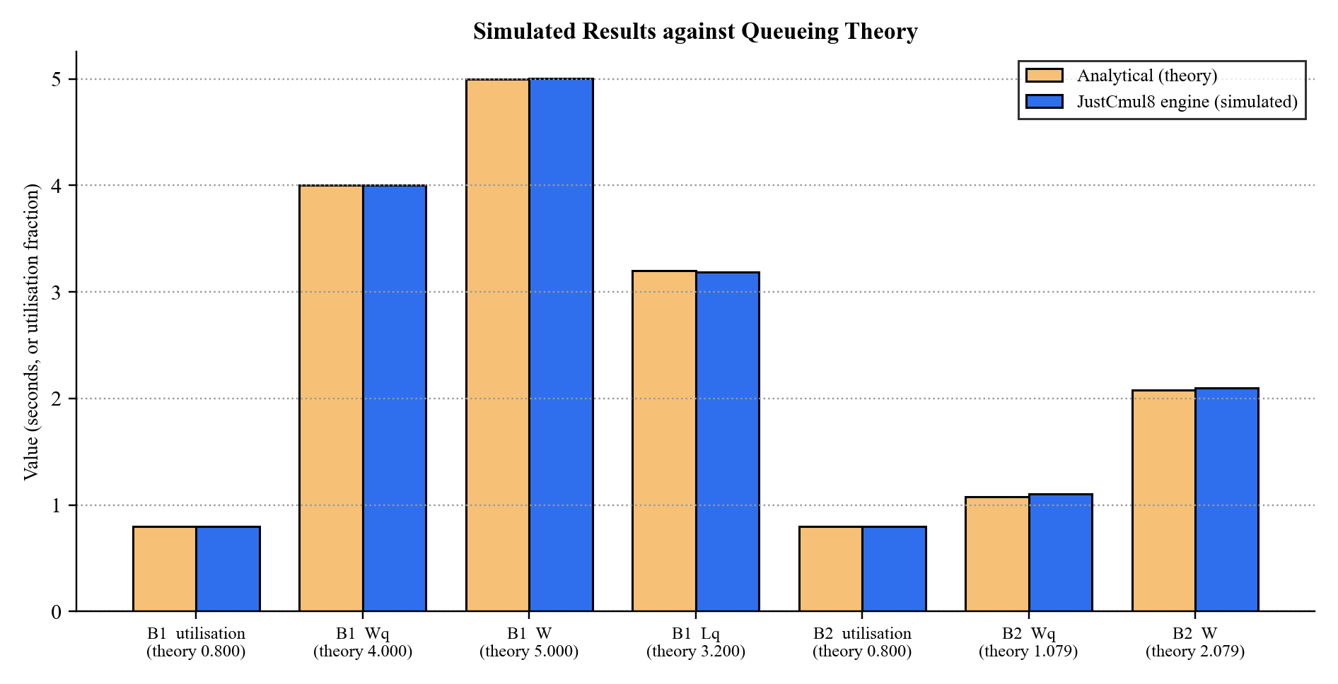
Figure 8.17: Simulated Results against Queueing Theory (M/M/1 and M/M/3 benchmarks)
The second figure gives the deviation of each of the fifteen main checks as a percentage of the theoretical value, next to the tolerance allowed. The biggest deviation, +2.09 per cent for the M/M/3 queue wait, is about half of its tolerance, and the M/M/1 deviations are all below 0.6 per cent.
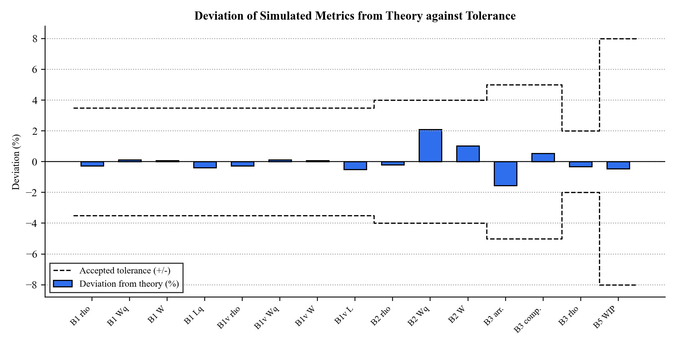
Figure 8.18: Deviation of Simulated Metrics from Theory against Accepted Tolerance
Table 8.1: Worked Example: M/M/1 Queue at ρ = 0.8 (λ = 0.8, μ = 1.0, 36,000 s, 5 replications)
Metric | Formula | Theory | Simulated | 95% CI (±)
Utilisation ρ | λ / μ | 0.800 | 0.798 | 0.0056
Mean wait in queue Wq | ρ / (μ − λ) | 4.000 s | 4.005 s | 0.173
Mean time in system W | 1 / (μ − λ) | 5.000 s | 5.004 s | 0.174
Mean queue length Lq | ρ² / (1 − ρ) | 3.200 | 3.188 | 0.183

8.2.2 A Multi-Stage Model: Hospital Flow
Benchmark B6 puts the platform through a realistic scenario. Patients arrive at 1.2 per second and pass through a triage nurse. A decision node then sends 70 per cent to minor treatment and 30 per cent to major treatment, and each station on its own is stable with utilisation near 0.7. The table sums up the results with and without patient abandonment.
Table 8.2: Results for the Multi-Stage Hospital-Flow Model (7,200 s, 3 seeds)
Measure | Abandonment on | Abandonment off
Patients arrived | 8,683 | 8,541
Patients served | 8,301 | 8,531
Patients who abandoned | 374 | 0
Throughput clearance across seeds | 0.956, 0.958, 0.954 | 0.999, 0.999, 1.000
Utilisation: triage / minor / major | 0.705 / 0.690 / 0.697 | 0.708 / 0.682 / 0.726
Decision split to minor treatment | 0.700 | 0.687
Little’s Law discrepancy and verdict | 3.2%, steady state | 0.2%, steady state
System health score | 91 | 93
Invariants satisfied | 11 of 11 | 11 of 11

This is the kind of result a decision-maker needs. With abandonment on, 4.3 per cent of patients leave unserved, yet the system stays stable, and the health score of 91 describes a well-balanced service that is not perfect. With abandonment off, the service clears almost all of the offered load. The same model can be run again under a proposed change, for instance a third triage nurse, and compared through the Monte Carlo scenario view to see whether the gain is larger than the noise.

8.2.3 The Platform Detects Failure as Well as Success
An analytics layer is only useful if it notices a system in trouble. In the saturated benchmark the arrival rate is twice the service rate. 1,181 entities arrive but only about 603 complete, utilisation is 0.997 and work-in-progress climbs to 578. The Little’s Law verdict switches to accumulating backlog and the health score drops to 45.8, well under the alert threshold of 70. So the platform separates a healthy system from a failing one without asking the user to interpret raw numbers. A separate smoke test also confirmed that a model using the extended node types (broadcaster, channel, store and container) runs without error and conserves flow, with 1,225 entities in and out at every stage.

8.3 Performance Evaluation
We assessed performance on two levels. The first is the speed of the engine, measured by the verification harness, which runs the generated SimPy script in native CPython. The second is how responsive the application is in the browser, measured with the browser’s developer tools.

8.3.1 Engine Throughput
Table 8.3: Engine Throughput Measured by the Verification Harness
Measurement | Workload | Observed
Analytical benchmark suite (B1–B5) | Five replications of each benchmark at a 36,000 simulated-second horizon; the M/M/1 benchmark generates ≈ 28,600 entities per replication | 159 s wall-clock for the whole suite
Single long run | 28,714 entities through one resource | 3.65 s wall-clock
Complex model | Hospital flow, 7,200 simulated seconds, 3 seeds, two configurations | Completed within the harness run
Clock accuracy | 36,000 accumulated timeouts | Simulated clock exactly 36,000.0

One run with nearly thirty thousand entities finishes in under four seconds, and a working day of a typical service model takes far less. A discrete event simulation jumps from event to event, so run time depends on how many events occur and not on the simulated duration, and the heap-based event queue keeps the cost per event logarithmic. In the browser the same script runs through WebAssembly, which for CPU-bound Python is usually within a small multiple of native speed.

8.3.2 Application Performance in the Browser
The measurements below are to be taken on the target device with Chrome DevTools and Lighthouse and entered in the table.
Table 8.4: Browser Performance Measurements (to be recorded)
Measurement | Target | Measured
Canvas interaction (drag / connect a node) | Immediate; no dropped frames
First-run Pyodide download and start-up | Cached thereafter
Run of a 10-node model, 1,000 simulated seconds | Interactive
Run of a 100-node model, 1,000 simulated seconds | A few seconds
Dashboard render after a run | Perceptibly immediate
Peak browser memory for the 100-node run | Well below device limits
Lighthouse performance score (landing page) | ≥ 90
Presence / cursor update between two sessions | Near real time

8.3.3 Discussion
The measurements back the main claim of the project, that a genuine discrete event simulator can run acceptably inside a browser. Verification is the more important result. The engine agrees with queueing theory to within a few per cent, conserves entities across a multi-stage model, and classifies both healthy and overloaded systems correctly. That shows the platform is not just fast enough but correct, and for a simulator correctness is what counts. Three points follow from the results and feed into the roadmap of Chapter 10. Memory, and not processing speed, sets the ceiling on model size. Monte Carlo replications are independent, so they are good candidates for running in parallel. And the first-run download of the runtime is the first thing a new user notices, which makes it the best target for optimisation.

9. COST AND BENEFIT ANALYSIS AND SOFTWARE PARAMETER ESTIMATION
This chapter estimates the effort, schedule and cost that JustCmul8 would represent if a company built it commercially. We apply two independent models, the Constructive Cost Model (COCOMO), which starts from code size, and Function Point Analysis (FPA), which starts from delivered functionality. Their results are compared with each other and with the effort we actually spent. The chapter ends with a cost and benefit analysis of the platform for its users.

9.1 Effort Estimation

9.1.1 Basic COCOMO
Basic COCOMO estimates effort from size, using coefficients that depend on the development mode. We classify JustCmul8 as organic, meaning a small team in a well-understood application domain with stable requirements and flexible constraints.
Table 9.1: COCOMO Coefficients by Development Mode
Mode | a | b | c | d | Applicable
Organic | 2.4 | 1.05 | 2.5 | 0.38 | Yes: small team, familiar domain, stable requirements
Semi-detached | 3.0 | 1.12 | 2.5 | 0.35 | No: assumes a medium team of mixed experience
Embedded | 3.6 | 1.20 | 2.5 | 0.32 | No: assumes tight hardware and regulatory constraints

For a measured size of 22.19 KSLOC (Section 9.2) the model gives:
Effort E = a × (KSLOC)^b = 2.4 × (22.19)^1.05 = 2.4 × 25.93 = 62.19 person-months
Duration D = c × E^d = 2.5 × (62.19)^0.38 = 2.5 × 4.80 = 12.01 months
Staffing S = E / D = 62.19 / 12.01 = 5.18 persons
Productivity P = KSLOC / E = 22.19 / 62.19 = 0.357 KSLOC per person-month
Table 9.2: COCOMO Estimation Results
Parameter | Estimated value
Effort | 62.19 person-months
Development duration | 12.01 months
Average staffing | 5.18 persons
Productivity | 0.357 KSLOC per person-month
Cost at ₹40,000 per person-month | ₹24,87,600 (≈ ₹24.88 lakh)

The money figure uses a notional forty thousand rupees per person-month, roughly an entry-level Indian software engineering salary with overhead. The rate is only illustrative; effort and duration are the substantive output of the model.

9.2 KSLOC Analysis
We measured size from the delivered source tree, counting TypeScript, TSX and Python files under the application’s source directory and leaving out dependencies, build output and generated artefacts.
Table 9.3: Source Lines of Code by Layer
Layer / directory | Contents | SLOC | Share
src/components | Workspace, landing, layout and shared interface components | 11,544 | 52.0%
src/lib/simulation | Code generator, engine, analytics, Monte Carlo, export, registry | 4,905 | 22.1%
src/app | Pages and API routes (auth, dashboard, workspace, share, AI, export) | 3,848 | 17.3%
src/lib/ai | Model router, prompts, graph operations, flow analysis | 1,654 | 7.5%
src/lib/realtime | Presence and broadcast hook | 143 | 0.6%
src/lib/supabase, hooks | Database clients and helper hooks | 59 | 0.3%
src/middleware.ts | Session refresh and route protection | 39 | 0.2%
Total | 91 source files (.ts, .tsx) | 22,192 | 100%

Table 9.4: Measured Project Size
Measure | Value
Source files | 91
Total lines of source code | 22,192
Non-blank lines | 20,286
Size in KSLOC | 22.19
Application pages | 9 pages and 7 API routes (including the authentication callback)
Node types implemented | 15
Simulation domains | 6
Delivered modules | 12
Database tables (application) | 5, plus 2 access functions and 1 trigger

More than half of the code (52 per cent) is interface code, which reflects how much the workspace contains: a canvas editor, eight result tabs, a Monte Carlo panel, a WebGL digital twin and a landing page. The engine, analytics and export logic, which decide whether the numbers are right, take another 22 per cent, and the AI layer 7.5 per cent. The database schema is small on purpose, since the graph is stored as a document and Supabase provides authentication and authorisation.

9.3 Function Point Analysis
Function Point Analysis measures the functionality delivered and not the code written, so it works as a cross-check on a size-based estimate. The IFPUG method counts five categories of component, weights each by complexity and adjusts the total with fourteen general system characteristics.
Table 9.5: Standard IFPUG Complexity Weights
Component type | Simple | Average | Complex
External Input (EI) | 3 | 4 | 6
External Output (EO) | 4 | 5 | 7
External Inquiry (EQ) | 3 | 4 | 6
Internal Logical File (ILF) | 7 | 10 | 15
External Interface File (EIF) | 5 | 7 | 10

Table 9.6: Function Point Count by Component Type
Component type | Simple | Average | Complex | Count | Weighted
External Inputs: forms, edits and commands | 6 | 8 | 4 | 18 | 74
External Outputs: dashboards, charts and exports | 2 | 4 | 4 | 10 | 56
External Inquiries: listings and retrievals | 2 | 3 | 2 | 7 | 30
Internal Logical Files: application tables | 3 | 0 | 2 | 5 | 51
External Interface Files: Auth, Gemini, Pyodide CDN | 1 | 2 | 0 | 3 | 19
Unadjusted Function Points (UFP) |  |  |  | 43 | 230

The eighteen external inputs are the authentication forms, project creation, renaming and deletion, graph edits, parameter configuration, template loading, run initiation, AI prompts, fix application, share-link creation and revocation, profile update and account deletion. The ten external outputs are the KPI dashboard, the bottleneck flag, the Monte Carlo interval charts, the digital-twin playback, the streamed log, the entity journey trace and the export formats. The five internal logical files are the database tables of Section 5.6. Two of them, projects and runs, count as complex because they hold JSON documents.
Table 9.7: General System Characteristics and Degrees of Influence
No. | General system characteristic | Rating | Justification
1 | Data communications | 4 | Client, server, database and AI service all communicate
2 | Distributed data processing | 5 | Simulation executes on the client, not the server
3 | Performance | 4 | Responsive canvas and immediate dashboard expected
4 | Heavily used configuration | 2 | No constrained deployment hardware
5 | Transaction rate | 3 | Moderate, rising during collaborative editing
6 | Online data entry | 5 | All modelling is interactive and immediate
7 | End-user efficiency | 5 | No-code operation is a primary objective
8 | Online update | 5 | Automatic persistence on every change
9 | Complex processing | 5 | Discrete event simulation, Monte Carlo statistics, AI
10 | Reusability | 3 | Service modules reusable; interface is application-specific
11 | Installation ease | 5 | Zero installation by design
12 | Operational ease | 4 | Managed hosting with automatic deployment
13 | Multiple sites | 3 | Browser-portable across platforms
14 | Facilitate change | 4 | Registry-driven extension of domains and node types
 | Total Degree of Influence (TDI) | 57

VAF = 0.65 + (0.01 × TDI) = 0.65 + 0.57 = 1.22
Function Points FP = UFP × VAF = 230 × 1.22 = 281 function points
Effort E = FP / productivity = 281 / 13 = 21.6 person-months
Cost at ₹40,000 per person-month = 21.6 × 40,000 = ₹8,64,000 (≈ ₹8.64 lakh)
Implied size 22,192 SLOC / 281 FP = 79 SLOC per function point
For a modern web application of this kind, industry productivity is around thirteen function points per person-month. The implied 79 lines per function point is above the usual 50 to 60 for TypeScript. The reason can be seen in Table Table 9.3: a very large share of the code is presentation, and the landing page alone is about 1,900 lines. That code adds polish and usability but few function points.

9.4 Comparison of Estimates and Cost–Benefit Analysis
Table 9.8: Comparison of Estimates against Planned Effort
Basis | Effort | Duration | Team | Indicative cost
COCOMO (basic, organic) | 62.19 PM | 12.01 months | 5.18 persons | ₹24.88 lakh
Function Point Analysis | 21.6 PM | n/a | n/a | ₹8.64 lakh
Actual project (planned) | 12 PM | 6 months | 2 students | Nil cash cost; academic, open-source stack

The three rows differ a lot, and the gap says more than any single number. Both models were calibrated on projects written largely from scratch, and neither allows for the head start that a modern framework stack gives. The simulation engine is the clearest case. A discrete event scheduler with resource contention, preemption, container levels and typed stores would probably account for a third of the COCOMO estimate on its own, yet we got all of it from SimPy, and our effort went into the code generator that targets it. The same holds for React Flow, which gave us the canvas, and for Supabase, which gave us authentication, access control and the realtime transport. The twenty-two thousand lines we wrote sit on top of a very large amount of code we did not write. Function Point Analysis lands nearer to our actual effort than COCOMO does, which fits with its measuring delivered functionality and not code volume.
The estimates therefore give an upper bound on what the platform would cost to build without such foundations, and they show what the open-source ecosystem is worth to a project like this. A commercially built equivalent would probably fall between the two estimates.

9.4.1 Costs
Table 9.9: Development and Operating Costs
Item | Nature | Cost
Development effort | Two students, six months | Academic; no cash cost
Software licences | Entire stack is open source or free-tier | Nil
Hosting (front end) | Vercel free tier | Nil at academic scale
Database, authentication, realtime | Supabase free tier | Nil at academic scale; paid tiers scale with data volume
AI inference | Gemini API, metered per explicit request | Small and controllable
Simulation compute | Runs on the user’s own device | Nil; does not grow with usage
Maintenance | Dependency upgrades, registry additions | Student / community effort

9.4.2 Benefits
Table 9.10: Benefits of the Platform
Benefit | Type | Beneficiary
Removes per-seat licence fees that commercial tools charge | Tangible, recurring | Institutions, small businesses
Removes installation and IT-support effort on every machine | Tangible | Laboratories, IT departments
No server compute cost that scales with the number of simulations | Tangible | The platform operator
Decisions tested on a computer instead of on the real system, avoiding costly mistakes | Tangible, decision-dependent | Small-business owners
Time to first result measured in minutes rather than days of training | Tangible (time) | Students, lecturers
Wider access to a decision-support technique | Intangible | Society, education
A transparent, reproducible engine that supports teaching of SimPy and queueing theory | Intangible | Educators, researchers

The balance of cost and benefit is unusually good. The main cost, computation, moves onto hardware the user already owns, while the main benefit, access to trustworthy simulation, arrives with no licence fee. A single commercial seat at a few thousand dollars a year would cost more than the whole annual running cost of the platform at academic scale, and each extra user adds benefit without adding cost.

10. CONCLUSION AND FUTURE SCOPE

10.1 Achievements of the Project
JustCmul8 set out to remove three barriers that keep Discrete Event Simulation away from most of the people who could use it: the price of commercial licences, the programming skill that open-source alternatives demand, and the installation that desktop software needs. What the project achieved is summarised below.
- A complete no-code simulation platform: twelve integrated modules, from creating an account and modelling on a canvas to analysis, sharing and collaboration, all running in a web browser.
- A real engine and not an imitation: each model is compiled into a genuine Python SimPy program and run by CPython compiled to WebAssembly in a Web Worker, so results come from the same library researchers use directly.
- Verified correctness: all 28 analytical checks against M/M/1, M/M/c and saturated-queue theory passed within tolerance, every deviation was below 2.1 per cent, and all 22 conservation and flow-balance invariants held on a multi-stage hospital-flow model.
- Breadth of modelling: fifteen node types across six application domains, including preemptive resources, typed stores, containers, channels, broadcasters, event synchronisers and interrupters.
- Decision support and not only numbers: bottleneck flagging, a Little’s Law consistency check, a composite health score, cost and return-on-investment analysis, and Monte Carlo confidence intervals with baseline-versus-scenario comparison.
- AI-assisted workflow: plain-English model generation and one-click, cost-aware fixes, served through a router that watches model health and fails over between models automatically.
- Output that is easy to understand: an eight-tab results dashboard, a WebGL digital-twin animation, an entity tracer and a traffic heatmap turn statistics into pictures.
- Transparency and reproducibility: a live Python code inspector and one-click Jupyter export let anyone verify a result independently.
- Security built in: Row-Level Security on every table, opaque revocable share links served through narrow database functions, secrets kept on the server and cascading deletion of user data.
- Sustainable economics: client-side computation and an open-source stack keep the running cost almost independent of usage.
On the academic side, the project put material from across the programme to work and did not just cite it. Priority queues and graph traversal from data structures appear in the event scheduler and the validation pass. Normalisation, referential integrity and access control from database management appear in the schema and its policies. The software development life cycle shows in the scheduling decisions of Chapter 3, including the choice to tackle the riskiest component first. Probability and statistics appear in the distribution samplers, the confidence intervals and the check against queueing theory.

10.2 Conclusion
The decision that shaped the result most was our refusal to approximate the engine. Writing a rough event loop in JavaScript would have been far easier, and the platform would have looked much the same from outside. Instead, the graph is compiled into a genuine SimPy script, and the verification in Chapter 7 turns that from a claim into evidence: agreement with theory to within a few per cent shows that the generated script expresses the intended model and that the statistics are gathered correctly.
In practical terms the platform can be used today. A student can open a template and see queueing behaviour within a minute. A lecturer can demonstrate congestion live and send a share link afterwards. A small-business owner can describe a shop in plain English and read off a confidence interval before committing any money. All of this needs no licence, no installation and no code, which was the outcome we wanted. JustCmul8 shows that serious simulation can be as easy to reach as a web page, and that accessibility does not have to cost accuracy.

10.3 Future Scope
We designed the architecture to be extended: one registry defines each domain, the engine sits behind a worker boundary, and authorisation lives in the database. The roadmap below builds on those decisions and does not replace them, and it answers each limitation recorded in Section 1.4.

Near-term enhancements
- Parallel Monte Carlo: spreading replications over several Web Workers, so a hundred-replication analysis takes close to the machine’s core count times less, since the replications are independent.
- Reproducible runs: user-selectable random seeds, so any run can be repeated exactly and shared together with its seed.
- Pause and resume: checkpointing, so a long run can be suspended and continued later.
- Streaming result aggregation: dropping per-entity detail once it has been aggregated and keeping full traces only when playback is requested, which raises the ceiling on model size.
- Role-based collaboration: invitations by email with owner, editor and viewer permissions enforced by Row-Level Security, and version history with rollback.
- Convergent conflict resolution: replacing last-write-wins with a merge based on operational transformation or CRDTs, so two users can edit the same node without either losing work.
- Input-validation hardening: turning every boundary condition, such as a zero arrival rate, into a friendly message before a run.
- Progressive runtime loading: fetching a reduced Pyodide payload to shorten the first-run start-up.

Medium-term extensions
- Custom node types through a plugin interface, run safely inside the existing sandbox, so users can model domains we did not foresee.
- More simulation paradigms: an agent-based engine and a true continuous solver next to SimPy, chosen per project.
- Search-based optimisation: sweeping a parameter space to find the configuration with the lowest cost that still meets a service-level constraint, so that advice becomes optimisation.
- Offline and classroom mode: a progressive web application with local storage for laboratories without dependable internet.
- A native mobile companion for viewing dashboards and playback.
- A community template marketplace where users publish and rate models for their own domains.

Longer-term directions
- Optional cloud execution for models too big for browser memory, with client-side execution staying the default.
- Parallel and distributed simulation: splitting very large models across workers or machines with synchronised clocks.
- Calibration from real data: fitting arrival and service distributions automatically from historical or sensor data, so measured parameters replace estimated ones.
- Live digital-twin integration: linking a running model to IoT feeds so the simulation follows the physical system it represents.
- Institutional features: single sign-on, organisation management and classroom cohorts for department-scale adoption.
None of these requires us to revisit what we decided in this project. The layered architecture, the worker boundary, the registry-driven definition of domains and node types and the enforcement of authorisation at the database were each picked to make extension possible, and every item above builds on them.

REFERENCES AND BIBLIOGRAPHY
References follow IEEE citation style. Textbooks and articles that give the theoretical basis come first, then standards, then the technical documentation of the software the platform is built on.
[1] A. M. Law, Simulation Modeling and Analysis, 5th ed. New York, NY, USA: McGraw-Hill Education, 2015.
[2] J. Banks, J. S. Carson, B. L. Nelson and D. M. Nicol, Discrete-Event System Simulation, 5th ed. Upper Saddle River, NJ, USA: Pearson Prentice Hall, 2010.
[3] B. P. Zeigler, H. Praehofer and T. G. Kim, Theory of Modeling and Simulation, 2nd ed. San Diego, CA, USA: Academic Press, 2000.
[4] S. Robinson, Simulation: The Practice of Model Development and Use, 2nd ed. Basingstoke, U.K.: Palgrave Macmillan, 2014.
[5] D. Gross, J. F. Shortle, J. M. Thompson and C. M. Harris, Fundamentals of Queueing Theory, 5th ed. Hoboken, NJ, USA: John Wiley & Sons, 2018.
[6] L. Kleinrock, Queueing Systems, Volume 1: Theory. New York, NY, USA: Wiley-Interscience, 1975.
[7] J. D. C. Little, “A proof for the queuing formula: L = λW,” Operations Research, vol. 9, no. 3, pp. 383–387, 1961.
[8] T. H. Cormen, C. E. Leiserson, R. L. Rivest and C. Stein, Introduction to Algorithms, 4th ed. Cambridge, MA, USA: MIT Press, 2022.
[9] G. E. P. Box and M. E. Muller, “A note on the generation of random normal deviates,” The Annals of Mathematical Statistics, vol. 29, no. 2, pp. 610–611, Jun. 1958.
[10] A. B. Owen, Monte Carlo Theory, Methods and Examples. Stanford, CA, USA: Stanford University, 2013.
[11] B. W. Boehm, Software Engineering Economics. Englewood Cliffs, NJ, USA: Prentice Hall, 1981.
[12] A. J. Albrecht and J. E. Gaffney, “Software function, source lines of code, and development effort prediction: A software science validation,” IEEE Transactions on Software Engineering, vol. SE-9, no. 6, pp. 639–648, Nov. 1983.
[13] R. S. Pressman and B. R. Maxim, Software Engineering: A Practitioner’s Approach, 9th ed. New York, NY, USA: McGraw-Hill Education, 2020.
[14] I. Sommerville, Software Engineering, 10th ed. Harlow, U.K.: Pearson Education, 2015.
[15] IEEE Recommended Practice for Software Requirements Specifications, IEEE Std 830-1998, 1998.
[16] G. Booch, J. Rumbaugh and I. Jacobson, The Unified Modeling Language User Guide, 2nd ed. Boston, MA, USA: Addison-Wesley, 2005.
[17] A. Silberschatz, H. F. Korth and S. Sudarshan, Database System Concepts, 7th ed. New York, NY, USA: McGraw-Hill Education, 2019.
[18] Team SimPy, “SimPy: Discrete event simulation for Python, documentation.” [Online]. Available: https://simpy.readthedocs.io/ [Accessed: Sep. 2026].
[19] Pyodide Development Team, “Pyodide: Python with the scientific stack, compiled to WebAssembly.” [Online]. Available: https://pyodide.org/ [Accessed: Sep. 2026].
[20] WebAssembly Community Group, “WebAssembly Core Specification,” W3C Recommendation, 2019. [Online]. Available: https://www.w3.org/TR/wasm-core-1/ [Accessed: Sep. 2026].
[21] Vercel Inc., “Next.js Documentation: App Router.” [Online]. Available: https://nextjs.org/docs [Accessed: Sep. 2026].
[22] Meta Open Source, “React Documentation.” [Online]. Available: https://react.dev/ [Accessed: Sep. 2026].
[23] xyflow, “React Flow Documentation.” [Online]. Available: https://reactflow.dev/ [Accessed: Sep. 2026].
[24] Supabase Inc., “Supabase Documentation: Database, Auth, Realtime and Row Level Security.” [Online]. Available: https://supabase.com/docs [Accessed: Sep. 2026].
[25] PostgreSQL Global Development Group, “PostgreSQL Documentation: Row Security Policies.” [Online]. Available: https://www.postgresql.org/docs/ [Accessed: Sep. 2026].
[26] Google, “Gemini API Documentation.” [Online]. Available: https://ai.google.dev/docs [Accessed: Sep. 2026].
[27] Microsoft Corporation, “TypeScript Handbook.” [Online]. Available: https://www.typescriptlang.org/docs/ [Accessed: Sep. 2026].
[28] Mozilla Developer Network, “Using Web Workers.” [Online]. Available: https://developer.mozilla.org/en-US/docs/Web/API/Web_Workers_API [Accessed: Sep. 2026].
[29] International Function Point Users Group, Function Point Counting Practices Manual, Release 4.3.1. Princeton Junction, NJ, USA: IFPUG, 2010.

